Enantioselective rhodium-catalysed insertion of trifluorodiazoethanes into tin hydrides
Stephen Hyde,ª Janis Veliks,ª David M. H. Ascough,ª Robert Szpera,ª Robert S. Paton,^{a,b} Véronique Gouverneur*ª
^{[a]}Department of Chemistry, University of Oxford, Chemistry Research Laboratory, Mansfield Road, OX1 3TA, UK ^{[b]} Department of Chemistry, Colorado State University, Fort Collins, CO 80523, USA.

Supplementary Information
Contents
1. NMR Data 1
1.1 1-aryl-2,2,2-trifluorodiazoethanes 1
1.2 Stannanes 10
2. Computational methods 30

1. NMR Data

1.1 1-aryl-2,2,2-trifluorodiazoethanes

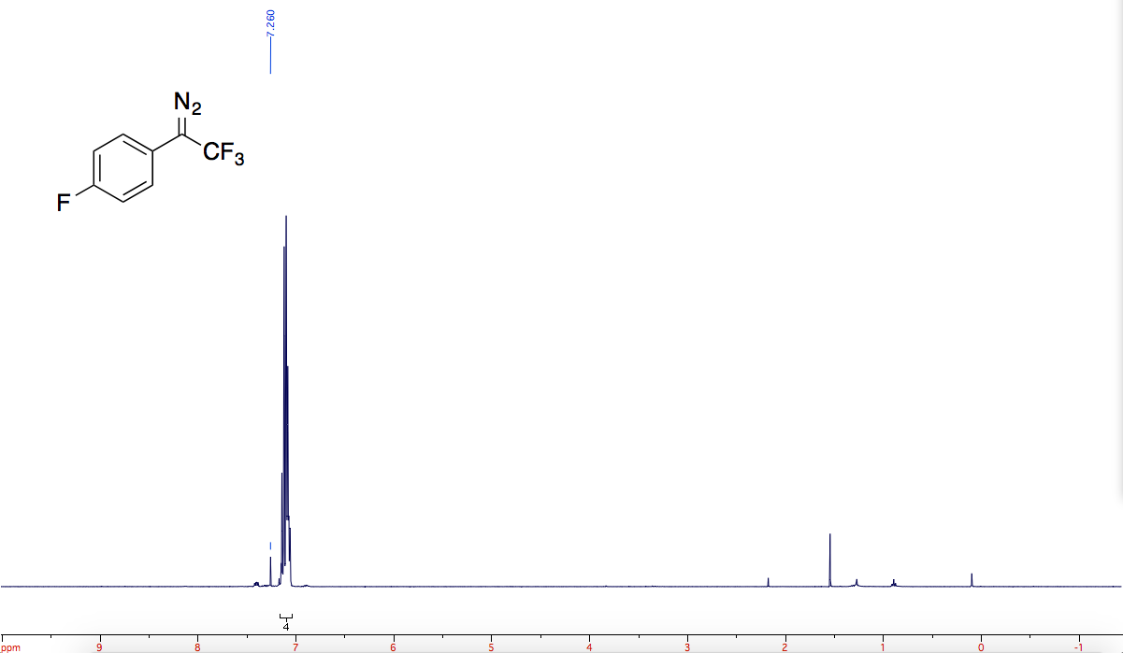

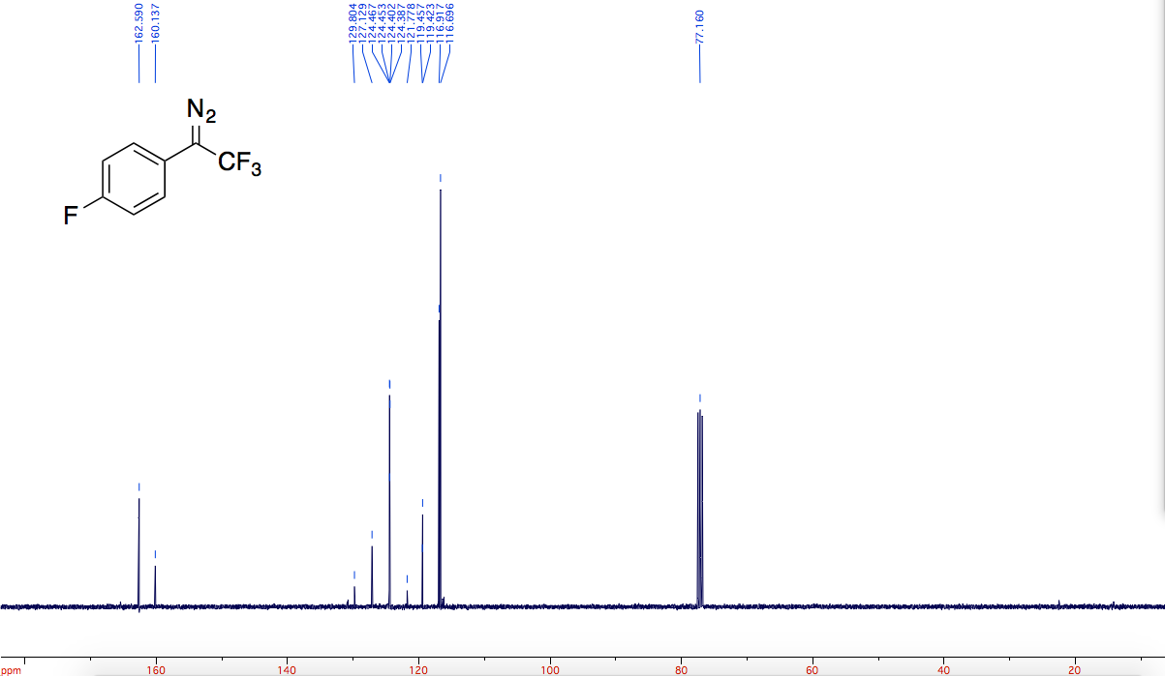
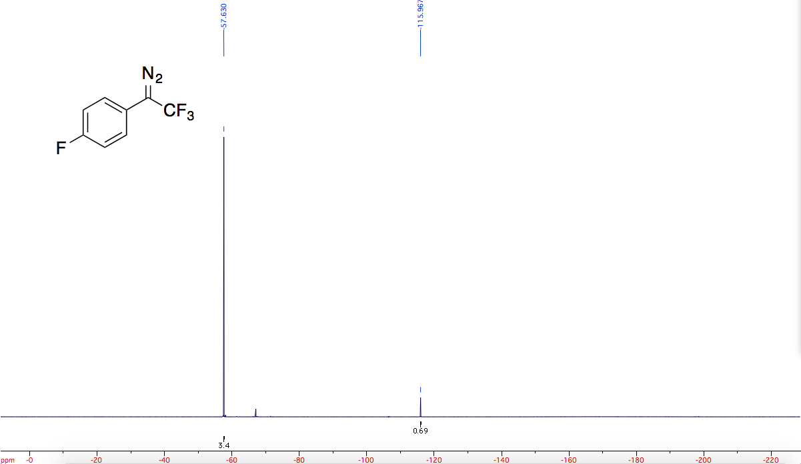

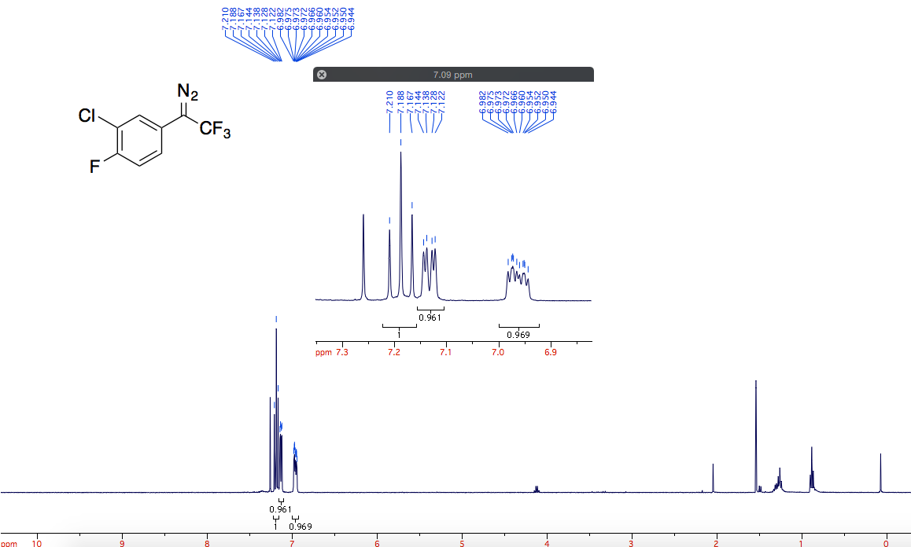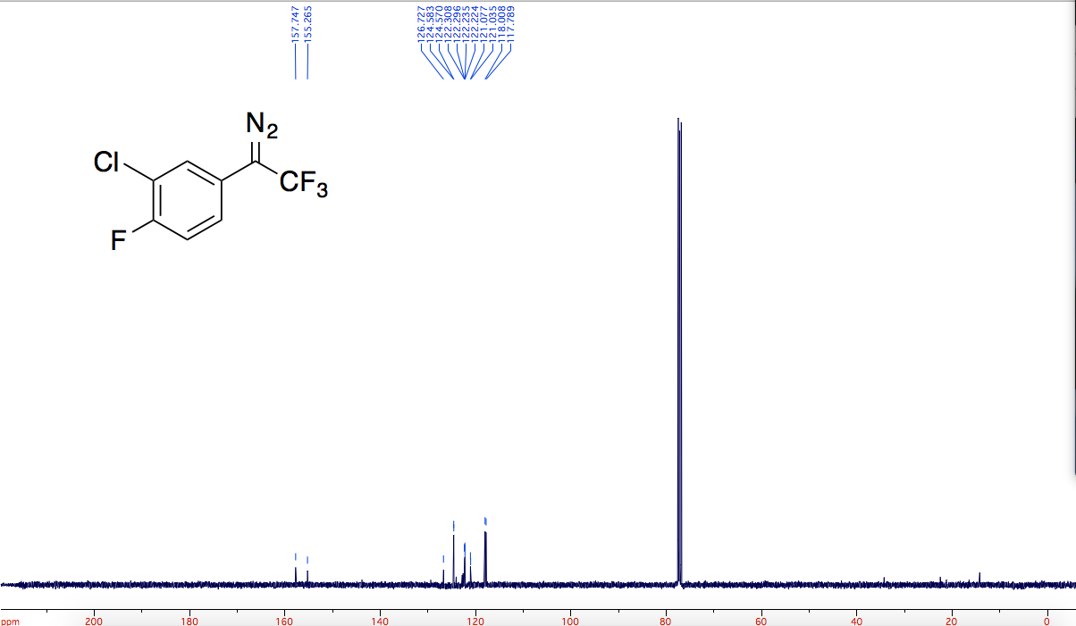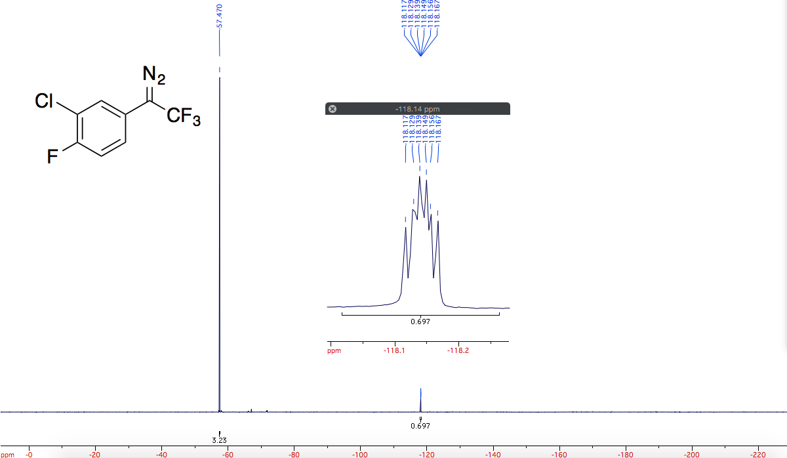

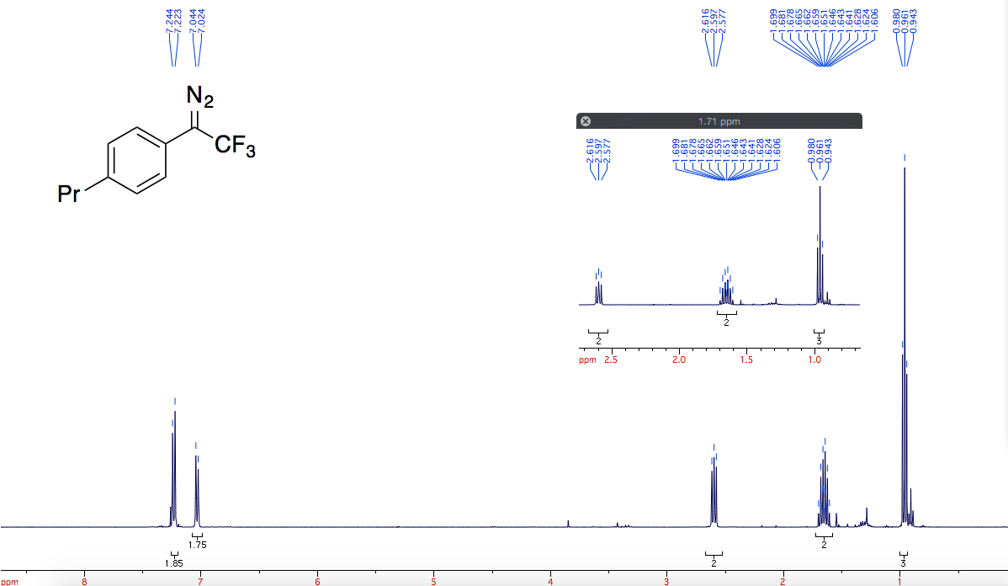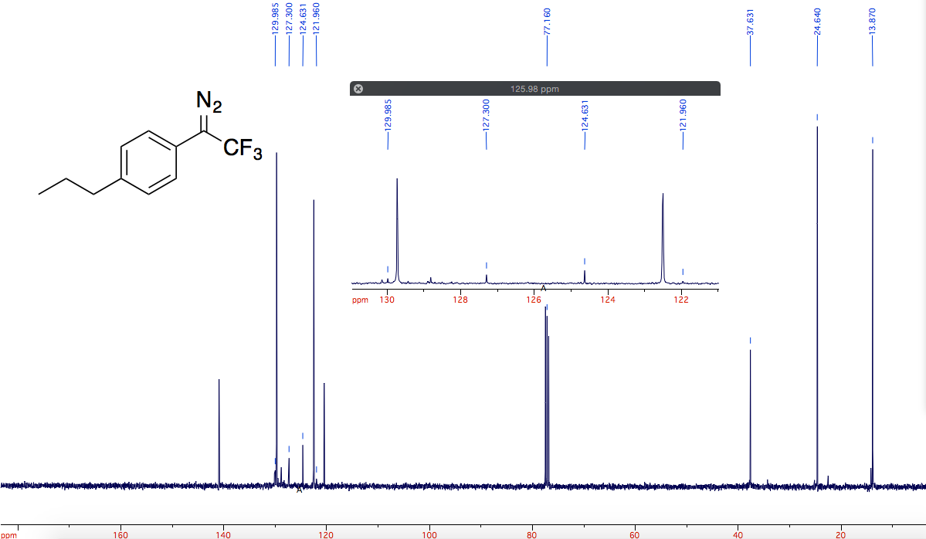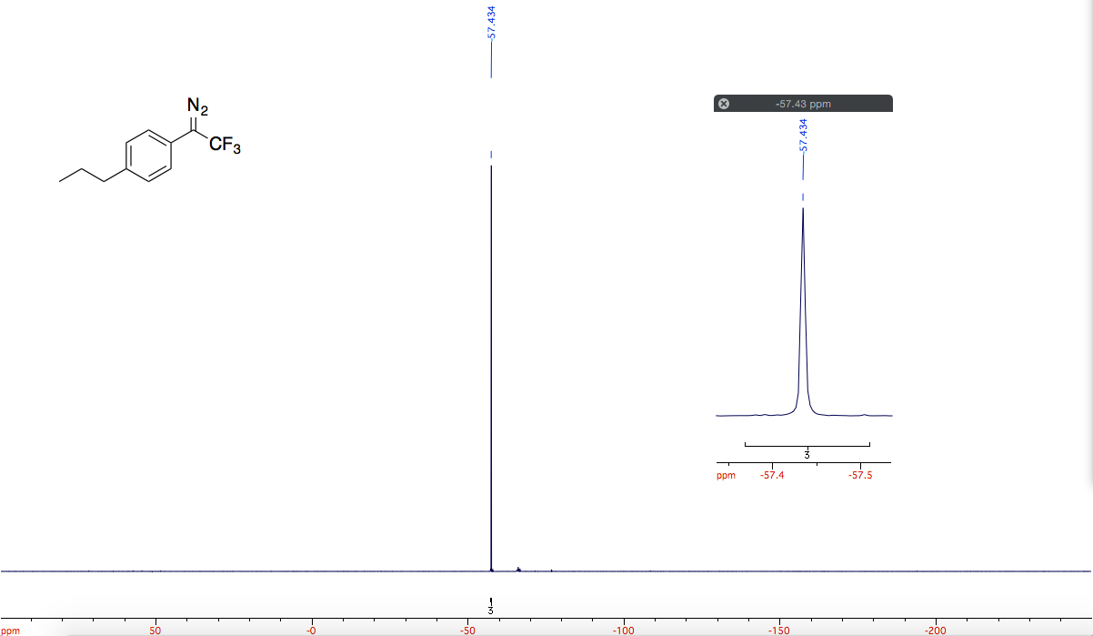

1.2 Stannanes

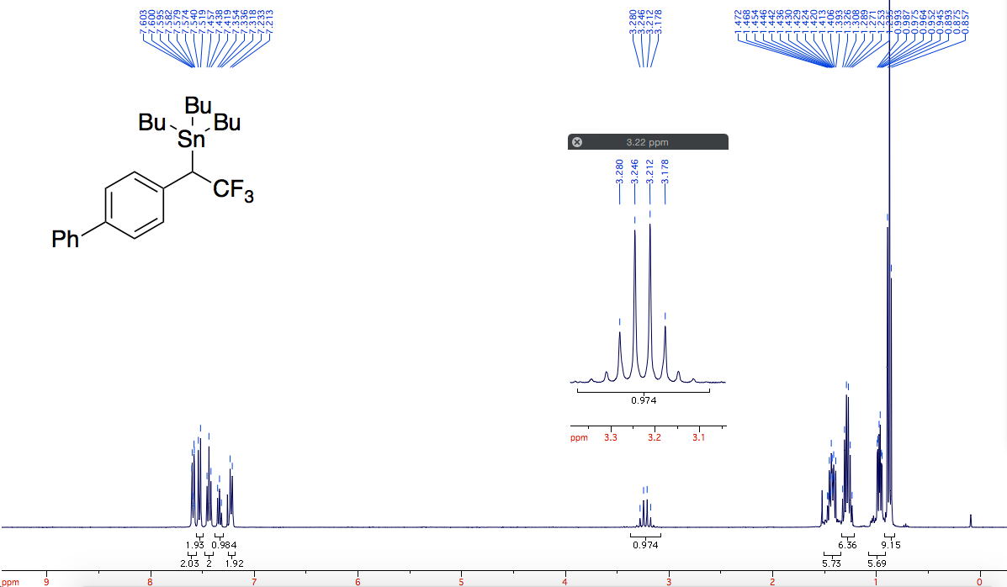

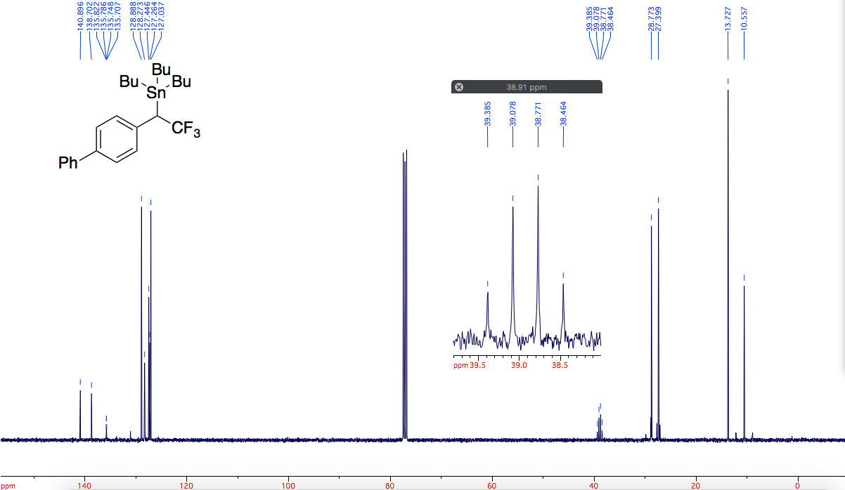
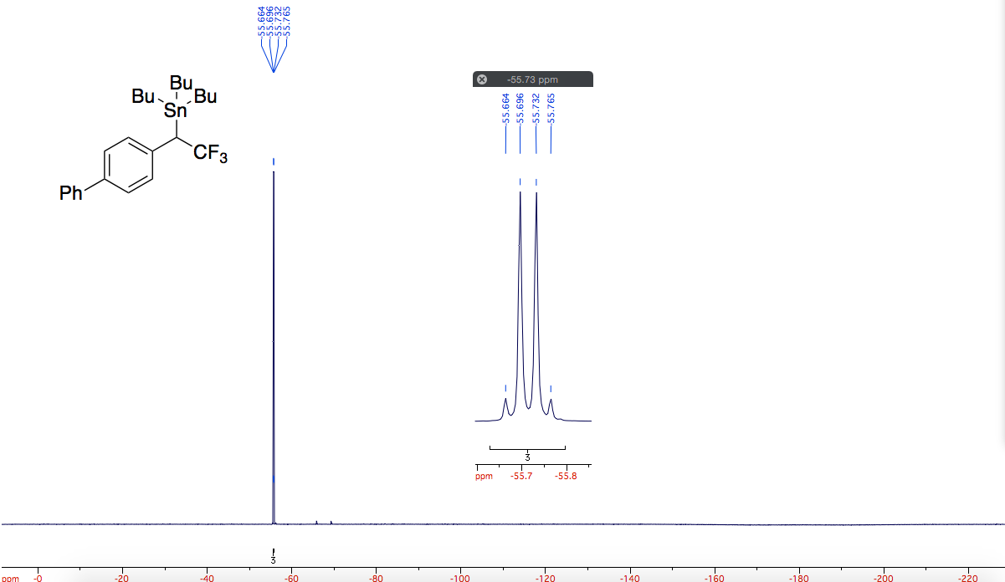

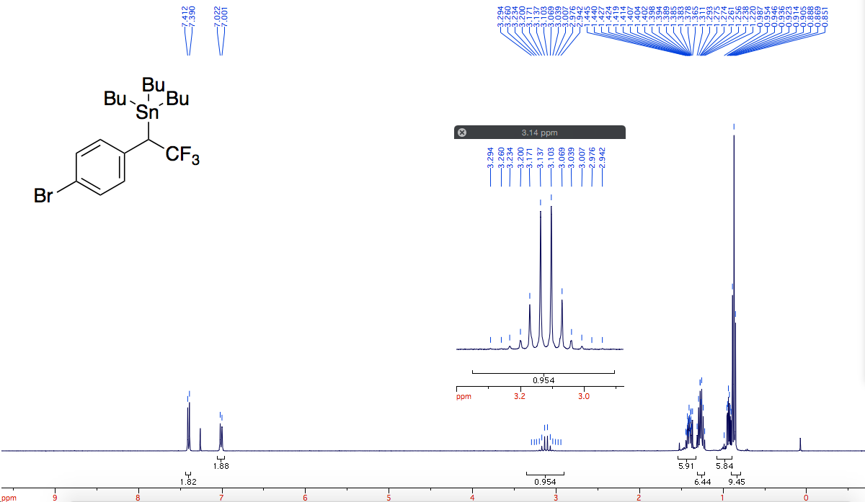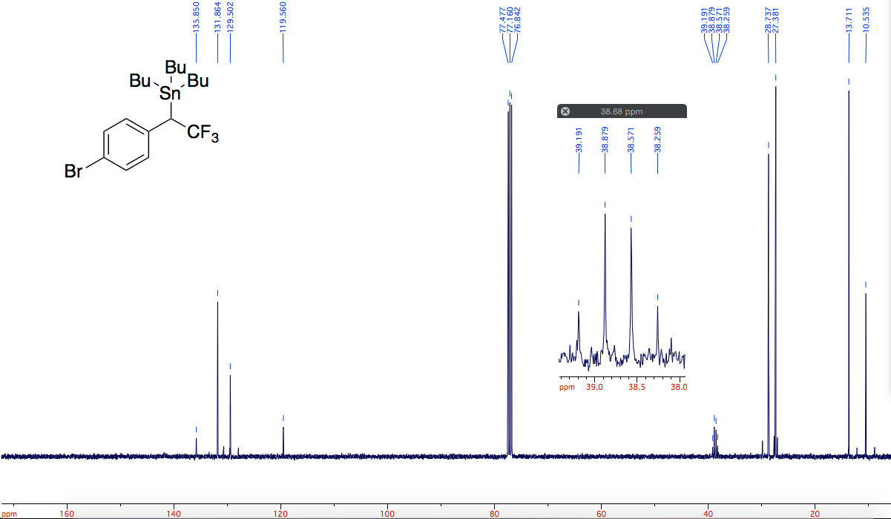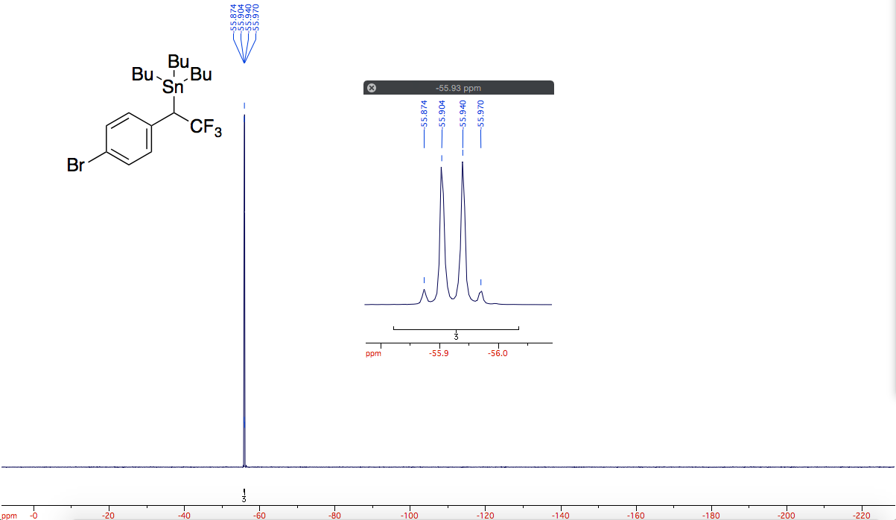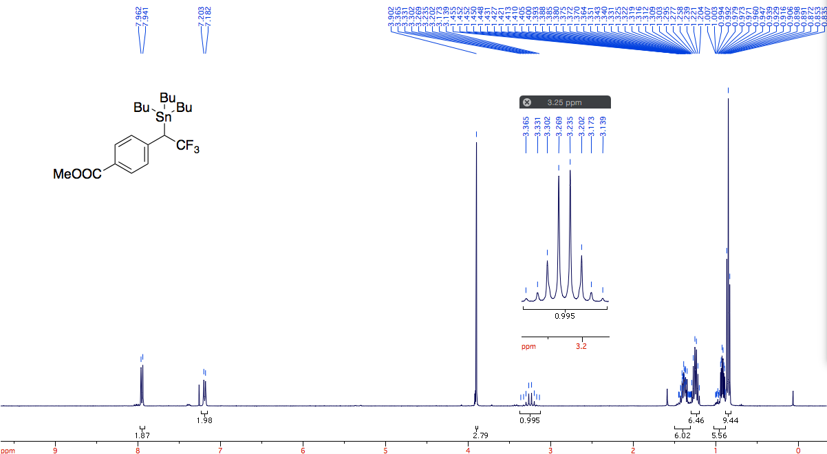

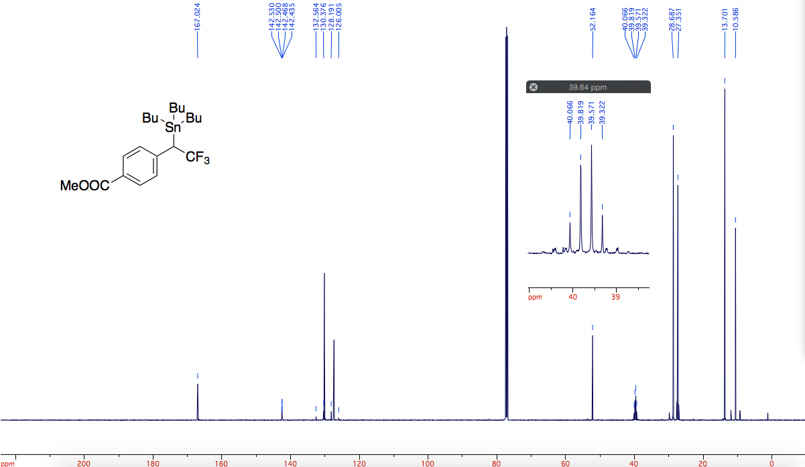

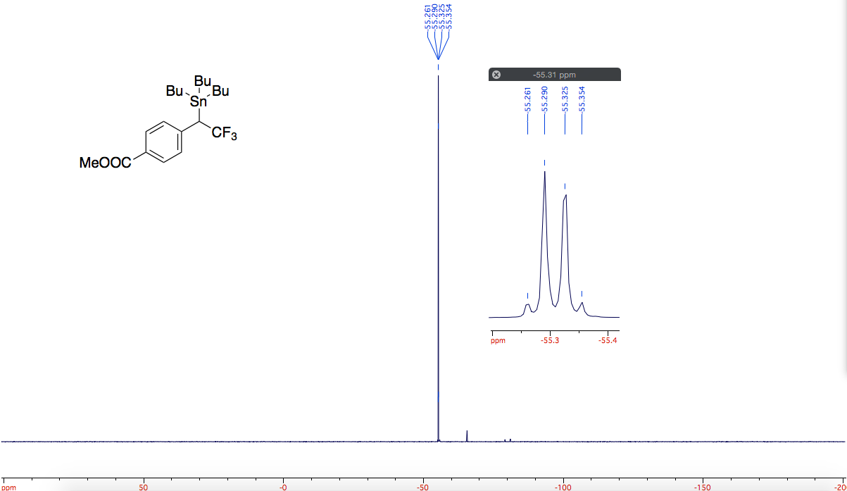

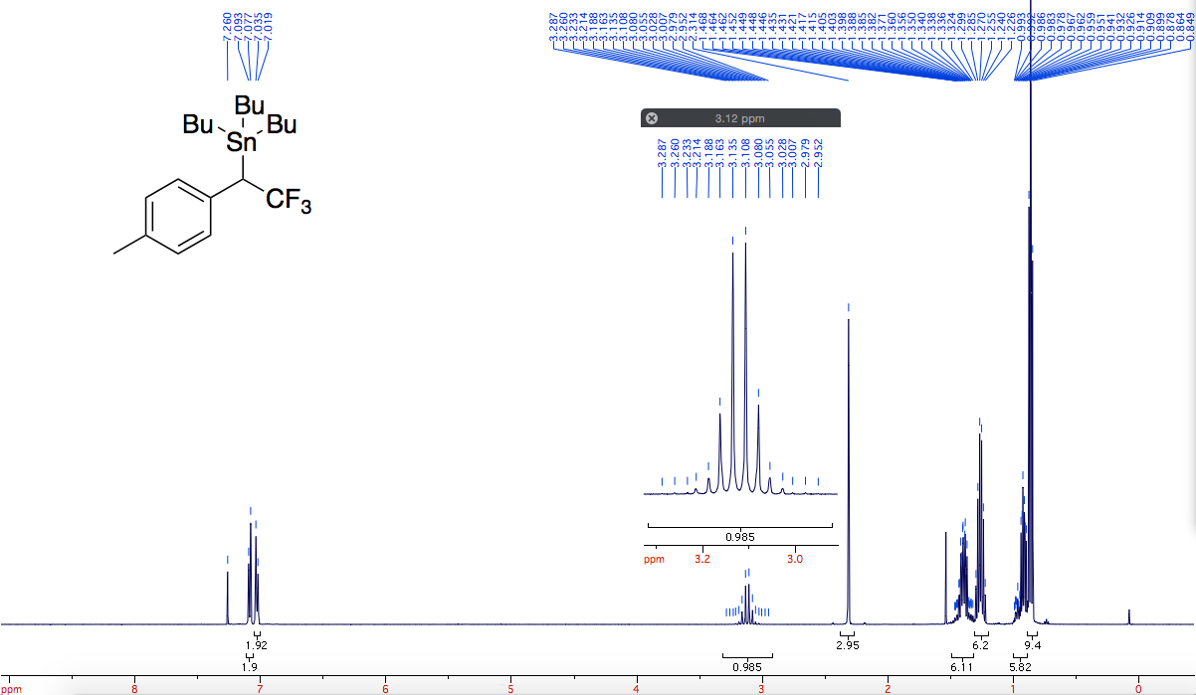
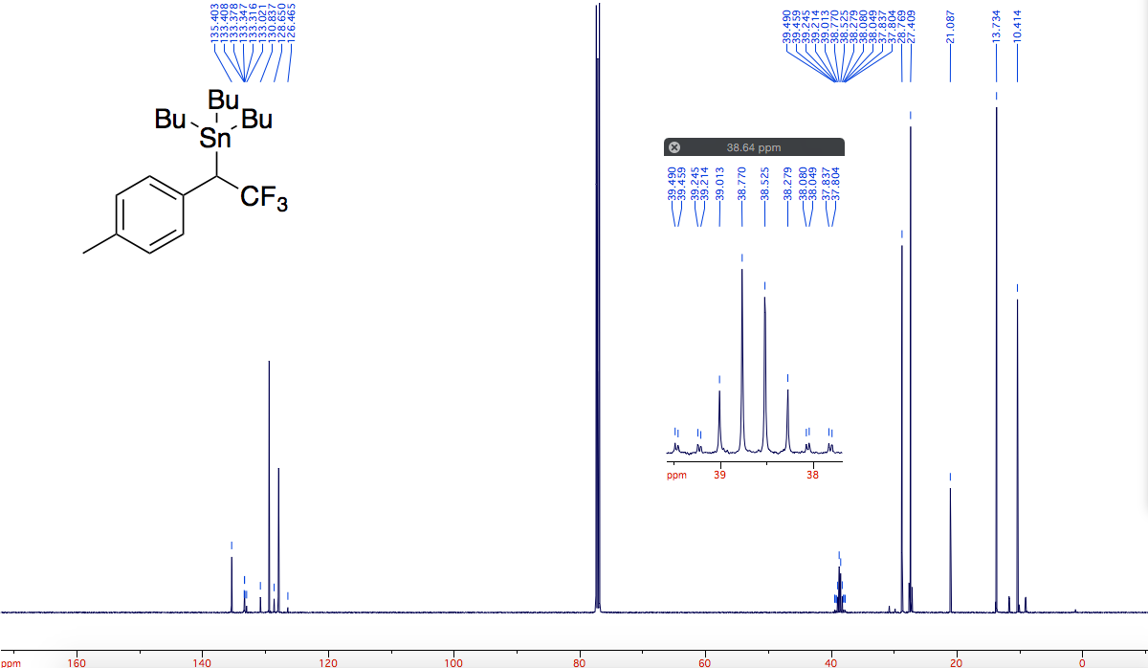
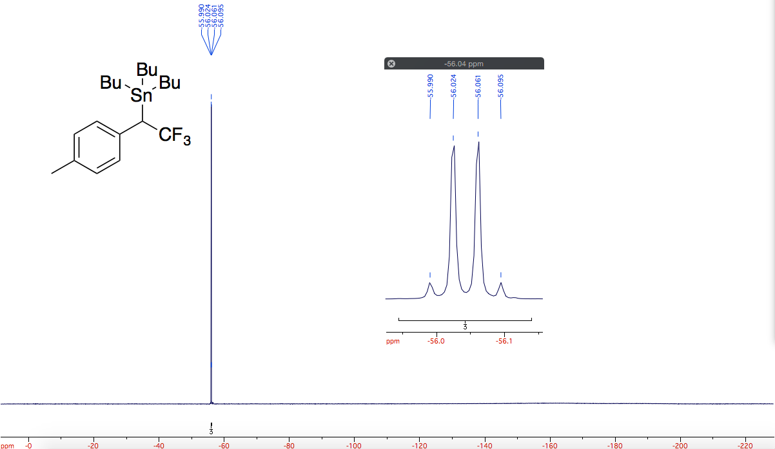

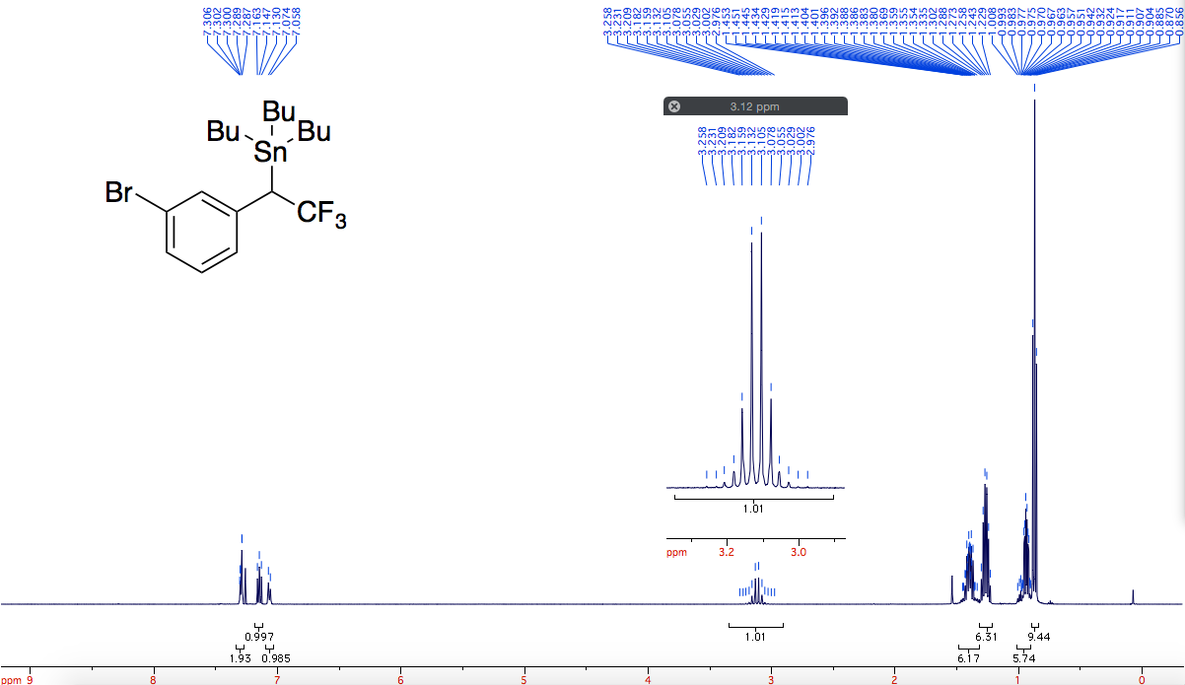
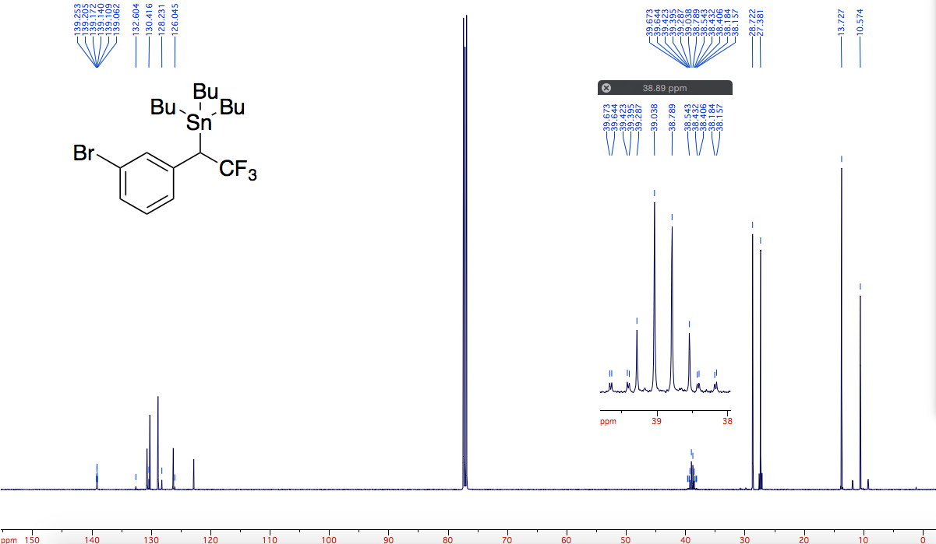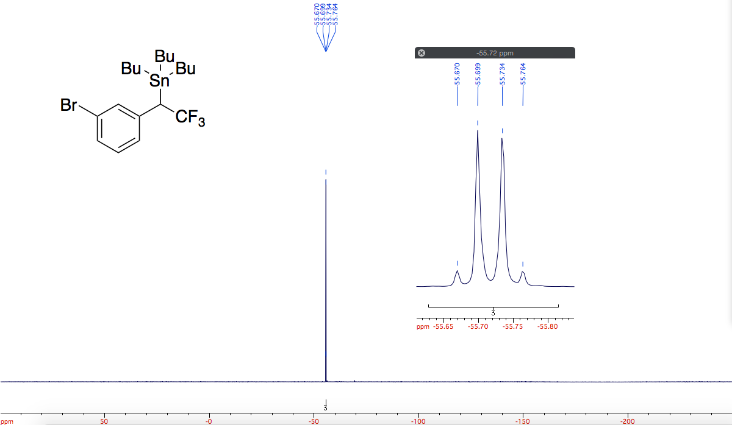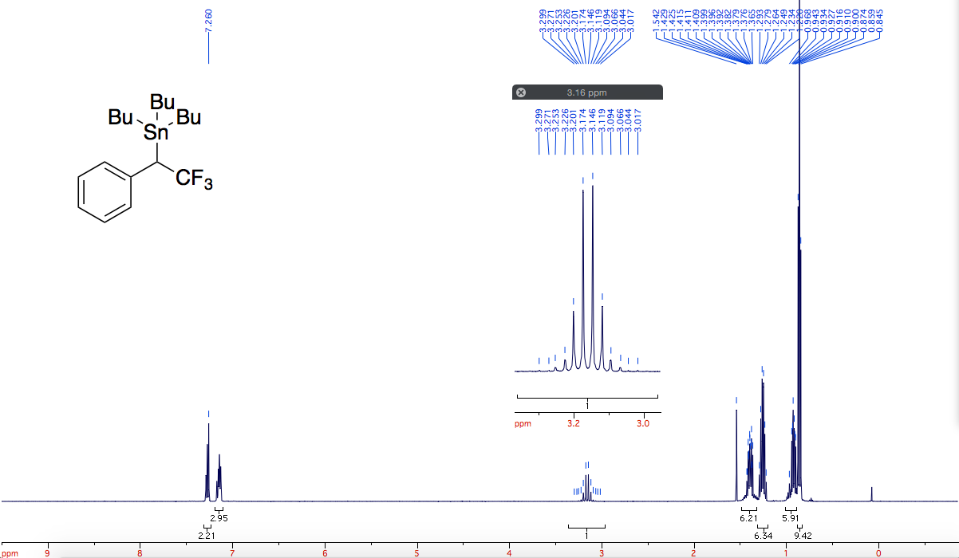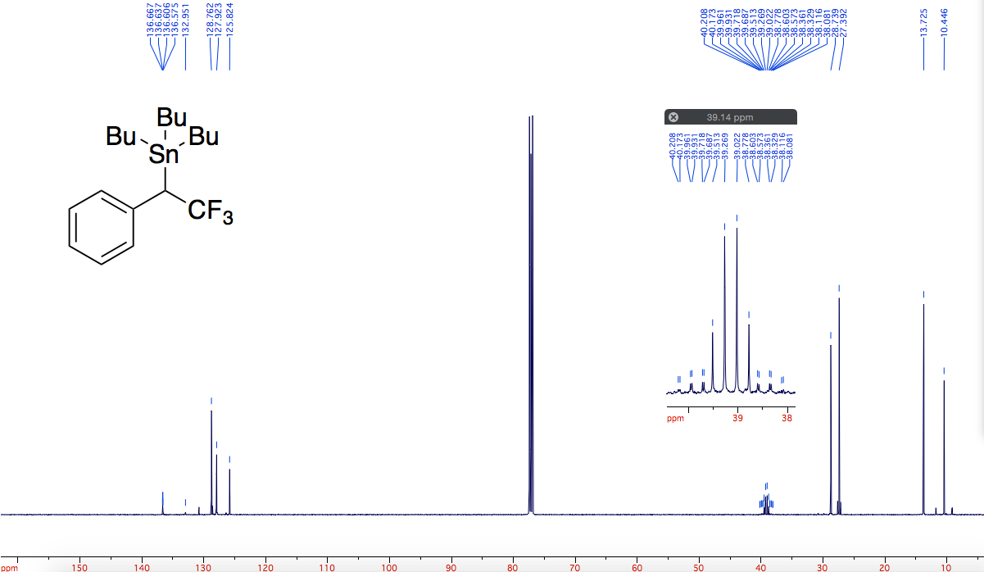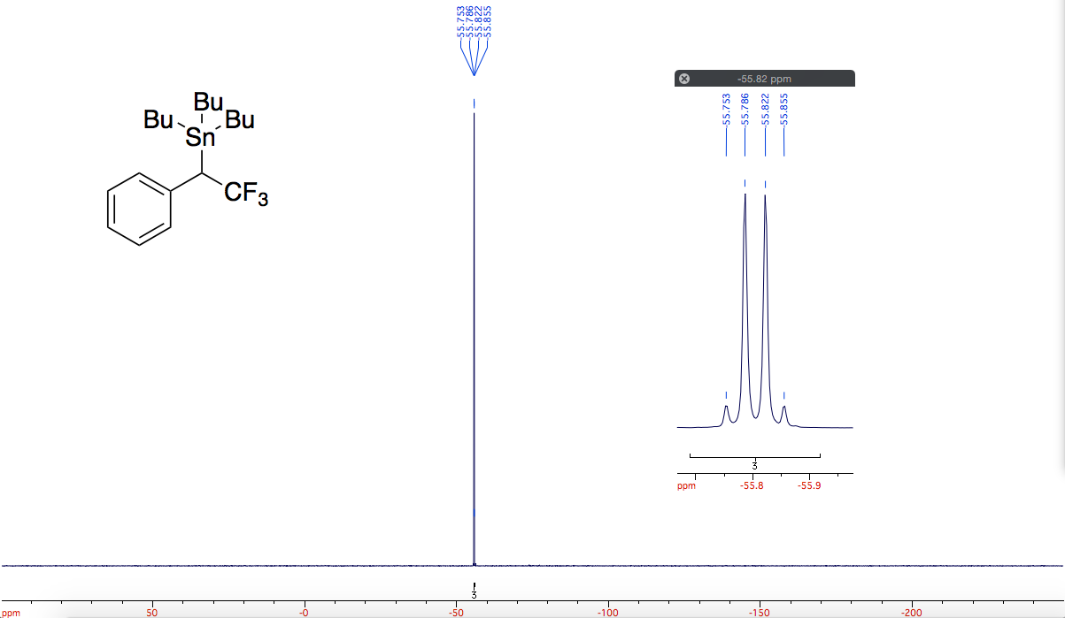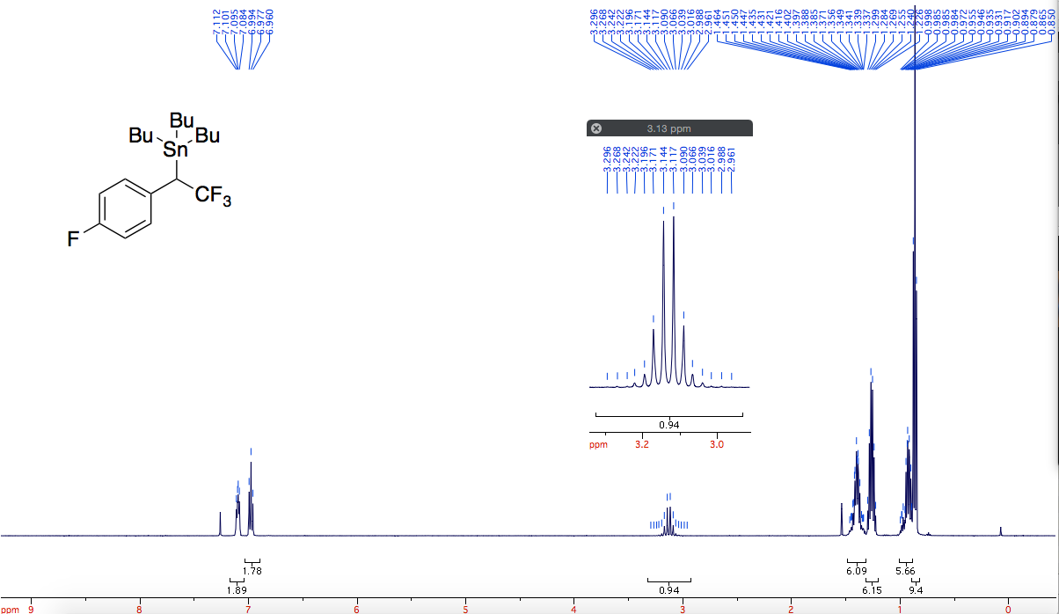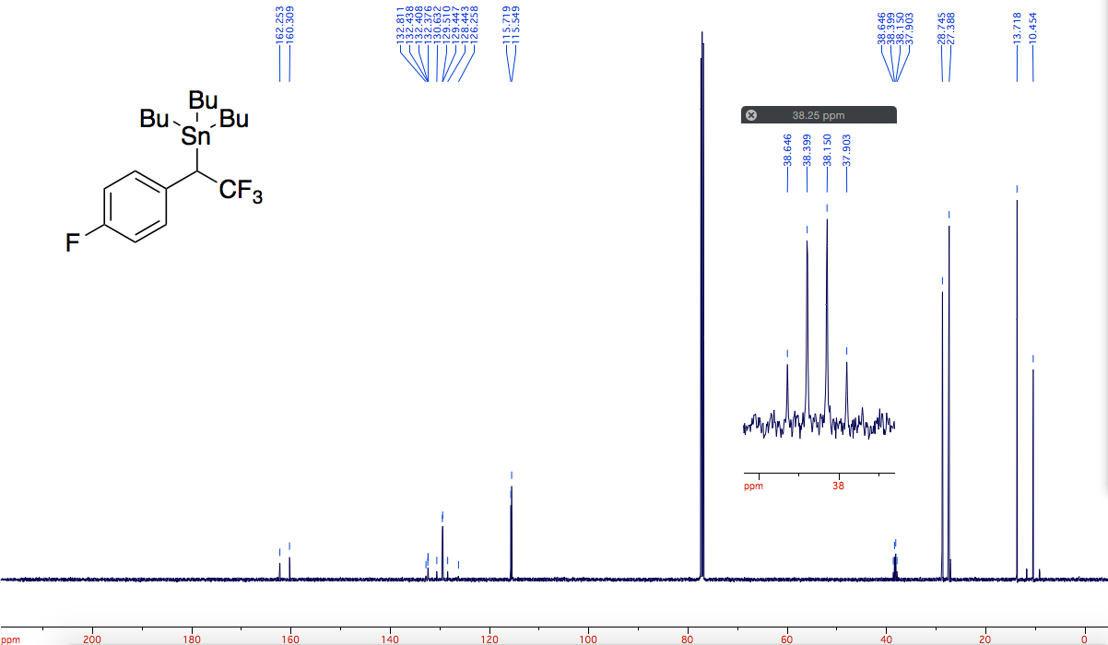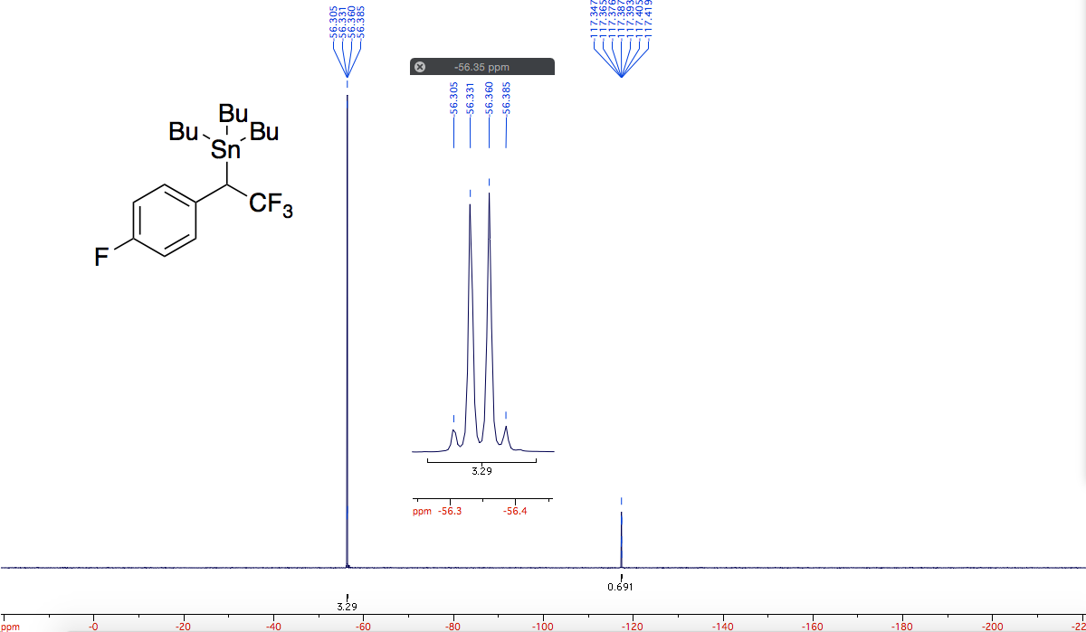

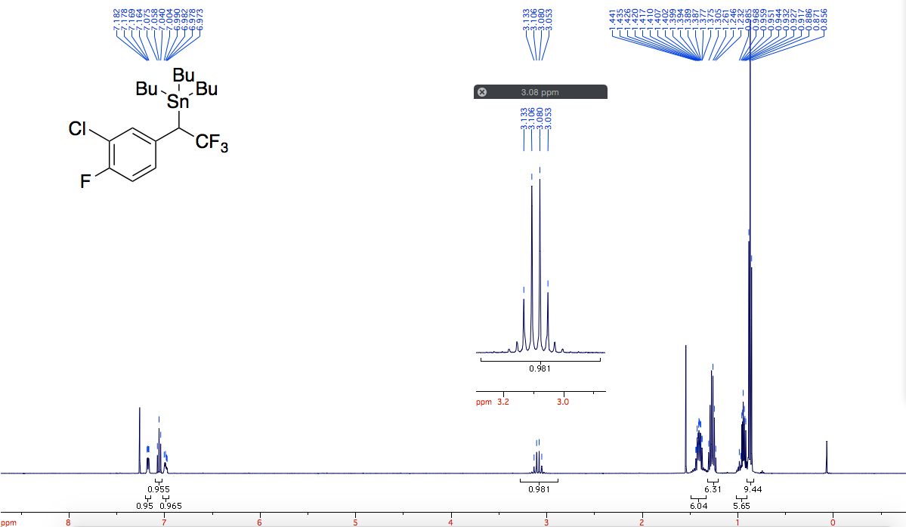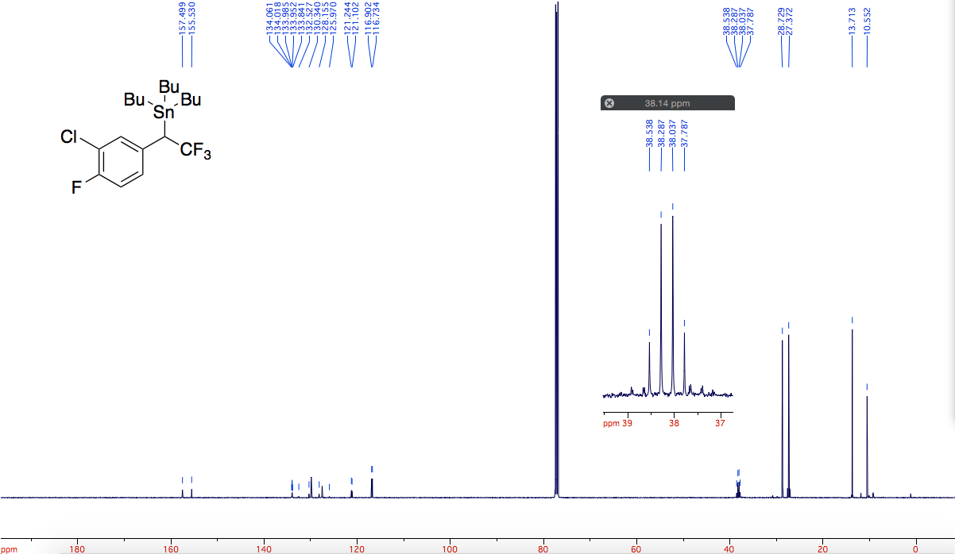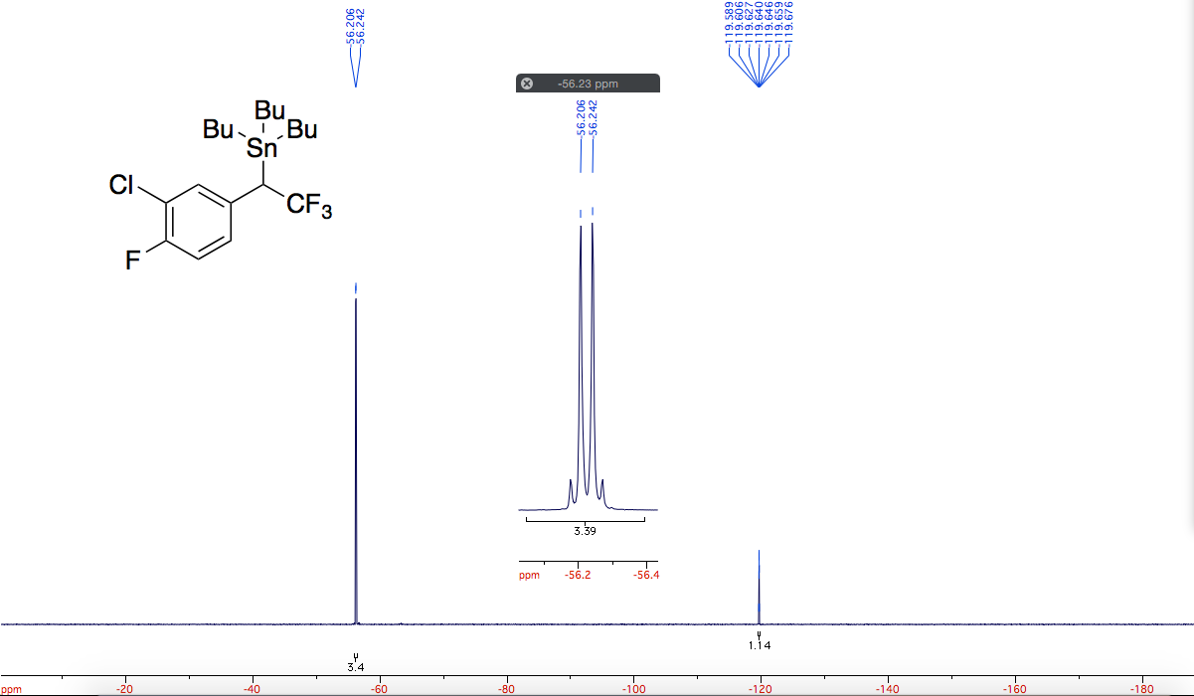

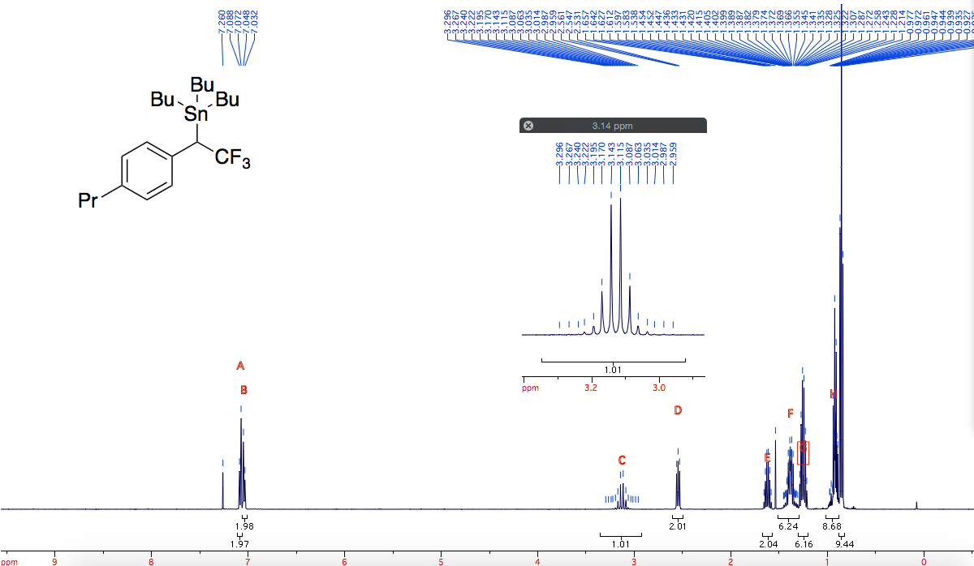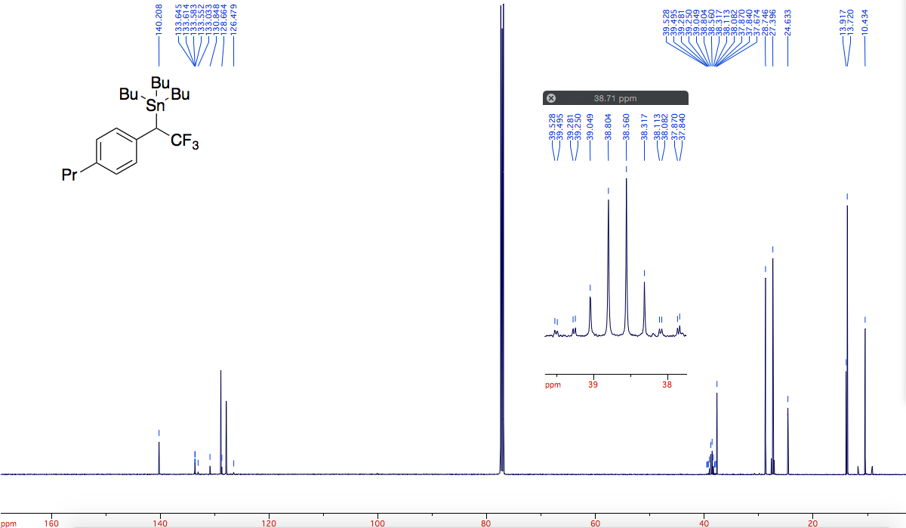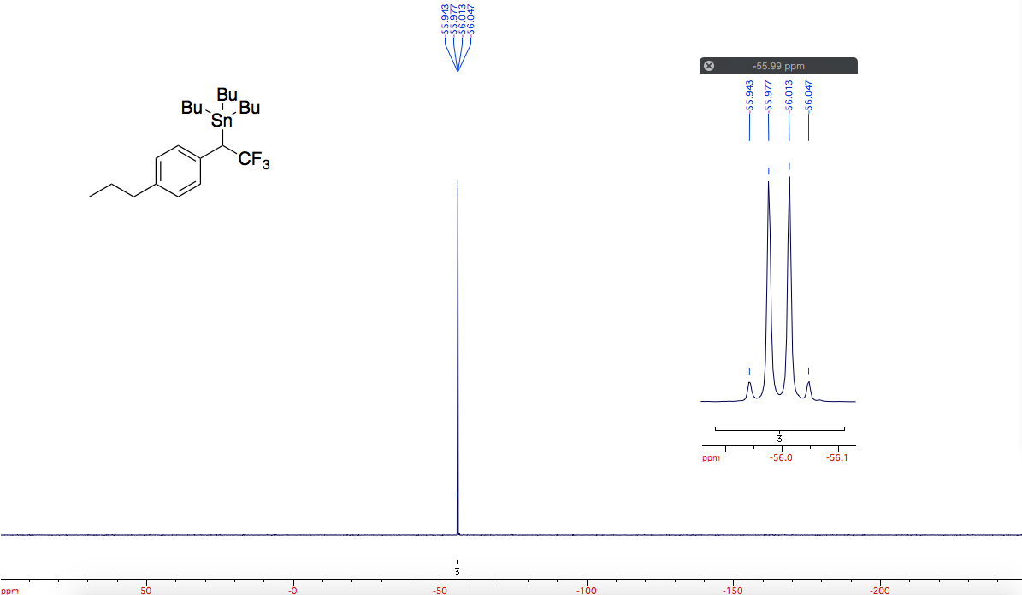

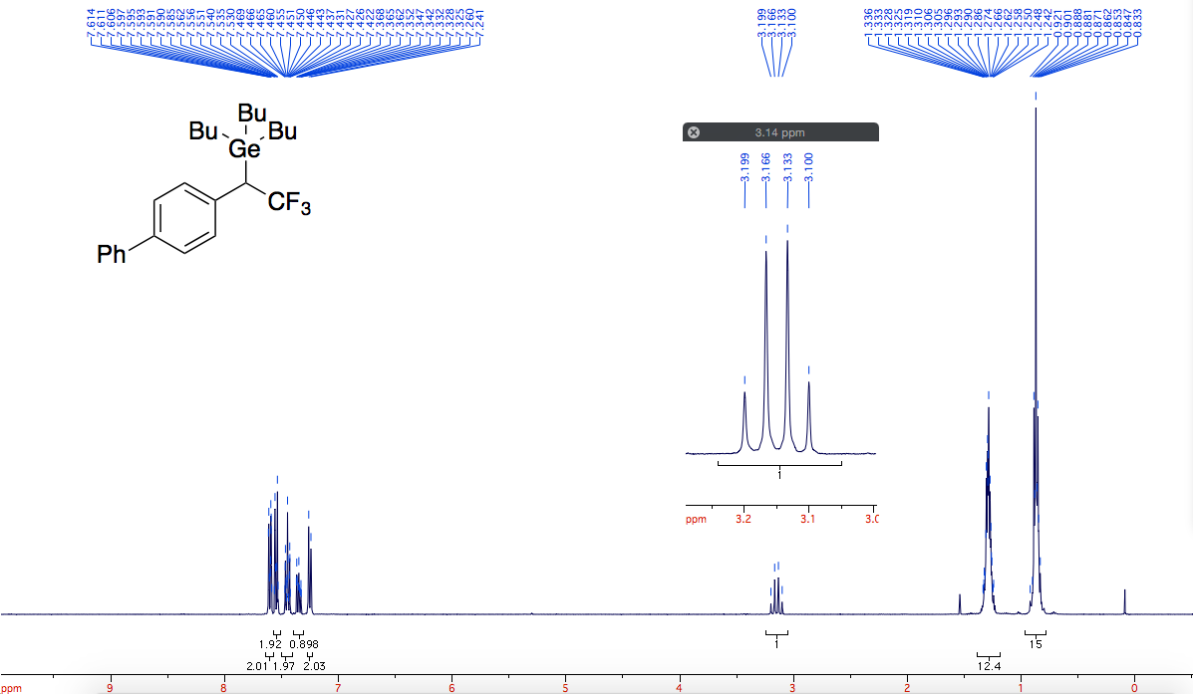

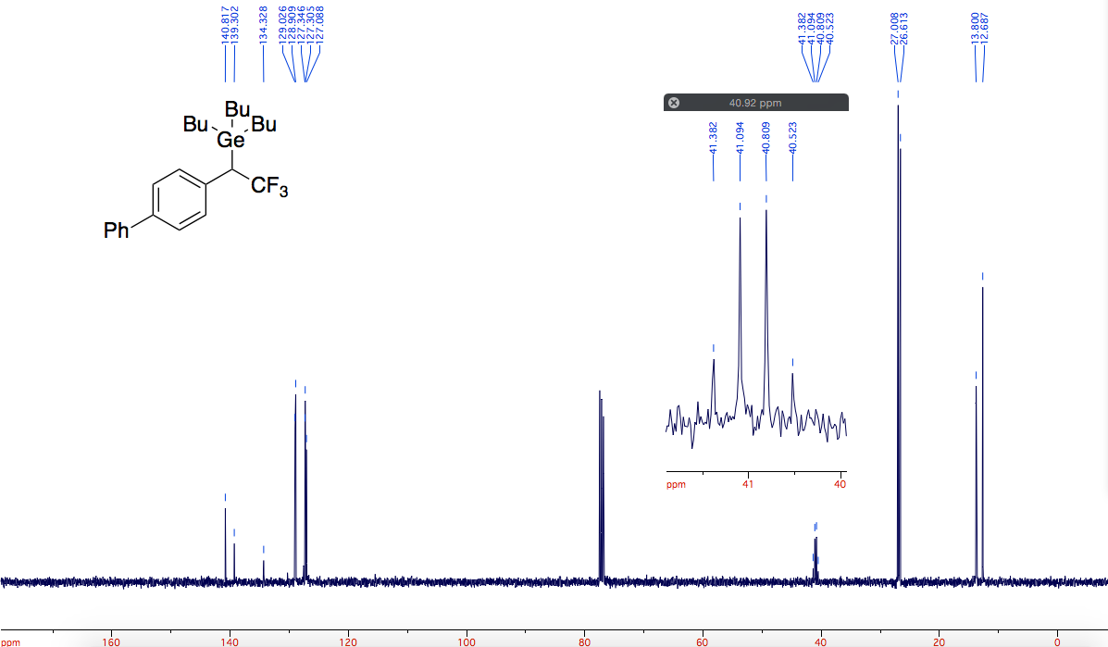

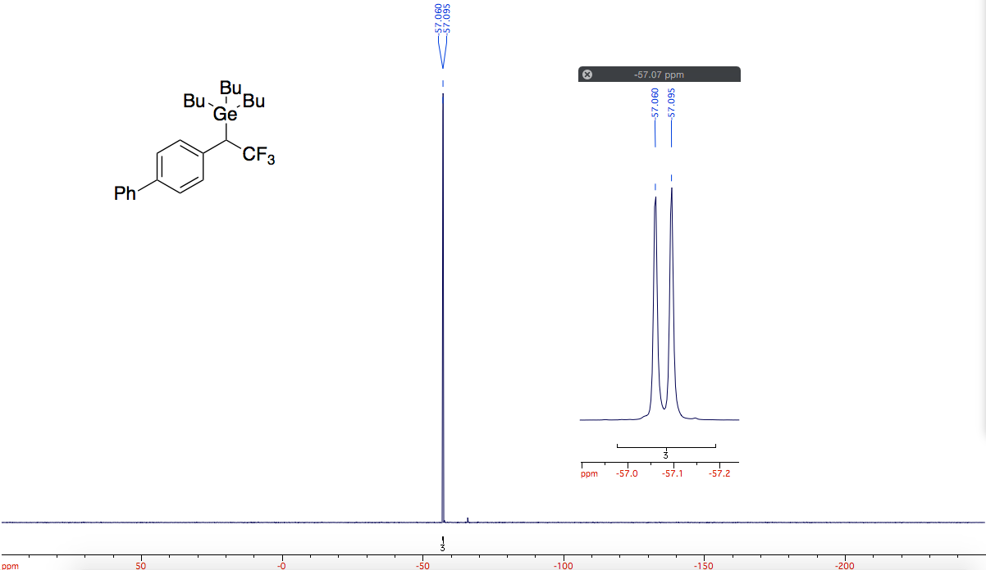

2. Computational methods

Homolytic C–H bond dissociation enthalpies (BDEs) were calculated using the Gaussian-4 (G4) method¹ as implemented in Gaussian 09 revision D.0.1². G4 is a seven-step composite method involving density functional theory (DFT) geometry optimisation and harmonic frequency calculation, followed by ab initio energy evaluations. Homolytic C–SnMe₃ BDEs were calculated using B3LYP/def2-SVPD geometries with B3LYP/SDB-aug-cc-pVTZ single point energies as described by Boyd et al.^{3–6,7} The latter basis set corresponds to the SDB-aug-cc-pVTZ basis set and effective core potential (ECP) on tin, and the aug-cc-pVTZ basis set on all other atoms.^{8,9} All BDEs are reported at a temperature of 298.15 K and pressure of 1 atmosphere, in kcal/mol. Stationary points were confirmed as minima by all real vibrational frequencies. Enthalpies correspond to those of the lowest energy conformer.
Radical stabilisation enthalpies (RSEs) were defined as follows:
RSE(R•) = BDE(CH₃-X) – BDE(R-X)
where:
BDE(R-X) = H(R•) + H(X•) – H(R-X)
with X = H, SnMe₃
Table S1: BDEs and RSEs of R₁R₂R₃C–X compounds, where X = H, SnMe₃
Substituents |  |  | X = H (G4) |  | X = SnMe₃ (B3LYP)
R₁ | R₂ | R₃ | BDE | RSE | BDE | RSE
H | H | H | 104.5 | 0.0 | 63.6 | 0.0
EtOCO | H | H | 97.0 | 7.5 | 58.6 | 5.0
C₆H₅ | CF₃ | H | 91.1 | 13.4 | 47.2 | 16.4
C₆H₅ | CH₃ | H | 87.6 | 16.9 | 41.8 | 21.8
C₆H₅ | CO₂Me | H | 83.9 | 20.6 | 42.7 | 20.9

Table S2: Tabulated energies of R₁R₂R₃C–H compounds and radicals using G4 method
Substituents |  |  | R₁R₂R₃C-H |  | R₁R₂R₃C•
R₁ | R₂ | R₃ | E(G4) | H(G4) | E(G4) | H(G4)
H radical |  |  |  |  | -0.500004 | -0.499060
H | H | H | -40.462426 | -40.461481 | -39.796850 | -39.795906
EtOCO | H | H | -307.521186 | -307.520242 | -306.867531 | -306.866587
C₆H₅ | CF₃ | H | -608.353101 | -608.352156 | -607.708877 | -607.707933
C₆H₅ | CH₃ | H | -310.648278 | -310.647334 | -310.009643 | -310.008699
C₆H₅ | CO₂Me | H | -499.151847 | -499.150903 | -498.519026 | -498.518082

Table S3: Tabulated energies of R₁R₂R₃C–SnMe₃ compounds and radicals using B3LYP/SDB-aug-cc-pVTZ//B3LYP/def2-SVPD method
Substituents
R₁ | R₂ | R₃ |  | E(opt) | E(SP) | H(opt) | H(SP)
SnMe₃ radical |  |  |  | -333.991342 | -123.152302 | -333.876539 | -123.037499
H | H | H | SnMe₃ | -373.910647 | -163.118190 | -373.756895 | -162.964438
 |  |  | • | -39.813130 | -39.859192 | -39.779528 | -39.825590
EtOCO | H | H | SnMe₃ | -640.930893 | -430.417783 | -640.699150 | -430.186040
 |  |  | • | -306.840372 | -307.167174 | -306.728283 | -307.055085
C₆H₅ | CF₃ | H | SnMe₃ | -941.621488 | -731.427300 | -941.372281 | -731.178093
 |  |  | • | -607.547671 | -608.195768 | -607.417236 | -608.065333
C₆H₅ | CH₃ | H | SnMe₃ | -644.092950 | -433.569426 | -643.822976 | -433.299452
 |  |  | • | -310.028230 | -310.346715 | -309.876908 | -310.195393
C₆H₅ | CO₂Me | H | SnMe₃ | -832.534374 | -622.211101 | -832.246143 | -621.922870
 |  |  | • | -498.468591 | -498.987535 | -498.298402 | -498.817346

(1) Curtiss, L. A.; Redfern, P. C.; Raghavachari, K. Gaussian-4 Theory. J. Chem. Phys. 2007, 126 (8).
(2) Frisch, M. J.; Trucks, G. W.; Schlegel, H. B.; Scuseria, G. E.; Robb, M. A.; Cheeseman, J. R.; Scalmani, G.; Barone, V.; Petersson, G. A.; Nakatsuji, H.; et al. Gaussian 09. Gaussian Inc: Wallingford, CT 2009.
(3) Becke, A. D. Density‐functional Thermochemistry. III. The Role of Exact Exchange. J. Chem. Phys. 1993, 98 (7), 5648–5652.
(4) Lee, C.; Yang, W.; Parr, R. G. Development of the Colle-Salvetti Correlation-Energy Formula into a Functional of the Electron Density. Phys. Rev. B 1988, 37 (2), 785–789.
(5) Vosko, S. H.; Wilk, L.; Nusair, M. Accurate Spin-Dependent Electron Liquid Correlation Energies for Local Spin Density Calculations: A Critical Analysis. Can. J. Phys. 1980, 58 (8), 1200–1211.
(6) Stephens, P. J.; Devlin, F. J.; Chabalowski, C. F.; Frisch, M. J. Ab Initio Calculation of Vibrational Absorption and Circular Dichroism Spectra Using Density Functional Force Fields. J. Phys. Chem. 1994, 98 (45), 11623–11627.
(7) Adams, M. R.; Bushnell, E. A. C.; Grindley, T. B.; Boyd, R. J. Organotin Bond Dissociation Energies: An Interesting Challenge for Contemporary Computational Methods. Comput. Theor. Chem. 2014, 1050 (December), 7–14.
(8) Dunning, T. H. Gaussian Basis Sets for Use in Correlated Molecular Calculations. I. The Atoms Boron through Neon and Hydrogen. J. Chem. Phys. 1989, 90 (2), 1007–1023.
(9) Martin, J. M. L.; Sundermann, A. Correlation Consistent Valence Basis Sets for Use with the Stuttgart-Dresden-Bonn Relativistic Effective Core Potentials: The Atoms Ga-Kr and In-Xe. J. Chem. Phys. 2001, 114 (8), 3408–3420.

