Supporting Information

Synthesis of purine nucleoside – amino acid conjugates and their photophysical properties

Dace Cīrule, Kristers Ozols, Oskars Platnieks, Ērika Bizdēna, Ilze Māliņa and Māris Turks*
Faculty of Materials Science and Applied Chemistry, Riga Technical University, P. Valdena 3/7, Riga, LV-1048, Latvia
E-mail: maris_turks@ktf.rtu.lv

Absorption and emission spectra
Compounds 8a-h and 11:
Absorption spectra of compounds 8a-h (c = 1·10⁻⁴ M, MeOH) and 11 (c = 0.5·10⁻⁴ M, MeOH).

Emission spectra of compounds 8a-h and 11 (c = 1·10⁻⁴ M, MeOH).

Compound 8a:
Solvent effects on absorption spectra at concentration of 10⁻⁴ M

Solvent effect on emission spectra at concentration of 10⁻⁴ M

Compound 8d:
Solvent effects on absorption spectra at concentration of 10⁻⁴ M

Solvent effect on emission spectra at concentration of 10⁻⁴ M

Compound 8e:
Solvent effects on absorption spectra at concentration of 10⁻⁴ M

Solvent effect on emission spectra at concentration of 10⁻⁴ M

Compound 8f:
Solvent effects on absorption spectra at concentration of 10⁻⁴ M

Solvent effect on emission spectra at concentration of 10⁻⁴ M

Comparison between characteristic UV spectra of 6-thio-2-triazolylpurines A-C and the obtained nucleoside-peptide conjugates 11 and 14:

Compounds A-C have previously been described in Novosjolova, I.; Bizdēna, Ē.; Turks, M. Tetrahedron Lett., 2013, 54, 6557-6561.

¹H-NMR spectra
N-(9-(2’,3’,5’-Tri-O-acetyl-β-d-ribofuranosyl)-2-(4-phenyl-1H-1,2,3-triazol-1-yl)-9H-purin-6-yl)-l-proline (8a)
¹H-NMR (300 MHz, DMSO-d₆ + D₂O) spectrum of 8a
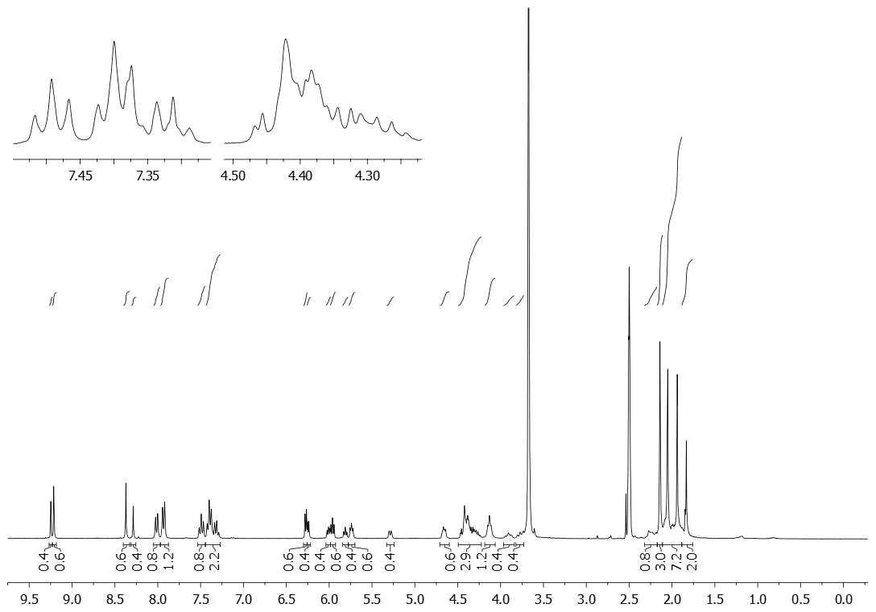
¹H-NMR (300 MHz, 80 ºC, DMSO-d₆ + D₂O) spectrum of 8a
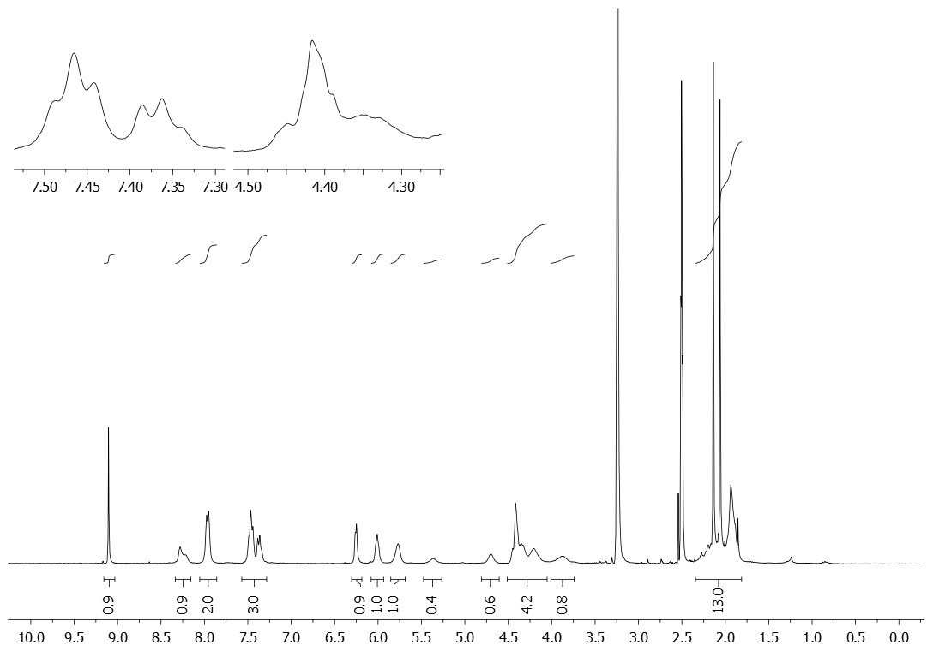
HSQC (300 MHz, DMSO-d₆ + D₂O) spectrum of 8a
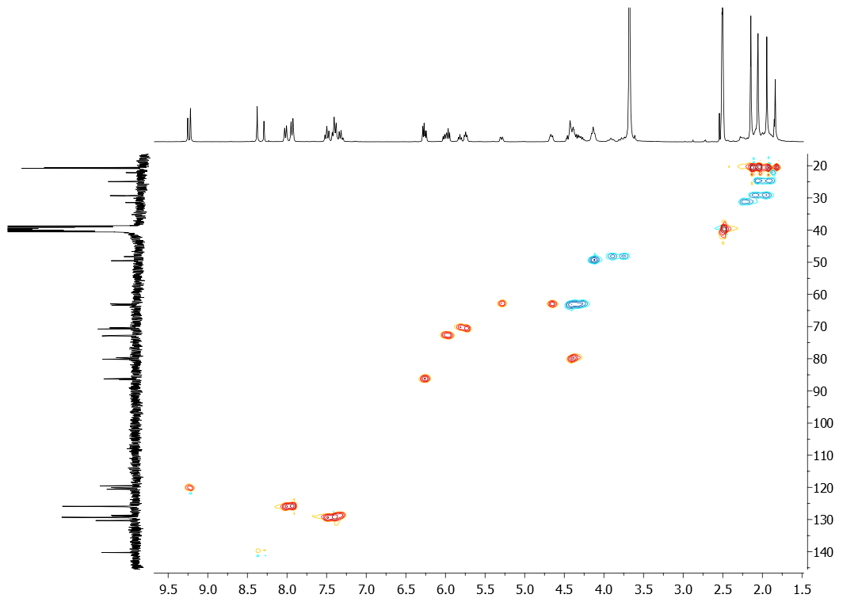

N-(9-(2’,3’,5’-Tri-O-acetyl-β-d-ribofuranosyl)-2-(4-phenyl-1H-1,2,3-triazol-1-yl)-9H-purin-6-yl)-l-alanine (8b)
¹H-NMR (300 MHz, 70 ºC, DMSO-d₆) spectrum of 8b:
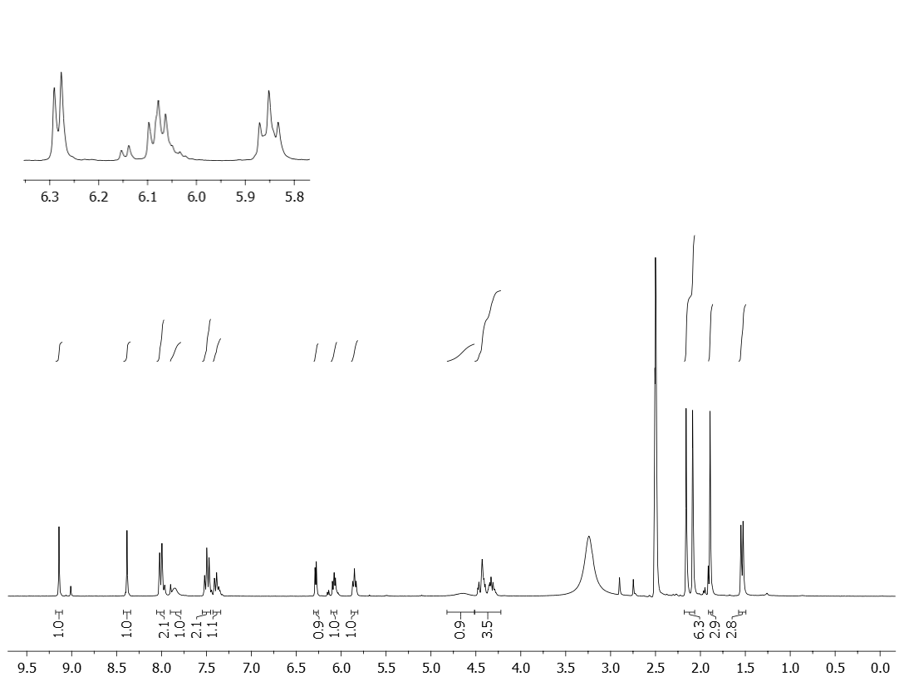

N-(9-(2’,3’,5’-Tri-O-acetyl-β-d-ribofuranosyl)-2-(4-phenyl-1H-1,2,3-triazol-1-yl)-9H-purin-6-yl)-l-phenylalanine (8c)
¹H-NMR (300 MHz, 70 ºC, DMSO-d₆ + D₂O) spectrum of 8c:
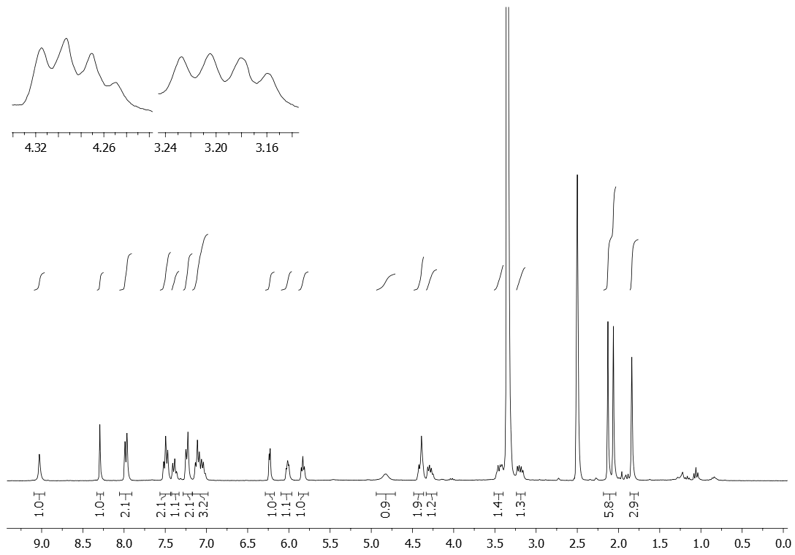

N-(9-(2’,3’,5’-Tri-O-acetyl-β-d-ribofuranosyl)-2-(4-phenyl-1H-1,2,3-triazol-1-yl)-9H-purin-6-yl)-l-valine (8d)
¹H-NMR (300 MHz, 70 ºC, DMSO-d₆ + D₂O) spectrum of 8d:
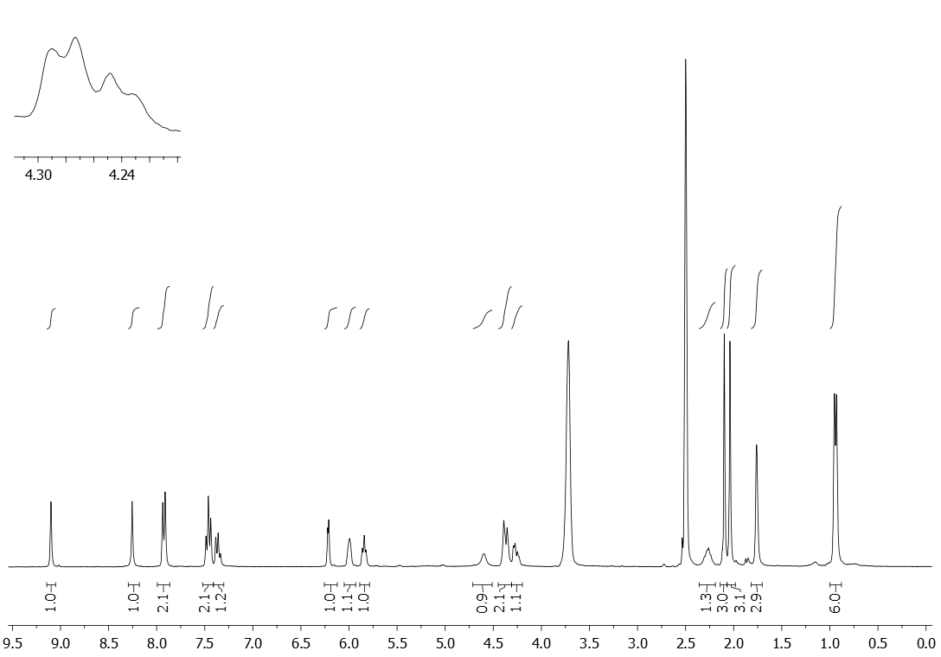

N-(9-(2’,3’,5’-Tri-O-acetyl-β-d-ribofuranosyl)-2-(4-phenyl-1H-1,2,3-triazol-1-yl)-9H-purin-6-yl)-l-leucine (8e)
¹H-NMR (300 MHz, 70 ºC, DMSO-d₆ + D₂O) spectrum of 8e:
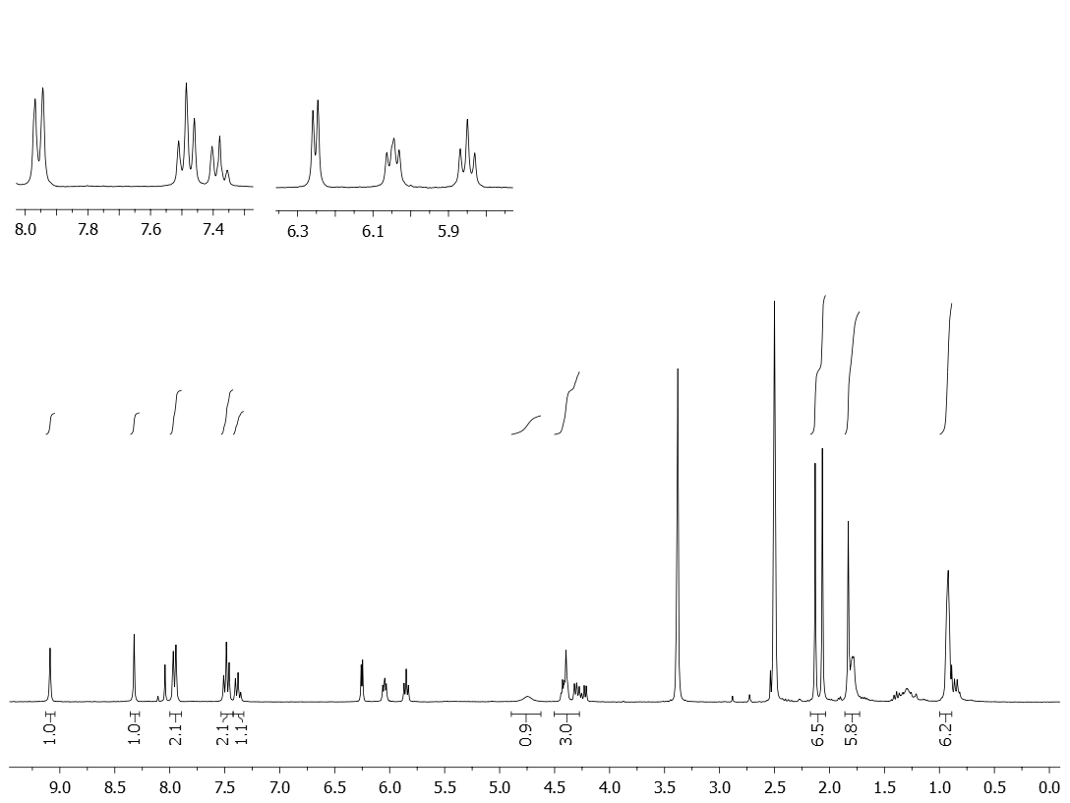

N-(9-(2’,3’,5’-Tri-O-acetyl-β-d-ribofuranosyl)-2-(4-phenyl-1H-1,2,3-triazol-1-yl)-9H-purin-6-yl)-l-isoleucine (8f)
¹H-NMR (300 MHz, 70 ºC, DMSO-d₆ + D₂O) spectrum of 8f:
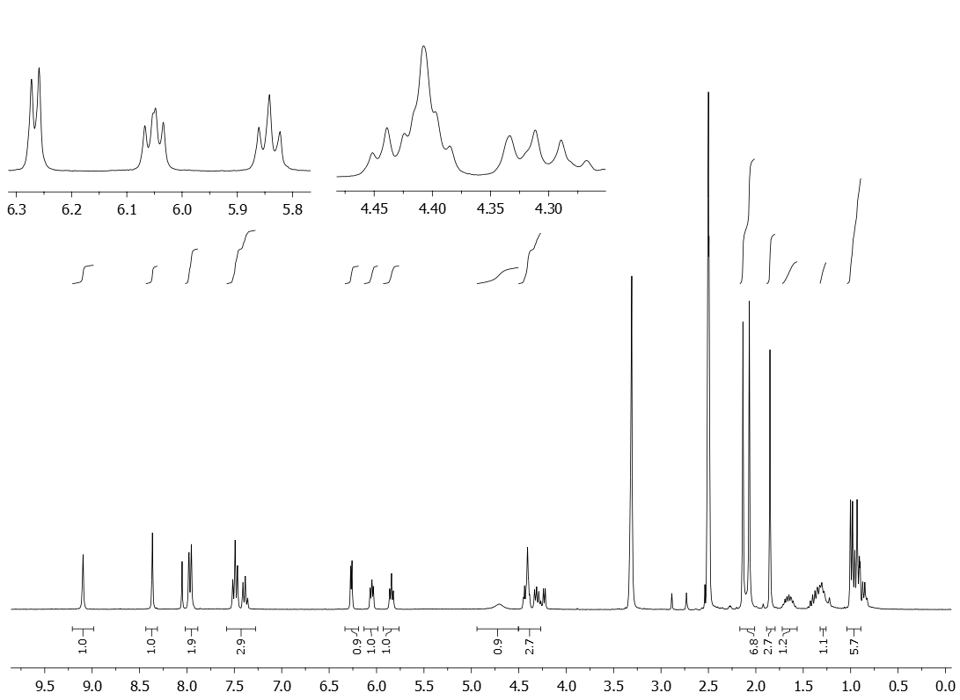

N-(9-(2’,3’,5’-Tri-O-acetyl-β-d-ribofuranosyl)-2-(4-phenyl-1H-1,2,3-triazol-1-yl)-9H-purin-6-yl)-glycine (8g)
¹H-NMR (300 MHz, 70 ºC, DMSO-d₆ + D₂O) spectrum of 8g:
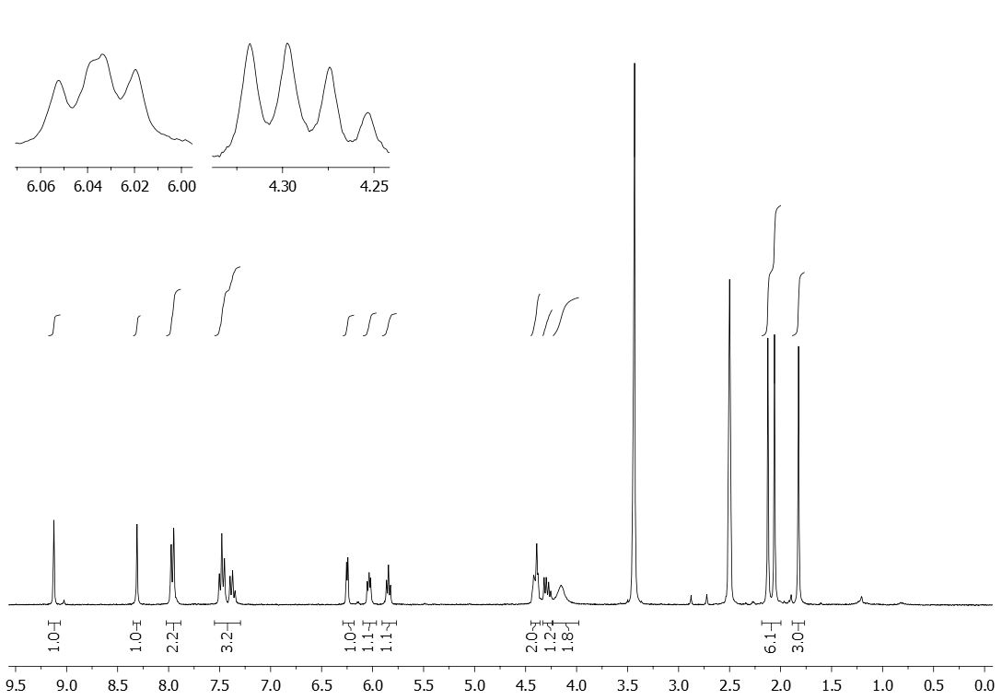

N-(9-(2’,3’,5’-Tri-O-acetyl-β-d-ribofuranosyl)-2-(4-phenyl-1H-1,2,3-triazol-1-yl)-9H-purin-6-yl)-l-methionine (8h)
¹H-NMR(300 MHz, 70 ºC, DMSO-d₆ + D₂O) spectrum of 8h:
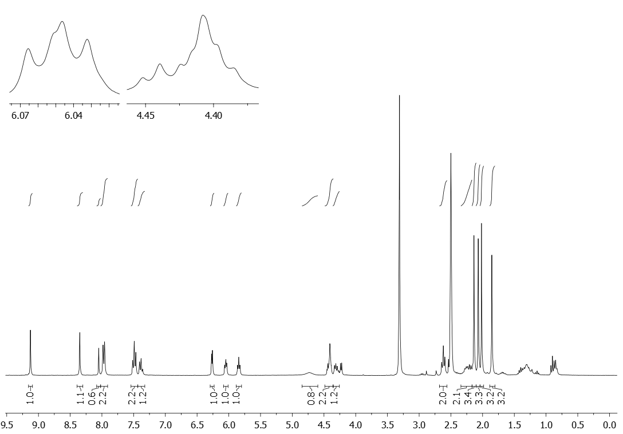
N-(9-(β-d-ribofuranosyl)-2-(4-phenyl-1H-1,2,3-triazol-1-yl)-9H-purin-6-yl)-glycine (9)
¹H-NMR (300 MHz, DMSO-d₆ + D₂O) spectrum of 9:
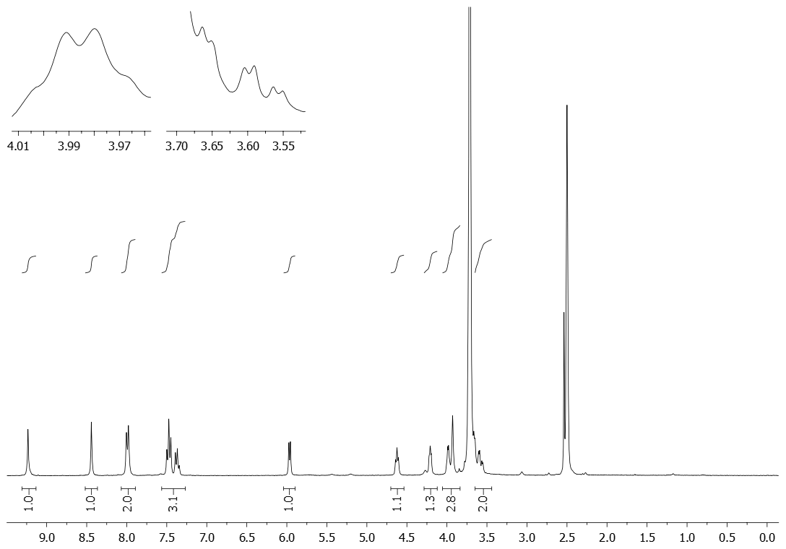

Purine nucleoside – glutathione conjugate 11
¹H-NMR (300 MHz, 70ºC, DMSO-d6 + D₂O) spectrum of 11:
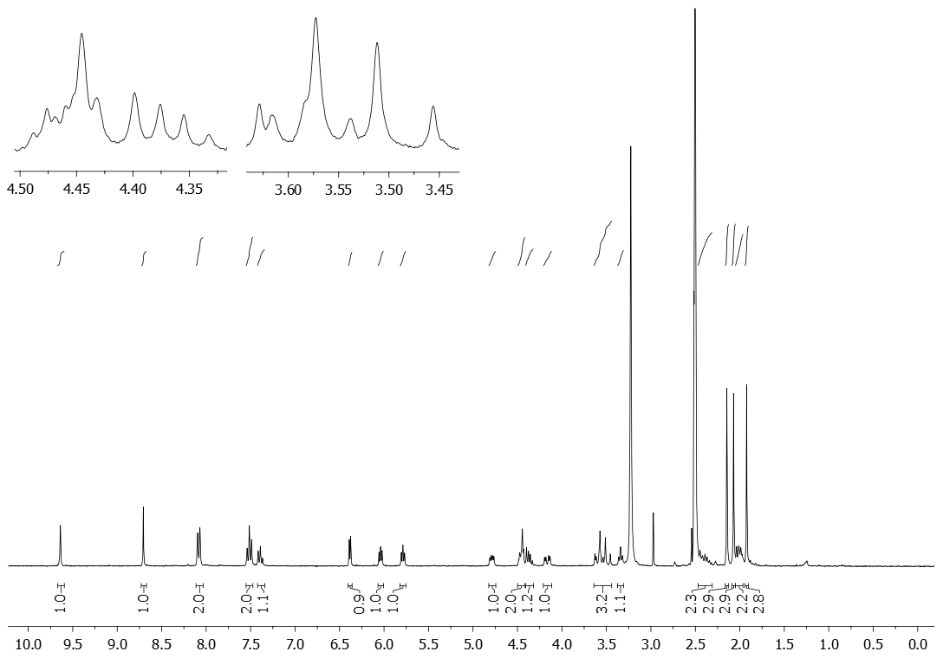

¹H-NMR (300 MHz, DMSO-d6 + D₂O) spectra of a reaction mixture of bistriazole 7 and glutathione (10) (using 2-bromomesitylene as internal standard)
a) before the addition of NEt₃; b) 3 min after addition of NEt₃ (2.5 equiv.); c) 6 min after addition of NEt₃ (2.5 equiv.).

