Supporting Information

Fabrication of poly (lactic acid), poly (butylene succinate), and poly (hydroxybutyrate) bio-based and biodegradable blends for application in fused filament fabrication (FFF) – based 3D printing

Alisa Sabalina*, Sergejs Gaidukovs*, Maksims Jurinovs, Liga Grase, Oskars Platnieks

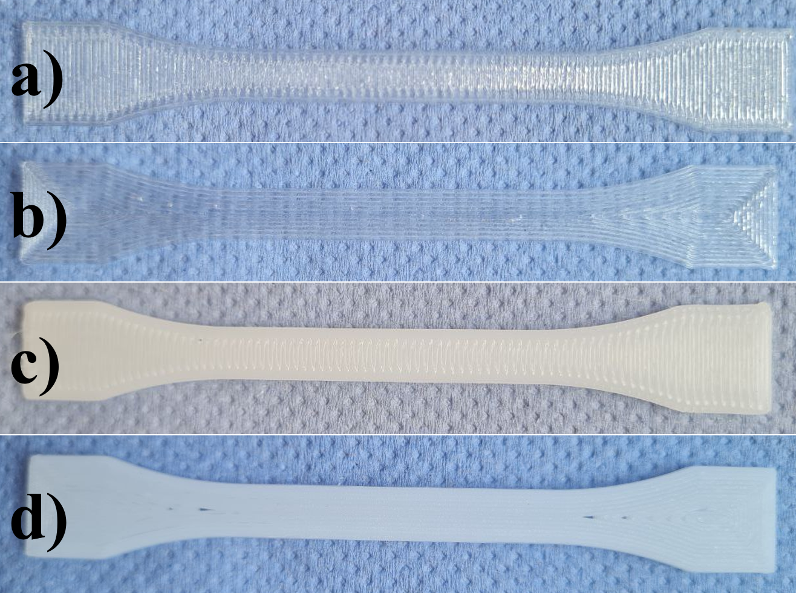
Figure S1. Images of (a) PLA-H, (b) PLA-V, (c) PBS-H, and (d) PBS-V 3D printed samples.

Figure S2. Crosscut SEM images for horizontal 3D-printed samples: (a) S5B5, (b) S7B3, (c) S5L5, and (d) S7L3.

