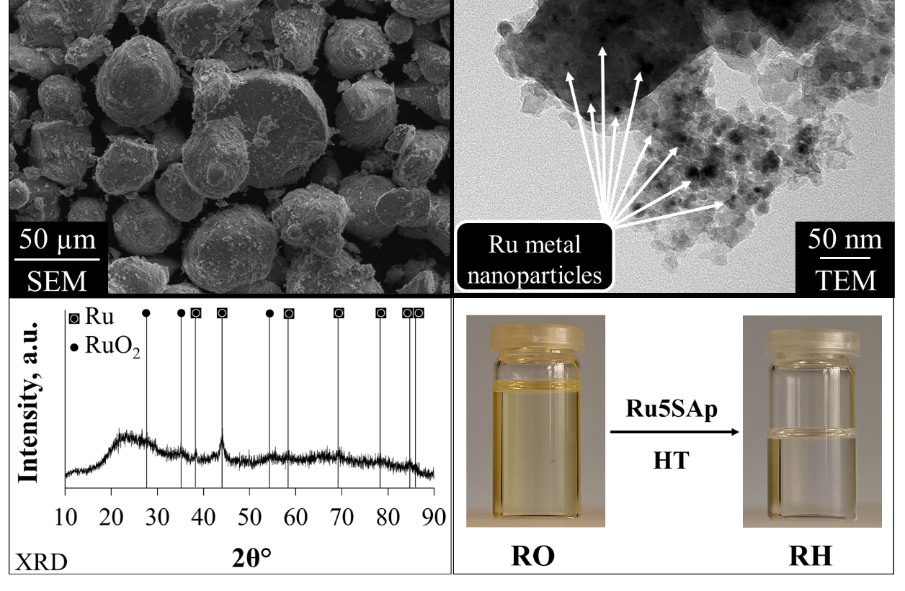
Fig. S1. SEM, TEM images, and XRD pattern of spent Ru5SAp catalyst recovered after fourth reaction cycle of rapeseed oil (RO) conversion process to renewable hydrocarbons (RH) by hydrotreatment (HT).

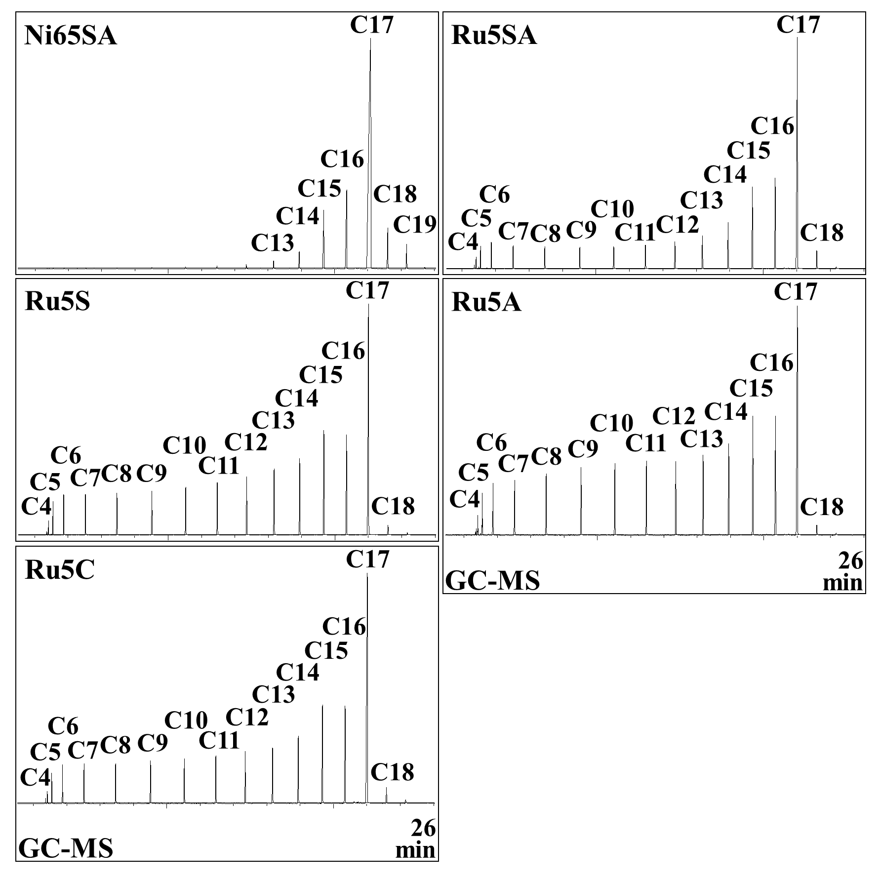
Fig. S2. GC chromatograms of renewable hydrocarbon (RH) samples produced from rapeseed oil (RO) by hydrotreatment (HT) over commercial supported Ni and Ru catalysts. Catalyst amount and HT conditions: 5%, reaction temperature 340 °C (heating rate 5 °C/min), initial H₂ pressure 10 MPa, mixing speed 300 rpm, and residence time – oxygen removal time (ORT) + 20 min (Table 2).
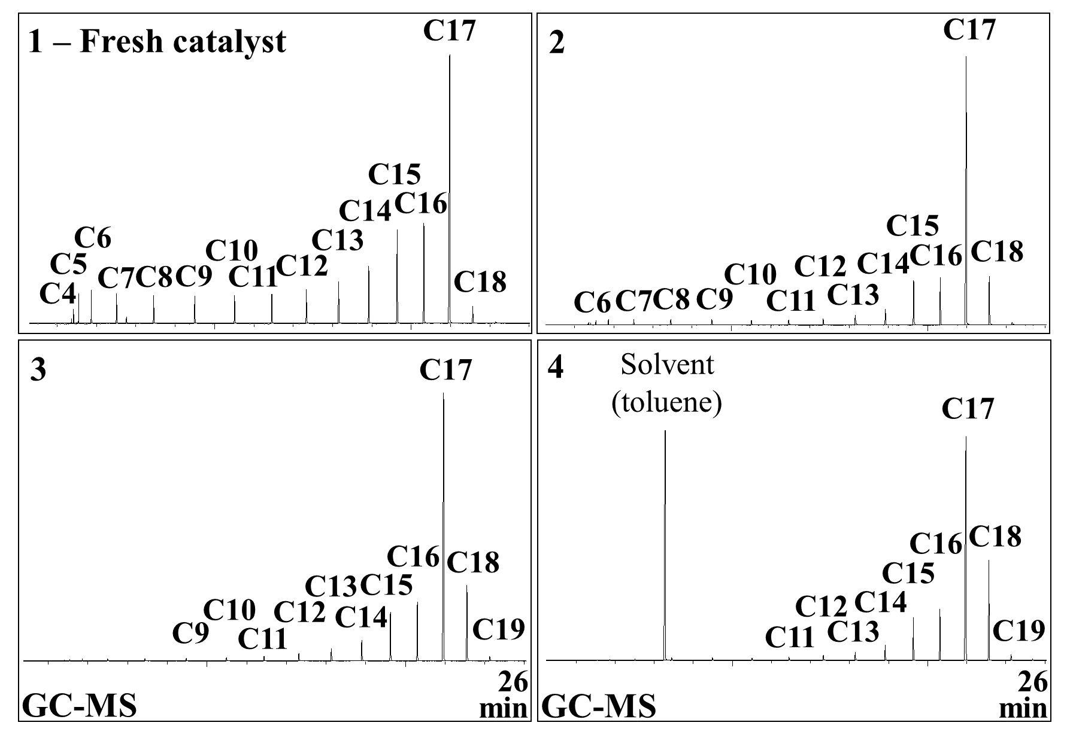
Fig. S3. GC chromatograms of renewable hydrocarbon (RH) samples produced from rapeseed oil (RO) over synthesized fresh and spent re-calcined Ru5SAp catalyst recovered after hydrotreatreating (HT) runs. Catalyst amount and HT conditions: 5%, reaction temperature 340 ℃ (heating rate 5 °C/min), initial H₂ pressure 10 MPa, residence time 5 min, mixing speed 300 rpm.

