Supplemental material

Biodiesel production through the transesterification of rapeseed oil over CaO-MgO/SBA-15 catalysts
Kristine Lazdovica*, Valdis Kampars and Anastasija Gaile
Institute of Applied Chemistry, Riga Technical University, Riga, P. Valdena Str. 3/7, LV-1048, Latvia

*Corresponding author: Kristine Lazdovica
Address: Riga Technical University, Institute of Applied Chemistry, P. Valdena Str. 3/7, Riga, LV-1048, Latvia
E-mail address: kristine.lazdovica@rtu.lv

SEM-EDX analysis

- SBA-15
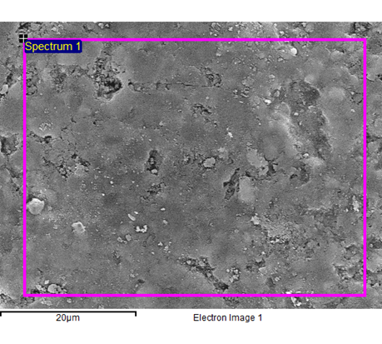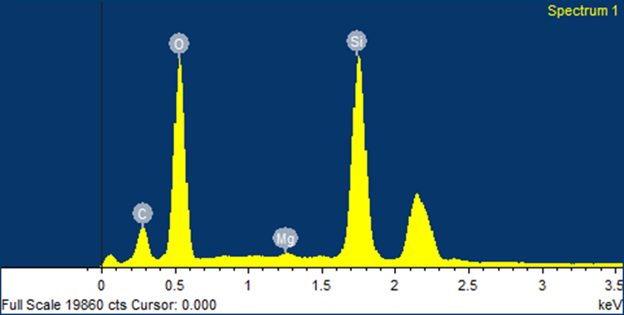
Figure S1. SEM-EDX analysis of SBA-15.
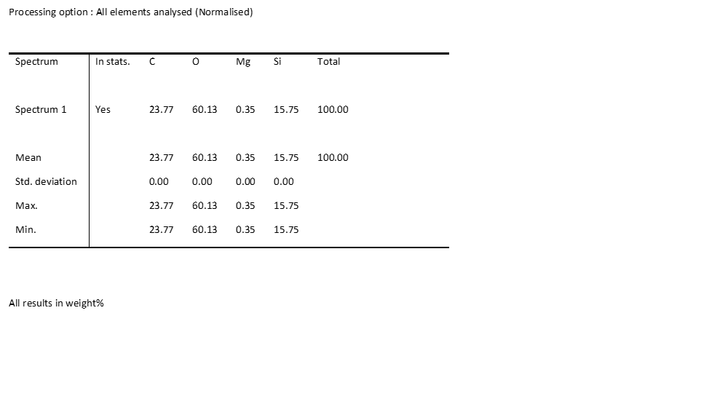
Figure S2. SEM-EDX analysis (elemental compositions) of SBA-15.

- 0.8-CaO-MgO/SBA-15
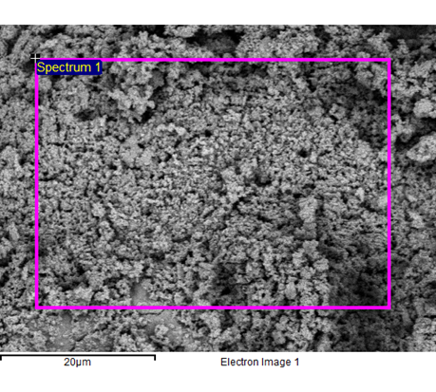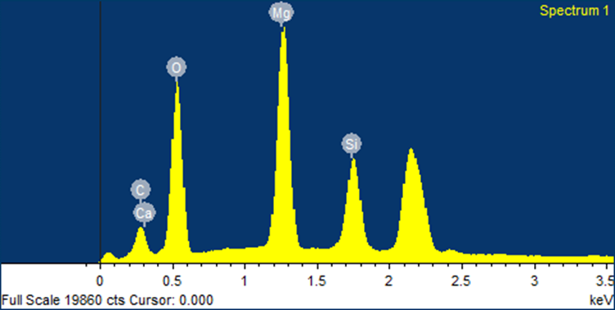
Figure S3. SEM-EDX analysis of 0.8-CaO-MgO/SBA-15 catalyst.

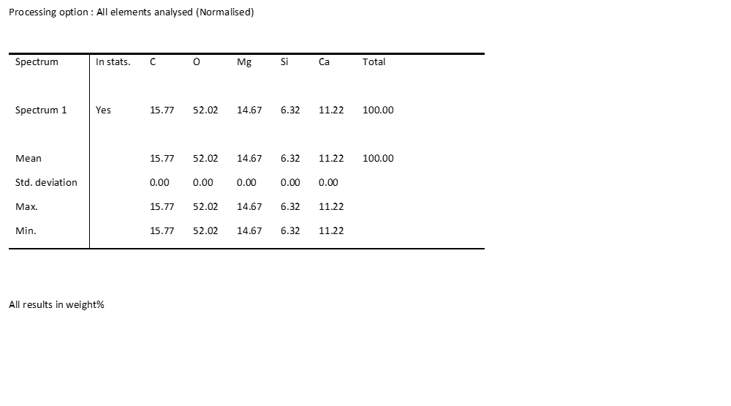
Figure S4. SEM-EDX analysis (elemental compositions) of 0.8-CaO-MgO/SBA-15 catalyst.

- 0.3-CaO-MgO/SBA-15

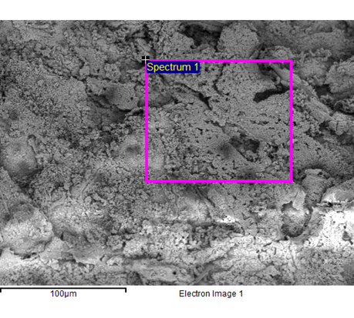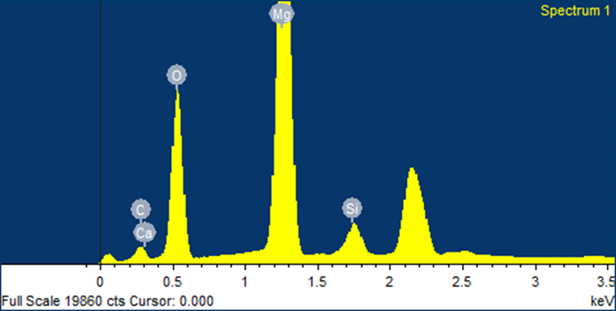
Figure S5. SEM-EDX analysis of 0.3-CaO-MgO/SBA-15 catalyst.

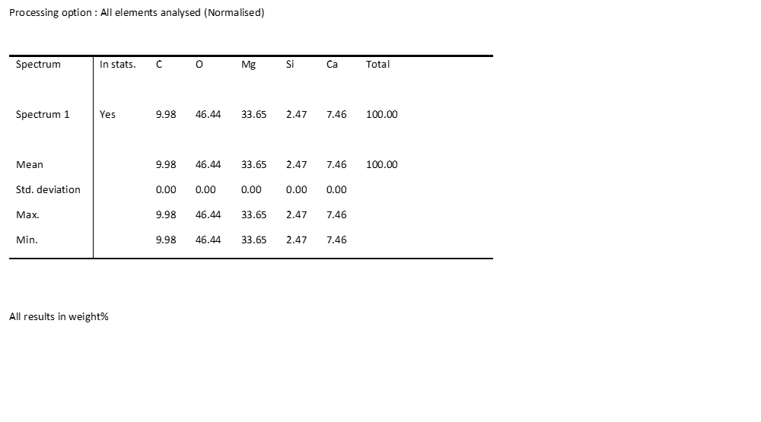
Figure S6. SEM-EDX analysis (elemental compositions) of 0.3-CaO-MgO/SBA-15 catalyst.

