Supporting information for:
Benzanthrone sulfides: synthesis, solvatochromism characterization and analysis of experimental photophysical parameters and theoretical calculations
Armands Maļeckis ^{a, *}, Marija Cvetinska ª, Evans Griškjāns ª, Kirills Dmitrijevs ^{b}, Kaspars Traskovskis ^{b}, Sergey Belyakov ^{c} and Elena Kirilova ^{d}
ª Institute of Technology of Organic Chemistry, Faculty of Materials Science and Applied Chemistry, Riga Technical University, P. Valdena Str. 3, LV-1048, Riga, Latvia
^{b} Institute of Applied Chemistry, Faculty of Materials Science and Applied Chemistry, Riga Technical University, P. Valdena Str. 3, LV-1048 Riga, Latvia
^{c} Latvian Institute of Organic Synthesis, Aizkraukles Str. 21, LV-1006, Riga, Latvia
^{d} Department of Applied Chemistry, Institute of Life Sciences and Technology, Daugavpils University, Parades Str. 1A, LV-5401, Daugavpils, Latvia

Index:

Single Crystal X-ray Crystallographic Data 2
NMR spectra 9
Absorption and emission data 39
HRMS data 41

Single Crystal X-ray Crystallographic Data
Table 1. Fractional Atomic Coordinates (×10⁴) and Equivalent Isotropic Displacement Parameters (Å²×10³) for the compound 2b. U_{eq} is defined as 1/3 of the trace of the orthogonalised U_{IJ} tensor.
Atom | x | y | z | U(eq)
C1 | 6513.1(13) | 4782.1(9) | 5760.3(7) | 26.5(2)
C2 | 6024.3(13) | 5213.7(10) | 6529.2(7) | 27.7(2)
C3 | 6458.7(13) | 6339.8(9) | 6795.5(7) | 25.2(2)
C4 | 7921.0(14) | 8229.7(10) | 6505.3(7) | 27.3(2)
C5 | 8884.3(15) | 8914.8(10) | 6008.6(7) | 30.9(2)
C6 | 9384.9(14) | 8466.8(10) | 5250.7(7) | 29.0(2)
C7 | 9525.4(14) | 6889.9(9) | 4194.8(7) | 26.2(2)
C8 | 9570.7(14) | 5241.8(11) | 3183.4(7) | 30.1(2)
C9 | 9135.2(15) | 4116.7(11) | 2911.5(7) | 33.0(3)
C10 | 8121.9(15) | 3422.4(11) | 3393.1(7) | 32.4(3)
C11 | 7567.0(14) | 3839.9(10) | 4141.4(7) | 29.2(2)
C12 | 7997.9(13) | 4983.9(9) | 4432.0(6) | 24.2(2)
C13 | 9007.3(13) | 5681.5(10) | 3934.5(6) | 25.6(2)
C14 | 8913.7(13) | 7340.6(9) | 4988.1(6) | 24.4(2)
C15 | 7906.7(12) | 6617.8(9) | 5487.8(6) | 22.4(2)
C16 | 7445.2(12) | 5443.5(9) | 5230.8(6) | 23.0(2)
C17 | 7418.1(13) | 7071.9(9) | 6265.3(7) | 23.4(2)
S18 | 5891.1(4) | 6963.6(2) | 7746.36(17) | 31.97(11)
C19 | 5114.7(14) | 5719.5(10) | 8340.6(7) | 29.3(2)
C20 | 6467.1(17) | 4838.9(12) | 8584.8(8) | 40.5(3)
C21 | 4344.4(16) | 6270.6(12) | 9099.1(8) | 37.3(3)
O22 | 10444.4(11) | 7493.5(8) | 3776.8(5) | 37.2(2)

Table 2. Anisotropic Displacement Parameters (Å²×10³) for the compound 2b. The Anisotropic displacement factor exponent takes the form: −2π²[h²a*²U₁₁+2hka*b*U₁₂+…].
Atom | U₁₁ | U₂₂ | U₃₃ | U₁₂ | U₁₃ | U₂₃
C1 | 28.0(5) | 18.7(5) | 32.5(5) | -3.4(4) | -2.2(4) | -0.3(4)
C2 | 28.3(5) | 22.9(5) | 31.8(5) | -4.6(4) | 2.5(4) | 1.8(4)
C3 | 24.7(5) | 22.3(5) | 28.4(5) | -0.1(4) | 0.2(4) | 0.0(4)
C4 | 32.0(5) | 20.0(5) | 29.7(5) | 0.2(4) | -0.3(4) | -1.5(4)
C5 | 40.4(6) | 17.7(5) | 34.6(6) | -4.8(4) | -0.5(5) | 0.2(4)
C6 | 36.2(6) | 20.3(5) | 30.4(5) | -4.8(4) | 0.2(4) | 5.4(4)
C7 | 28.6(5) | 24.6(5) | 25.0(5) | -0.4(4) | -3.2(4) | 5.4(4)
C8 | 32.5(5) | 32.5(6) | 25.1(5) | 5.2(4) | -2.9(4) | 2.3(4)
C9 | 38.3(6) | 33.9(6) | 26.3(5) | 9.8(5) | -5.1(4) | -3.9(5)
C10 | 36.5(6) | 25.5(5) | 34.7(6) | 4.8(5) | -8.5(5) | -6.6(5)
C11 | 31.6(5) | 22.6(5) | 33.1(6) | 0.3(4) | -3.8(4) | -2.4(4)
C12 | 24.4(5) | 21.1(5) | 26.7(5) | 2.2(4) | -5.9(4) | 0.5(4)
C13 | 27.1(5) | 24.4(5) | 24.9(5) | 3.6(4) | -5.3(4) | 1.5(4)
C14 | 27.7(5) | 19.3(5) | 25.8(5) | -0.3(4) | -3.8(4) | 3.7(4)
C15 | 22.4(5) | 18.2(5) | 26.3(5) | 0.6(4) | -4.0(4) | 3.0(4)
C16 | 23.6(5) | 19.0(5) | 26.1(5) | 0.5(4) | -4.3(4) | 0.5(4)
C17 | 23.9(5) | 18.7(5) | 27.4(5) | 0.6(4) | -2.6(4) | 1.5(4)
S18 | 39.66(18) | 24.10(16) | 32.74(17) | -3.92(10) | 9.50(12) | -3.09(10)
C19 | 30.5(5) | 27.4(5) | 30.2(5) | -1.3(4) | 4.2(4) | 1.4(4)
C20 | 47.5(7) | 38.4(7) | 35.8(6) | 12.3(6) | 3.3(5) | 2.2(5)
C21 | 39.9(6) | 36.6(6) | 36.2(6) | 1.6(5) | 10.7(5) | -0.3(5)
O22 | 46.8(5) | 34.0(5) | 31.1(4) | -9.3(4) | 6.6(4) | 4.3(3)

Table 3. Bond Lengths for the compound 2b.
Atom | Atom | Length/Å |  | Atom | Atom | Length/Å
C1 | C2 | 1.4024(16) |  | C8 | C13 | 1.4005(16)
C1 | C16 | 1.3793(15) |  | C9 | C10 | 1.3917(18)
C2 | C3 | 1.3784(15) |  | C10 | C11 | 1.3855(16)
C3 | C17 | 1.4369(15) |  | C11 | C12 | 1.4084(15)
C3 | S18 | 1.7627(11) |  | C12 | C13 | 1.4068(15)
C4 | C5 | 1.3758(16) |  | C12 | C16 | 1.4730(15)
C4 | C17 | 1.4138(14) |  | C14 | C15 | 1.4236(14)
C5 | C6 | 1.3962(16) |  | C15 | C16 | 1.4294(14)
C6 | C14 | 1.3844(15) |  | C15 | C17 | 1.4236(15)
C7 | C13 | 1.4783(15) |  | S18 | C19 | 1.8207(12)
C7 | C14 | 1.4788(15) |  | C19 | C20 | 1.5209(17)
C7 | O22 | 1.2284(14) |  | C19 | C21 | 1.5256(16)
C8 | C9 | 1.3805(17)

Table 4. Bond Angles for the compound 2b.
Atom | Atom | Atom | Angle/˚ |  | Atom | Atom | Atom | Angle/˚
C16 | C1 | C2 | 122.71(10) |  | C12 | C13 | C7 | 121.07(10)
C3 | C2 | C1 | 121.05(10) |  | C12 | C13 | C8 | 120.81(10)
C17 | C3 | C2 | 118.60(10) |  | C7 | C14 | C6 | 118.68(10)
S18 | C3 | C2 | 124.35(9) |  | C15 | C14 | C6 | 120.46(10)
S18 | C3 | C17 | 117.04(8) |  | C15 | C14 | C7 | 120.82(9)
C17 | C4 | C5 | 121.37(10) |  | C16 | C15 | C14 | 120.86(10)
C6 | C5 | C4 | 119.86(10) |  | C17 | C15 | C14 | 118.57(9)
C14 | C6 | C5 | 120.76(10) |  | C17 | C15 | C16 | 120.52(9)
C14 | C7 | C13 | 117.33(9) |  | C12 | C16 | C1 | 122.96(9)
O22 | C7 | C13 | 121.62(11) |  | C15 | C16 | C1 | 117.54(10)
O22 | C7 | C14 | 121.04(10) |  | C15 | C16 | C12 | 119.49(9)
C13 | C8 | C9 | 120.66(11) |  | C4 | C17 | C3 | 121.46(10)
C11 | C10 | C9 | 120.94(11) |  | C15 | C17 | C4 | 118.96(10)
C12 | C11 | C10 | 120.95(11) |  | C19 | S18 | C3 | 105.01(5)
C13 | C12 | C11 | 117.53(10) |  | C20 | C19 | S18 | 112.02(9)
C16 | C12 | C11 | 122.08(10) |  | C21 | C19 | S18 | 105.68(8)
C16 | C12 | C13 | 120.38(9) |  | C21 | C19 | C20 | 111.72(10)
C8 | C13 | C7 | 118.11(10)

Table 5. Hydrogen Atom Coordinates (Å×10⁴) and Isotropic Displacement Parameters (Å²×10³) for the compound 2b.
Atom | x | y | z | U(iso)
H1 | 6188.8(13) | 4001.9(9) | 5597.3(7) | 31.8(3)
H2 | 5383.6(13) | 4722.3(10) | 6871.9(7) | 33.2(3)
H4 | 7586.7(14) | 8541.1(10) | 7020.3(7) | 32.7(3)
H5 | 9208.2(15) | 9691.0(10) | 6181.0(7) | 37.1(3)
H6 | 10056.6(14) | 8940.2(10) | 4911.2(7) | 34.8(3)
H8 | 10259.5(14) | 5722.7(11) | 2857.8(7) | 36.2(3)
H9 | 9522.1(15) | 3820.3(11) | 2402.4(7) | 39.6(3)
H10 | 7806.2(15) | 2651.2(11) | 3206.1(7) | 38.9(3)
H11 | 6886.0(14) | 3347.6(10) | 4463.2(7) | 35.0(3)
H19 | 4232(18) | 5349(14) | 7999(9) | 34(4)
H20a | 7010(9) | 4567(8) | 8086.3(11) | 60.8(4)
H20b | 7276(7) | 5227(3) | 8960(5) | 60.8(4)
H20c | 5987(2) | 4155(5) | 8866(6) | 60.8(4)
H21a | 5182(3) | 6722(8) | 9418(4) | 56.0(4)
H21b | 3449(9) | 6805(7) | 8919.2(8) | 56.0(4)
H21c | 3907(12) | 5638.8(13) | 9448(3) | 56.0(4)
Experimental
Single crystals of C₂₀H₁₆OS [EDM6] were investigated on a Rigaku, XtaLAB Synergy, Dualflex, HyPix diffractometer. The crystal was kept at 150.0(1) K during data collection. Using Olex2 [1], the structure was solved with the ShelXT [2] structure solution program using Intrinsic Phasing and refined with the olex2.refine [3] refinement package using Gauss-Newton minimisation.
- Dolomanov, O.V., Bourhis, L.J., Gildea, R.J, Howard, J.A.K. & Puschmann, H. (2009), J. Appl. Cryst. 42, 339-341.
- Sheldrick, G.M. (2015). Acta Cryst. A71, 3-8.
- Bourhis, L.J., Dolomanov, O.V., Gildea, R.J., Howard, J.A.K., Puschmann, H. (2015). Acta Cryst. A71, 59-75.
Crystal Data for C₂₀H₁₆OS (M = 304.42 g/mol): monoclinic, space group P2₁/c (no. 14), a = 8.13153(6) Å, b = 11.23841(8) Å, c = 16.1305(1) Å, β = 92.0316(7)°; V = 1473.16(2) Å³, Z = 4, T = 150.0(1) K, μ(Cu Kα) = 1.923 mm⁻¹, Dcalc = 1.3724 g/cm³, 17086 reflections measured (2Θ ≤ 160°), 3229 unique (R_{int} = 0.0184, R_{sigma} = 0.0139) which were used in all calculations. The final R₁ was 0.0321 (I > 2σ(I)) and wR₂ was 0.0921 (all data).
Details:
1. Fixed Uiso
At 1.2 times of:
All C(H) groups
At 1.5 times of:
All C(H,H,H) groups
2.a Aromatic/amide H refined with riding coordinates:
C1(H1), C2(H2), C4(H4), C5(H5), C6(H6), C8(H8), C9(H9), C10(H10), C11(H11)
2.b Idealised Me refined as rotating group:
C20(H20a,H20b,H20c), C21(H21a,H21b,H21c)
This report has been created with Olex2, compiled on 2018.05.17 svn.r3504 for Rigaku Oxford Diffraction.

NMR spectra
S1. Compound 2a ¹H-NMR (500 MHz, CDCl₃).
S2. Compound 2a ¹H-NMR (500 MHz, CDCl₃), expanded.
S3. Compound 2a APT-NMR (126 MHz, CDCl₃).
S4. Compound 2b ¹H-NMR (500 MHz, CDCl₃).
S5. Compound 2b ¹H-NMR (500 MHz, CDCl₃), expanded.
S6. Compound 2b APT-NMR (126 MHz, CDCl₃).
S7. Compound 2c ¹H-NMR (500 MHz, CDCl₃).
S8. Compound 2c ¹H-NMR (500 MHz, CDCl₃), expanded.
S9. Compound 2c APT-NMR (126 MHz, CDCl₃).
S10. Compound 2d ¹H-NMR (500 MHz, CDCl₃).
S11. Compound 2d ¹H-NMR (500 MHz, CDCl₃), aromatic region.
S12. Compound 2d APT-NMR (126 MHz, CDCl₃).
S13. Compound 2e ¹H-NMR (500 MHz, CDCl₃).
S14. Compound 2e ¹H-NMR (500 MHz, CDCl₃), expanded.
S15. Compound 2e APT-NMR (126 MHz, CDCl₃).
S16. Compound 3a ¹H-NMR (500 MHz, CDCl₃).
S17. Compound 3a ¹H-NMR (500 MHz, CDCl₃), expanded.
S18. Compound 3a APT-NMR (126 MHz, CDCl₃).
S19. Compound 3b ¹H-NMR (500 MHz, CDCl₃).
S20. Compound 3b ¹H-NMR (500 MHz, CDCl₃), expanded.
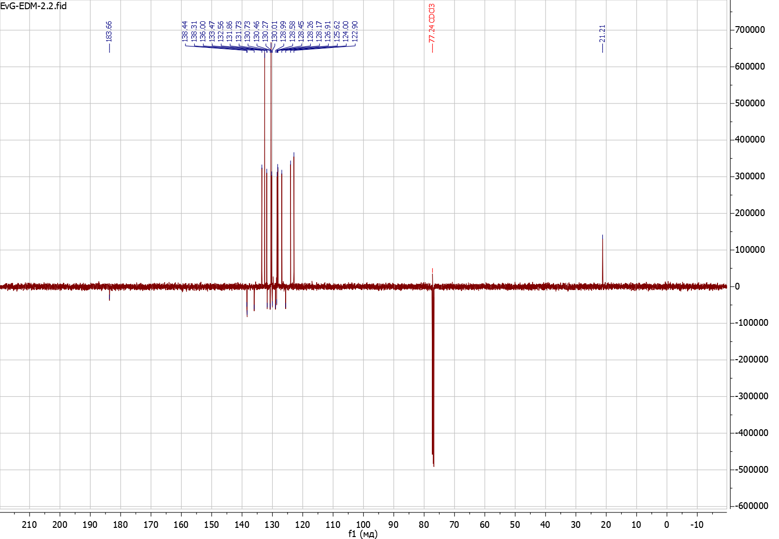
S21. Compound 3b APT-NMR (126 MHz, CDCl₃).
S22. Compound 3c ¹H-NMR (500 MHz, CDCl₃).
S23. Compound 3c ¹H-NMR (500 MHz, CDCl₃), expanded.
S24. Compound 3c APT-NMR (126 MHz, CDCl₃).
S25. Compound 3d ¹H-NMR (500 MHz, CDCl₃).
S26. Compound 3d ¹H-NMR (500 MHz, CDCl₃), expanded.
S27. Compound 3d APT-NMR (126 MHz, CDCl₃).
S28. Compound 4a ¹H-NMR (500 MHz, CDCl₃).
S29. Compound 4a ¹H-NMR (500 MHz, CDCl₃), expanded.
S30. Compound 4a APT-NMR (126 MHz, CDCl₃).

Absorption and emission data
Table 6
Absorption maxima of prepared dyes in organic solvents (concentration 10^{–5} M).
 | Absorption λ_{abs} (lgε) (nm)
 | 2a | 2b | 2c | 2d | 2e | 3a | 3b | 3c | 3d | 4a
Benzene | 429 (4.18) | 414 (4.01) | 416 (3.83) | 411 (4.26) | 422 (4.42) | 413 (4.16) | 426 (4.10) | 432 (3.90) | 418 (4.27) | 416 (4.14)
CH₃Cl | 444 (4.16) | 420 (4.02) | 421 (3.82) | 403 (4.30) | 430 (4.40) | 421 (4.18) | 436 (4.04) | 447 (3.94) | 424 (4.25) | 423 (4.14)
EtOAc | 431 (4.17) | 411 (4.03) | 412 (3.81) | 406 (4.16) | 424 (4.38) | 410 (4.14) | 423 (4.07) | 430 (3.95) | 414 (4.25) | 412 (4.14)
Acetone | 443 (4.19) | 413 (3.97) | 414 (3.84) | 407 (4.27) | 430 (4.39) | 413 (4.11) | 425 (4.04) | 438 (3.92) | 415 (4.20) | 416 (4.16)
DMF | 446 (4.06) | 422 (3.98) | 422 (3.83) | 411 (4.27) | 445 (4.21) | 417 (4.15) | 431 (4.02) | 443 (3.92) | 422 (4.23) | 419 (4.11)
DMSO | 448 (4.19) | 426 (4.00) | 425 (3.70) | 412 (4.21) | 446 (4.06) | 420 (4.07) | 430 (3.91) | 447 (3.92) | 424 (4.10) | 423 (3.93)
EtOH | 448 (4.15) | 423 (3.96) | 422 (3.79) | 405 (4.27) | 442 (4.31) | 423 (4.09) | 442 (4.03) | 447 (3.90) | 425 (4.21) | 423 (4.04)

Table 7
Emission maxima of prepared dyes in organic solvents (concentration 10^{–5} M).
 | Emission λ_{em} (nm)
 | 2a | 2b | 2c | 2d | 2e | 3a | 3b | 3c | 3d | 4a
Benzene | 508 | 507 | 521 | 503 | 505 | 504 | 523 | 520 | 501 | 510
CH₃Cl | 533 | 539 | 544 | 538 | 538 | 538 | 545 | 537 | 533 | 543
EtOAc | 519 | 518 | 515 | 514 | 518 | 516 | 518 | 517 | 514 | 543
Acetone | 541 | 536 | 538 | 540 | 537 | 533 | 545 | 562 | 538 | 560
DMF | 552 | 546 | 548 | 544 | 547 | 541 | 555 | 563 | 543 | 562
DMSO | 565 | 555 | 557 | 553 | 560 | 552 | 563 | 565 | 555 | 569
EtOH | 587 | 584 | 585 | 582 | 586 | 583 | 591 | 573 | 580 | 595

Table 8
Stokes shift of prepared dyes in organic solvents (concentration 10^{–5} M).
 | Stokes shift (cm^{– 1})
 | 2a | 2b | 2c | 2d | 2e | 3a | 3b | 3c | 3d | 4a
Benzene | 3625 | 4431 | 4845 | 4450 | 3895 | 4372 | 4354 | 3917 | 3963 | 4431
CH₃Cl | 3761 | 5257 | 5371 | 6227 | 4668 | 5166 | 4587 | 3749 | 4823 | 5224
EtOAc | 3934 | 5026 | 4854 | 5175 | 4280 | 5010 | 4336 | 3913 | 4699 | 5856
Acetone | 4089 | 5556 | 5567 | 6052 | 4634 | 5451 | 5181 | 5037 | 5509 | 6181
DMF | 4306 | 5382 | 5449 | 5949 | 4190 | 5497 | 5184 | 4811 | 5280 | 6073
DMSO | 4622 | 5456 | 5576 | 6189 | 4564 | 5694 | 5494 | 4672 | 5567 | 6066
EtOH | 5286 | 6517 | 6603 | 7509 | 5560 | 6488 | 5704 | 4919 | 6288 | 6834

HRMS data
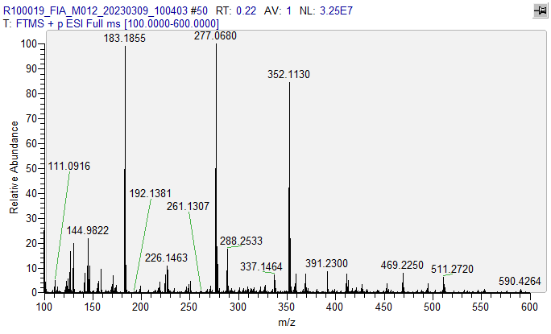
S31. FTMS ESI (+) spectrum of compound 2a.

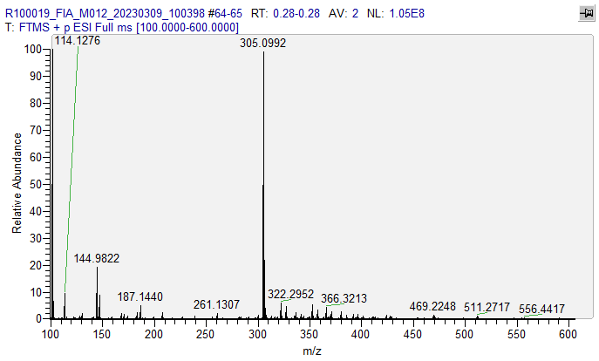
S32. FTMS ESI (+) spectrum of compound 2b.

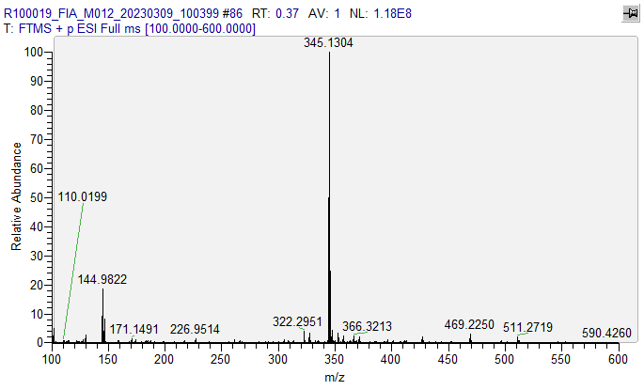
S33. FTMS ESI (+) spectrum of compound 2c.

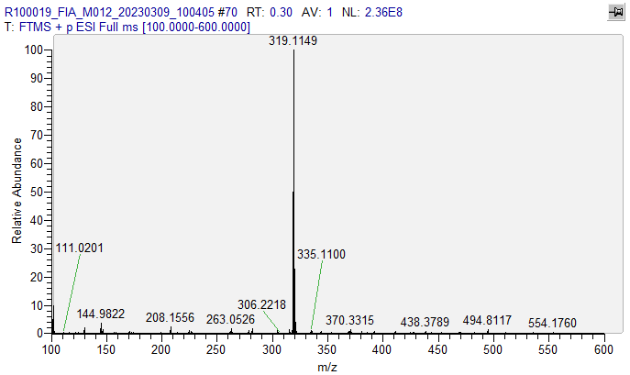
S34. FTMS ESI (+) spectrum of compound 2d.

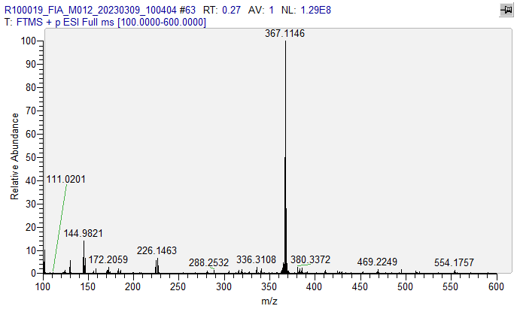
S35. FTMS ESI (+) spectrum of compound 2e.

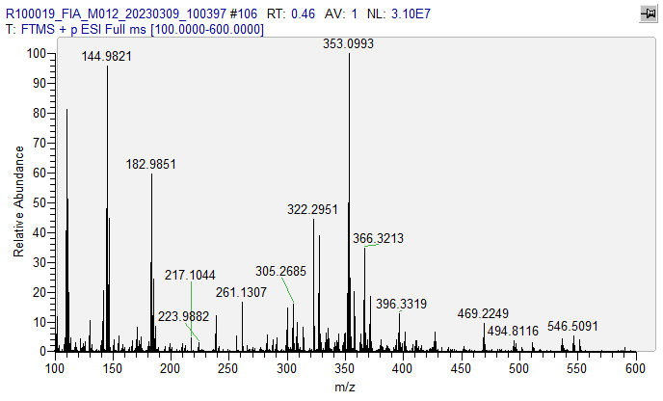
S36. FTMS ESI (+) spectrum of compound 3b.

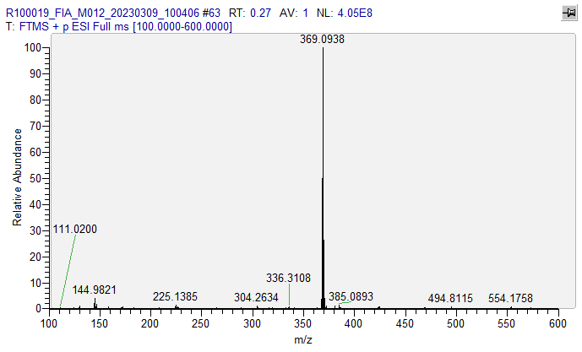
S37. FTMS ESI (+) spectrum of compound 3c.

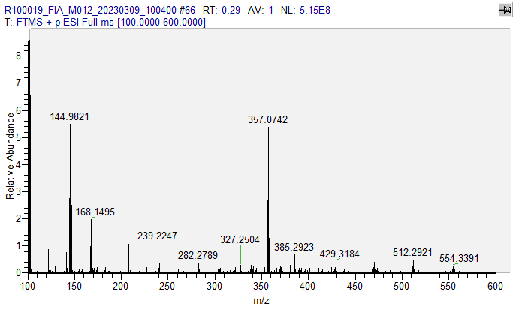
S38. FTMS ESI (+) spectrum of compound 3d.

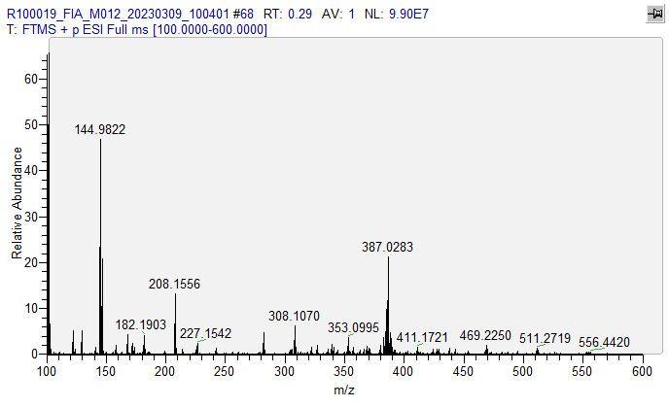
S39. FTMS ESI (+) spectrum of compound 4a.

