Supplemental material

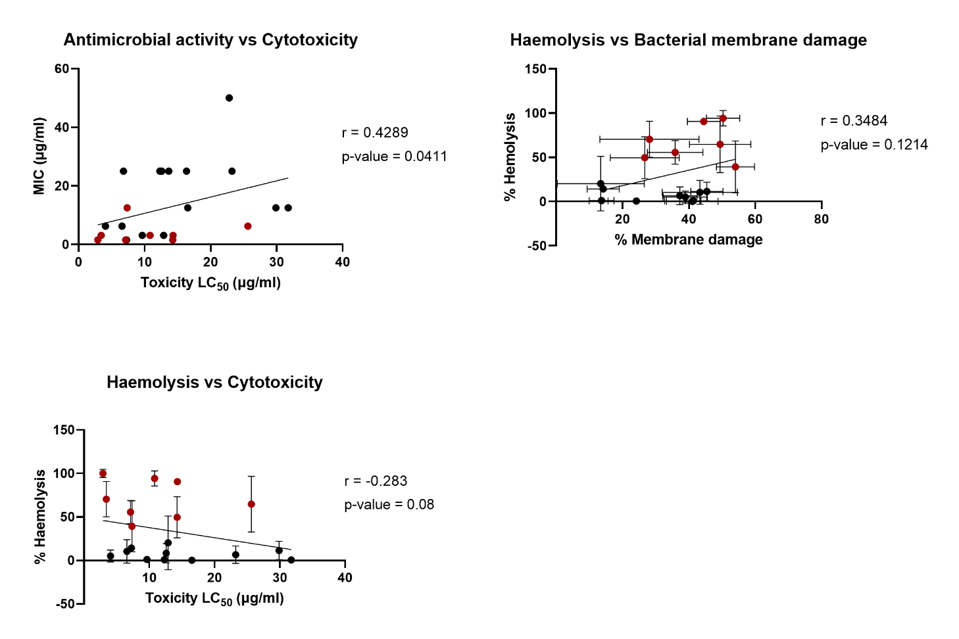
Supplementary Figure SF1. Correlation graphs of relevant parameters, including Spearman rank-correlation coefiecient (r) and p-value. A. Correlation between the antimicrobial activity expressed in MIC (μg/ml) and toxicity expressed as LC₅₀ (μg/ml). B. Correlation between haemolysis percentage in sheep red blood cells and percentage of membrane damage (Suplementary Table 3). C. Correlation between percentage of haemolysis in sheep red blood cells and toxicity expressed as LC₅₀ (μg/ml). Haemolytic compounds are shown in red.
Table ST1. MIC data of DPP compounds against a panel of Gram-positive and Gram-negative strains, including E. coli outer membrane and efflux mutants. n.t. non-tested, E. coli JW5503 (ΔtolC mutant), E. coli D21f2 defective LPS core..
DPP comp. |  |  | MIC (μg/ml)
DPP comp. | E. faecium | E. faecalis | P. haemolytica | P. aeruginosa | E. coli | E. coli  JW5503 | E coli D21f2
1 | 12.5 | 12.5 | 25 | >250 | >250 | 1.56 | n.t.
2 | 25 | 25 | 50 | >250 | >250 | 6.25 | 50
3 | >250 | >250 | 50 | >250 | >250 | 1.56 | n.t.
4 | 3.12 | 3.12 | 125 | >250 | >250 | 6.25 | >50
5 | 12.5 | 12.5 | 12.5 | >250 | 50 | 3.12 | 50
6 | 6.25 | 6.25 | 12.5 | >250 | >250 | 3.12 | 25
7 | 3.12 | 3.12 | 25 | >250 | >250 | 3.12 | 25
8 | 3.12 | 1.56 | 250 | >250 | >250 | 12.5 | 25
9 | 25 | 25 | 25 | >250 | >250 | 12.5 | 50
10 | 250 | 250 | 62.5 | >250 | >250 | 6.25 | 250
11 | 12.5 | 12.5 | 62.5 | >250 | >250 | 1.56 | 25
12 | 50 | 50 | 62.5 | >250 | >250 | 12.5 | >50
13 | 25 | 25 | >250 | >250 | >250 | 12.5 | >50
14 | 12.5 | 12.5 | >250 | >250 | >250 | 3.13 | n.t.
15 | 1.56 | 1.56 | >250 | >250 | >250 | 3.12 | n.t.
16 | 50 | 50 | 50 | >250 | >250 | 3.13 | n.t.
17 | >250 | 250> | 50 | >250 | >250 | 6.25 | n.t.
18 | 50 | 50 | >250 | >250 | >250 | 6.25 | n.t.
19 | 50 | 50 | >250 | >250 | >250 | 12.5 | n.t.
20 | 25 | 25 | >250 | >250 | >250 | 6.25 | n.t.
21 | 12.5 | 12.5 | 12.5 | >250 | >250 | 1.56 | >250
22 | 12.5 | 12.5 | 12.5 | >250 | >250 | 1.56 | 25
23 | 25 | 12.5 | 31.2 | >250 | 125 | 25 | 50
24 | >250 | >250 | 31.2 | >250 | 125 | 25 | 50

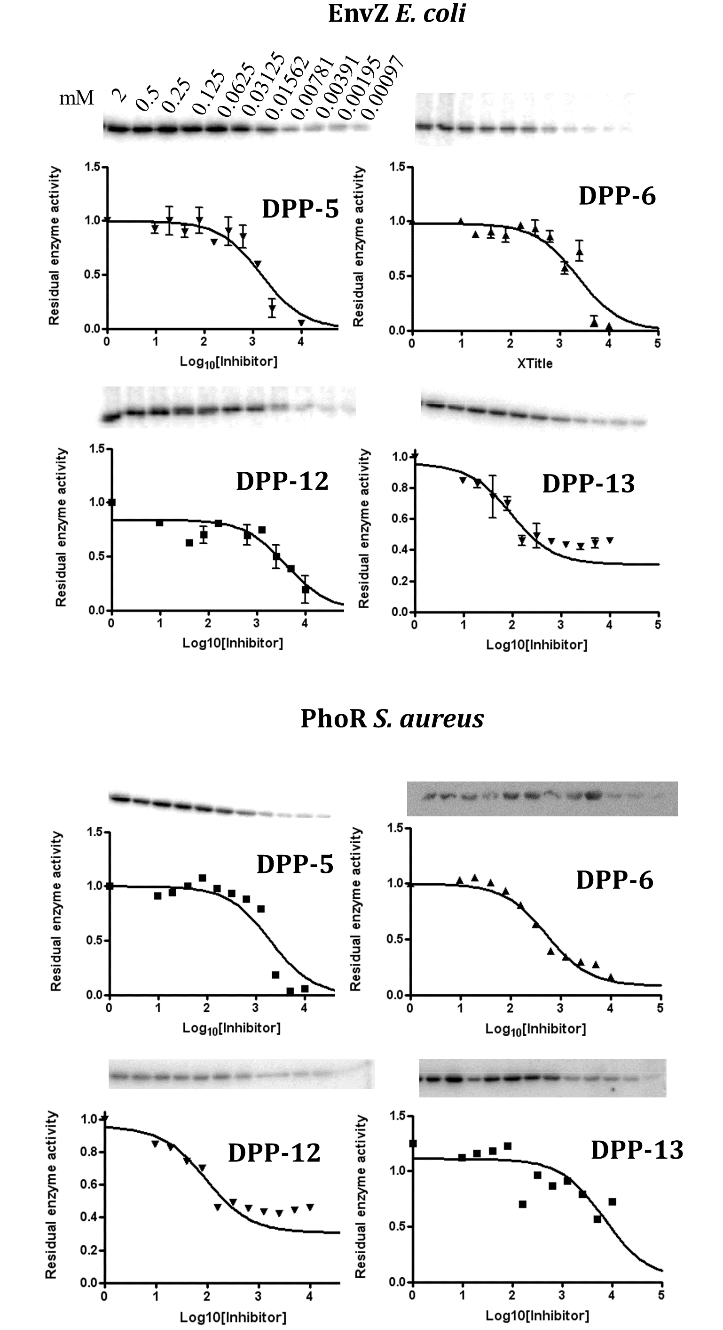
Figure SF2. Autophosphorylation inhibition assays of DPP compounds against EnvZ form E. coli and PhoR from S. aureus. A range of concentrations of DPP compounds was tested for inhibition of autophosphorylation of two HKs (PhoR from S. aureus and EnvZ from E. coli). Amount of phosphorylated HK was detected via Western Blot and percentage of autophosphorylation calculated according to the positive (ATP) and inhibition (ATP+AMP-PNP) controls. Curves were plotted using Prism 4.1.
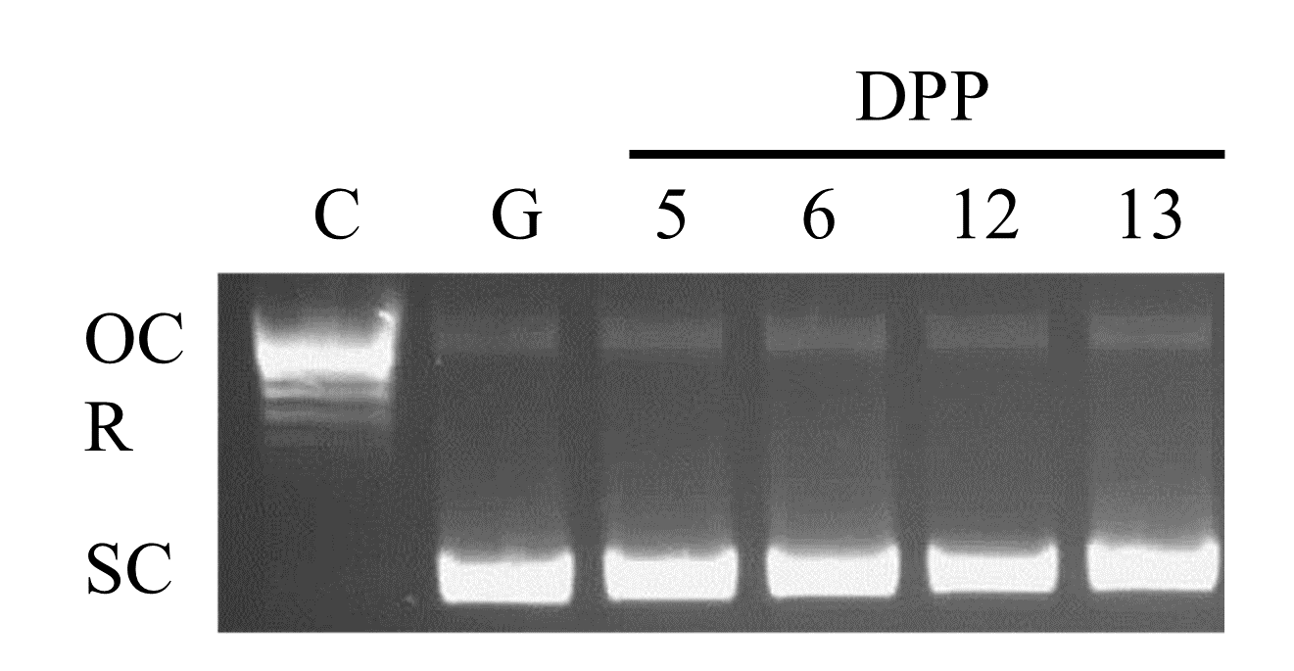
Figure SF3. Bacterial gyrase inhibition assay of DPP compounds. Gyrase inhibition was tested using a supercoiling inhibition assay. Control (C) contained relaxed pBR322, Gyrase control (G) contains relaxed pBR322 and E. coli gyrase (0.1 mU/reaction). DPP-compounds were added at a concentration of 2 mM. No inhibition of the supercoiled activity of E. coli gyrase is observed by any of the DPP compounds. OC = nicked, open circular; R = relaxed topoisomers; SC = supercoiled topoisomers
Supplementary method
Gyrase inhibition assay. Gyrase activity inhibition assays were performed using E. coli gyrase supercoiling kit (Inspiralis, Norwich, UK)(66) following the manufacturer instructions. Briefly, assay buffer (35 mM Tris-HCl pH 7.5, 24 mM KCl, 4 mM MgCl₂, 2 mM DTT, 1.8 mM spermidine, 1 mM ATP, 6.5% (w/v) glycerol, and 0.1 mg/ml albumin) was mixed with 0.5 μg relaxed pBR322, and 2 mM final concentration of desired inhibitor in DMSO. Reaction was started by adding 0.1 mU of E. coli gyrase per reaction, for a total final volume of 30 μl per reaction. Samples were incubated for 30 mins at 37 ºC, stopped by adding 30 μl STEB (40% sucrose, 100 mM Tris-HCl pH 8.0, 10 mM EDTA and 0.5 mg/ml bromophenol blue) and 30 μl 24:1 chloroform/isoamyl alcohol and mixed by vortexing. Samples were centrifuged for 1 minute and 30 μl was loaded into a 1% agarose gel supplemented with SYBRSafeTM followed by electrophoresis at 85 V for 2 hours. Gels were visualized using GelDoc XR+ gel documentation system (Bio-Rad).
Treatment | % FITC stained bacteria 0.5 xMIC | % FITC stained bacteria 1 xMIC | % FITC stained bacteria 2 xMIC
Unstained | 0
Alive | 4.10
Nisin | 16.37 | 53.32 | 59.41
Novobiocin | 8.28 | 12.62 | 13.17
1 | 30.46 | 39.72 | 46.63
2 | 49.81 | 54.03 | 63.56
3 | 35.78 | 49.41 | 58.28
4 | 7.94 | 14.15 | 19.78
5 | 13.40 | 13.42 | 41.29
6 | 36.93 | 44.48 | 48.91
7 | 42.44 | 50.30 | 54.59
8 | 12.26 | 32.15 | 36.10
9 | 38.22 | 41.34 | 43.78
10 | 28.57 | 37.28 | 40.99
11 | 24.77 | 28.12 | 57.97
12 | 9.04 | 24.16 | 29.11
13 | 35.10 | 45.40 | 45.44
14 | 28.78 | 44.58 | 56.62
15 | 9.29 | 13.68 | 18.42
20 | 31.90 | 40.99 | 50.97
21 | 31.51 | 35.84 | 51.03
Suplementary Table ST2. Porcentage of FITC-stained bacteria as measured using flow-citometry at different concentrations and different treatments.

Table ST3. Overview of the data obtained for the DPP compounds. The overview includes compound structure, MIC against S. aureus (in μg/ml and μM), LC₅₀ in HEK293 cells (in μg/ml and μM), selectivity index (LC₅₀/MIC), inhibition of PhoR histidine kinase (μM), inhibition of Hsp90 (IC₅₀ in μM), if it is considered to cause membrane damage to S. aureus and if it is considered to cause haemolysis to red blood cells (red). n.d. not done; N.A. not applicable.
DPP comp. | X | R₁ | R₂ | R₃ | R₄ | R₅ | MIC S. aureus | LC₅₀ HEK293 cells  μg/ml (μM) | Selectivity Index | Inhibition HKs | Membrane damage | Haemolysis | Inhibition Hsp90
1 | N | -CF₃ | -OH | -H | -H | -H | 6.25 (19.53) | 4.06 (12.69) | 0.65 |  | YES | NO
2 | N | -CF₃ | -OMe | -H | -H | -H | 12.50 (37.3)† | 7.34 (21.91) | 0.60 | <2 mM | YES | MILD
3 | N | -CF₃ | -OEt | -H | -H | -H | 6.25 (17.86) | 25.64 (76.53) | 4.1 |  | YES | YES
4 | N | -CF₃ | -OBn | -H | -H | -H | 1.56 (3.80)† | 7.26 (17.71) | 4.65 |  | NO | NO
5 | N | -CF₃ | -OH | -H | -Cl | -H | 3.12 (8.79) | 12.88 (36.28) | 4.13 | 95 | MILD | NO | 0.496
6 | N | -CF₃ | -OMe | -H | -Cl | -H | 3.12 (8.43)† | 14.30 (38.65) | 4.58 | 55 | YES | YES | 0.798
7 | N | -CF₃ | -OEt | -H | -Cl | -H | 3.12 (8.21) | 10.82 (28.47) | 3.47 | <2 | YES | YES
8 | N | -CF₃ | -OBn | -H | -Cl | -H | 1.56 (3.51)† | 14.25 (32) | 9.14 |  | YES | YES
9 | N | -Me | -OH | -H | -Cl | -H | 25 (83.33)† | 12.30 (41) | 0.49 |  | YES | NO
10 | N | -Me | -OMe | -H | -Cl | -H | 25 (79.37) | 23.23 (73.74) | 0.93 |  | YES | NO
11 | O | -CF₃ | -OH | -H | -Cl | -H | 3.12 (8.76)† | 3.41 (9.61) | 1.10 |  | YES | YES
12 | N | -CF₃ | -OH | -H | -OMe | -H | 12.50 (35.71) | 31.74 (90.69) | 2.54 | 328 | MILD | NO | 0.574
13 | N | -CF₃ | -OMe | -H | -OMe | -H | 12.50 (34.34)† | 29.88 (82.09) | 2.39 | 89 | YES | NO | 0.838
14 | N | -CF₃ | -OEt | -H | -OMe | -H | 6.25 (16.45) | 6.57 (17.29) | 1.05 |  | YES | NO
15 | N | -CF₃ | -OBn | -H | -OMe | -H | 3.12 (7.09) | 9.64 (21.91) | 3.10 |  | NO | NO
16 | N | -CF₃ | -OH | -OMe | -H | -H | 25 (71.43) | 16.35 (46.71) | 0.65 |  | n.d. | NO
17 | N | -CF₃ | -OMe | -OMe | -H | -H | 25 (68.49) | 12.58 (34.47) | 0.50 |  | n.d. | NO
18 | N | -CF₃ | -OH | -H | -OMe | -OMe | 50 (131.58) | 22.81 (60.03) | 0.45 |  | n.d. | n.d.
19 | N | -CF₃ | -OMe | -H | -OMe | -OMe | 25 (63.29) | 13.65 (34.56) | 0.55 |  | n.d. | n.d.
20 | N | -CF₃ | -OEt | -H | -OMe | -OMe | 12.5 (30.49) | 16.53 (40.32) | 1.32 |  | YES | NO
21* | N | -CF₃ | -H | -H | -Cl | -H | 1.56 (4.8)† | 7.12 (21.91) | 4.56 |  | YES | YES
22 | N | -CF₃ | -H | -H | -Cl | -H | 1.56 (4.59) | 2.89 (8.5) | 1.85 |  | n.d. | YES
23** | N | -CF₃ | -OH | -H | -H | -H | 250 (961.54)† | >250 (>650) | N.A. |  | n.d. | n.d.
24** | N | -CF₃ | -OMe | -H | -H | -H | 25 (102.04)† | 6.79 (27.71) | 0.27 |  | n.d. | n.d.

Supplementary Figure SF4. Cell imaging of HEK293 cells after 24 hours exposure to DPP compounds. A. HEK293 cells grown in exposure media B. HEK293 cells grown in the presence of LC₂₀ concentration of DPP-5 (5 μg/ml) (B), or DPP-6 (6 μg/ml) (C) and imaged in 24-well plates at 40x amplification. Exposed cells were also transferred from the plate to a glass slide for visualization at 100x amplification of cells grown in the presence of LC₂₀ (3 μg/ml) DPP-14. Arrows point to morphological abnormalities.

Figure SF5. Schematic synthesis of DPP-22.

Table ST4. Data collection and refinement statistics for CheA-resorcinol complex.
Data collection statistics | CheA-Resorcinol
Beamline | ALBA-XALOC
Wavelength (Å) | 0.9795
Resolution range (Å)* | 44.19-2.1 (2.17 -2.1)
Space group | P 2₁
Unit cell parameters  a, b, c (Å)  α, β, γ (°) | 40.97, 59.12, 67.06  90, 97.28, 90
Total no. of reflections | 123148 (12471)
Unique reflections | 18443 (1847)
Completeness (%) | 98.42 (97.75)
Multiplicity | 6.7 (6.7)
Mean I/sigma(I) | 9.26 (3.56)
R_{merge} | 0.1321 (0.87)
R_{pim} | 0.05581 (0.3777)
R_{work} | 0.1867 (0.2102)
R_{free} | 0.2404 (0.2558)
No. of atoms  Protein  Water  Ligand | 2724  2680  28  16
Rmsd:  Bonds (Å)  Angles (°) | 0.016  2.21
Ramachandran plot (%)  Favored  Allowed  Outliers | 97.63  2.37  0.00
Rotamer outliers (%) | 4.05
Clashscore | 5.52
B Factors (Å2)  Average  Macromolecules  Ligands  Solvent | 41.53  41.56  36.09  42.22
Number of TLS groups | 2
PDB code | 8PF2

*Values in parentheses are for the high-resolution shell.

