Critical Stages/Scènes Critiques
The IATC journal/Revue de l'AICT – December/Décembre 2024: Issue No 30
- Special Topic
- Essays
- Inter/National Reflections
- Interviews
- Performance Reviews
- Book Reviews
- Critics on Criticism
- In Memoriam
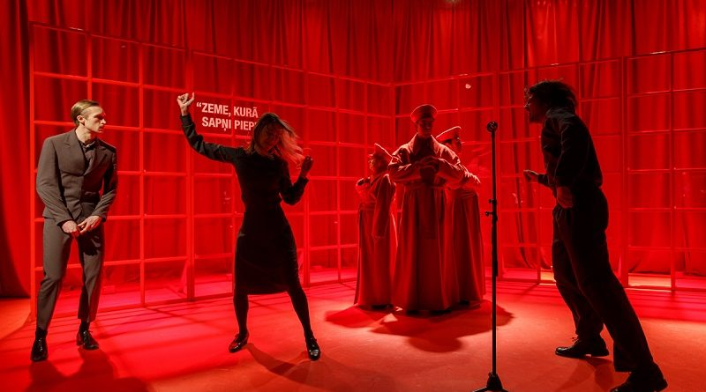
Representation of the Collective Memory in the Contemporary Latvian Theatre: A Few Recent Examples
Vesma Levalde
Vesma Levalde*
Abstract
This essay examines the representation of twentieth-century Latvia in contemporary Latvian theatre, with a particular focus on the events of the last decade of Soviet occupation (1980–90). The subject of the research encompasses several recent theatrical productions that have been staged in Latvian theatres, with a particular focus on the production entitled Us, Rock, Sex and the USSR. It is noteworthy that the creative team responsible for this production have not themselves experienced the Soviet occupation at a conscious age. The objective of this research is to identify the manifestations of collective memory across generations, based on the theoretical frameworks of post-memory and cultural trauma, and to elucidate the relationship between the concepts of collective memory and national identity as represented on stage. The study concludes that the trauma experienced by parents and grandparents as a dramaturgical theme represents an attempt to shape collective memory. This is characterised by a desire to understand the traumatic past of previous generations, but not necessarily to identify with these experiences. The projection of the past in the productions, the article claims, serves as a moral reconciliation with historical experience, while also acknowledging the traumatic lessons of previous generations. The challenge for the new generation is to reconcile these two opposing perspectives.
Keywords: collective memory, post-memory, cultural trauma, national identity, Soviet occupation, Latvian drama
Memory and Identity
The capacity for self-awareness in time and space requires an anthropological quality, memory. Cultural memory is a form of collective memory whose purpose is to establish communication between generations and to ensure the continuation of the relatively transitory. The formulation of culturologists Aleida Assmann and Linda Shortt, in Memory and Political Changes, posits that collective memories are constructed through mediated representations of the past that involve a process of selection, rearrangement, re-description and simplification, as well as the conscious but perhaps also unconscious inclusion and exclusion of information (3–4). Theatre is a synthetic medium that fuses action, time and space into a conditioned space-time in which several levels of communication take place simultaneously. These include the relationship between dramaturgy and its presentation on the stage, among the actors involved in the performance, and between the stage and the audience. One of the most frequently cited literary quotations pertaining to the nature of theatre is the assertion of Hamlet that actors are the “abstract and brief chronicle of time” (Shakespeare). When analysing a specific theatre production, it becomes clear that the era reflected by the actors is largely a decision of the director. However, as a medium between the stage and the audience, theatre also serves as a creator of cultural memory.
Cultural memory is collective memory that is localised in material objects such as texts, images, media, as well as traditions and rituals. Cultural memory is purposefully created, maintained and has a formalised and ritualised nature. The content of cultural memory and the meanings it contains are created, nurtured and interpreted by professionals such as archivists, librarians, museologists, scientists, writers, journalists, directors and producers. Cultural memory is a reflection of a society’s self-image, encompassing its collective knowledge, emotions, and values, as well as the social groups’ justifications for their unity and sense of distinctiveness.
Zelče 4–5
Collective and cultural memory is crucial for the formation of national identity and the unity of the people of a nation and a country. As the American sociologist Jeffrey C. Alexander points out, “cultural trauma is first of all an empirical, scientific concept, suggesting new meaningful and causal relationships between previously unrelated events, structures, perceptions, and actions” (1). During the Soviet occupation, cultural transformation was accompanied by physical and psychological violence not only in the occupied countries, but also throughout the Soviet Union.
In her article “The Long Shadow of the Past,” Aleida Assmann clearly states that the continuation of trauma from generation to generation can only be broken if the excluded and unconscious parts of trauma can be transformed into conscious forms of memory (94). The current generation of theatre professionals in Latvia includes individuals who were children during the period of occupation and those who were not even born at the time. The way these generations deal with the past determines whether the newly created collective memory will overcome the cultural trauma and form a moral reconciliation with historical experiences. Such a reconciliation would help to overcome the barriers of alienation between generations and between different groups of society, in order to build a future based on human values and human emotions.
Forms of Representation
The productions that reflect on the Soviet occupation differ in terms of dramaturgical material and in the approach of the creative team in representing the events of the past in the theatre. As Carlson makes the point:
All theatrical cultures have recognized, in some form or another, this ghostly quality, this sense of something coming back in the theatre, and so the relationships between theatre and cultural memory are deep and complex. Just as one might be say that every play might be called Ghosts, so, with equal justification, one might argue that every play is a memory play. Theatre, as a simulacrum of the cultural and historical process itself, seeking to depict the full range of human actions within their physical context, has always provides society with the most tangible records of its attempts to understand its own operations. In the repository of cultural memory, but, like the memory of each individual, it also subject to continual adjustment and modification as the memory is recalled in new circumstances and contexts. The present experience is always ghosted by previous experiences and associations while these ghosts are simultaneously shifted and modified by the processes of recycling and recollection.
2
One of the more notable trends in Latvian theatre over the last decade has been the production of documentary plays which draw their dramaturgy from the research of archival documents. For instance, The History Research Commission (New Riga Theatre, 2019), directed by Alvis Hermanis, where documentary evidence that a person could be registered as a Cheka (Soviet secret police, better known as KGB) informer without knowing it, plays a significant role. Hermanis says about the creative idea:
In the published lists (KGB informers), I found dozens of people I knew personally. And I know enough about the private life of many of them to imagine the basis on which they got there or were blackmailed. Putting them all in one pile is a pretty satanic plan, and with this show we wouldn’t want to take part in it. . . . This show is about how people can be manipulated and how history can be manipulated. Both then and now.
Mārtiņš Eihe’s production of the drama The Smell of Mushrooms (2015), written by Gunārs Priede (1928–2000), serves as only one of the sources of literary material of the production. The Smell of Mushrooms is the only play in Latvian theatre history that was banned by Soviet censors. The play was written in the winter of 1967/68, just a couple of months before the student riots in Prague and the following invasion of Russian tanks. The play ended up in the hands of ideology workers, who didn’t miss the hidden irony in the text aimed at the current regime and the ridiculous decisions made by the Communist party. Gunārs Priede lost his position as First Secretary of the Board of the Union of Cinematographers of the LSSR, and the production of his plays was forbidden for several years. The production was named the best small-hall production of the 2015/2016 season in Latvia.
The play is set during the birthday party of a high-ranking communist. An uninvited woman arrives to remind him of the ideals they once fought for as partisans against the Nazis. The title of the play is part of a forgotten password. Although the old communist never appears on stage, the woman dies, and the guests hide her body in the cellar. The ghosts of the past literally come to life. The 2015 production of the play includes documentary elements, such as readings from the playwright’s diary and extracts from the minutes of the Writers’ Union of Soviet Latvia. These materials provide context for the era and reveal the story of how the play was banned from production in 1968.
In a contemporary reinterpretation of Soviet period drama, the unspoken may be as significant, if not more important, than the spoken. Nevertheless, it is not the case that all directors are interested in the subtexts of the era. For instance, the production of Five Evenings, a play by Russian playwright Alexander Volodin, was directed by Leons Leščinskis and presented in Liepāja in 2014. The play focuses on the relationship between the main characters, Ilyin and Tamara. The production is categorized as “a love story.” However, the director overlooks the play’s implied but underdeveloped narrative about Ilyin’s 17-year absence from Moscow, which, viewed through a modern lens, provides a different context. It is important to point out that Soviet censorship restricted any discussion of the deportations to Siberian camps. Nonetheless, the subtext of the play suggests that the main character faces an insurmountable obstacle that prevents him from returning to Moscow. Only those who had been in the Gulag were prohibited from settling in the major urban centres. The director overlooks the traumatic history and presents a romantic atmosphere of the so-called “thaw,” the period following Stalin’s death. Consequently, the playwright’s meaningful subtext about the relationship drama caused by the system is overshadowed by a focus on individual indecisiveness and priorities. The romantic mood of the play, reinforced by the Western rock’n’roll playing and dancing, which might be challenging to imagine in a 1950s communist apartment, subtly evokes a sense of nostalgia for the Soviet era.
A different approach is taken by director Toms Treinis, who staged the Priede’s play The Blue (2017). In this case, points of contact with current events in the twenty-fist century are deliberately sought. Treinis highlights the connection between the past and present through symbols such as the volumes of Latvian folk songs and the rare Latvian blue cow, still found in seaside regions. These symbols confront the protagonist after a car crash, guiding him toward a sense of identity in his moment of despair:
The play “The Blue” deals with the concept of identity and, in particular, how our past shapes our identity. To understand the factors that shape my identity, the motivations of the people around me, the reasons for being in this country and the aspects of this nation that are important to me. To gain an understanding of the nature of the country Latvia.
LETA
The most interesting projects in the discourse of cultural memory are the selection of culturally recognisable objects or specific events from the Soviet occupation and their subsequent creative interpretation in literary fiction.
Ance Muižniece’s satirical play Us, Rock, Sex and the USSR, directed by Jānis Znotiņš at the Valmiera Theatre in 2022, is a synthesis of documentary facts and memory narratives in literary fiction. The production received extraordinary warm references both from audiences and critics, as well as several nominations for the Latvian Theatre Award.
Linking Timespaces
It is crucial to acknowledge that the creative team of the production Us, Rock, Sex and the USSR comprises individuals who did not directly witness the events of the 1980s upon which the play is based.The creators of the production attempt to “unlock” the real meaning of “USSR” in a temporal and spatial sense. As the author Ance Muižniece explained:
I am not a historian, nor do I claim to be one. But I wanted to give today’s young people a sense of that time, so that they could imagine themselves as their parents, grandparents, teachers, etc. I wanted them to feel that they were my grandparents. This was particularly important to me because the generation gap began with my generation—the children of the 1990s. My generation’s knowledge of previous generations is already quite limited. Furthermore, the understanding of the younger generation in society is decreasing with each passing year. There is a big gap between grandparents and grandchildren. For example, they don’t watch the same programmes or listen to the same songs. This is because they do not understand English or Russian. In addition, the terms used in everyday life are different, as are the ways of thinking and perceiving the world. Our team acts as a bridge between the generations, facilitating communication across the divide. We occupy a unique position, neither fully belonging to the younger or older generations, nor fully assimilated into Western culture.
The concept of the play was initially inspired by Juris Podnieks’ documentary Is it Easy to Be Young? (1986), a portrayal of rebellious teenagers growing up under Communist rule in Latvia, as well as the documentary film Homo Sovieticus (2021) by Ivo Briedis and the video series XX Century. POST SCRIPTUM (2013) by Eriks Niedra. The play’s characters, plot and dialogue were created through interviews with the playwright’s parents and others who were of a similar age to the play’s characters in 1985.
The narrative revolves around a musical performance by Latvia’s most popular rock group of the time, Pērkons (Thunder) and their fans. Pērkons is a rock band formed in 1981. Their music was originally akin to folk songs for youth. As a result, they frequently found themselves in trouble with the state authorities. In 1983, the band was banned for an extended period and compelled to seek alternative avenues for the dissemination of their music. They recorded two clandestine albums, which were subsequently copied and disseminated illegally. In the summer of 1985, the band gave a concert in the town of Ogre. Following the concert, a group of youths vandalized a train carriage traveling from Ogre to Riga. This led to their arrests and a subsequent Soviet show trial, where seven youths received various punishments, with one sentenced to prison. The playwright of the production Us, Rock, Sex, and the USSR drew inspiration from aspects of this event
The extensive use of the band’s music and the documentary facts about the concert and the consequences represent the word “Rock” in the show’s title Us, Rock, Sex and the USSR. In the context of the Soviet Union, “rock” was not only associated with the illicit Western culture but also with a defiant protest against the occupation.
The word “Sex” in the title reflects both the ups and downs of the characters’ relationships and, on a larger scale, the unspoken knowledge that was present during the Soviet era but officially suppressed. For example, when a teenage girl becomes pregnant, her mother convinces her to have an abortion to avoid bringing disgrace to their “ideologically correct” family.
The most significant code is the first word of the performance’s title, “us,” which can be interpreted in a broader or narrower sense. This can be used to understand the central figures of the show—three young people, schoolmates—whose characters were developed based on interviews with the older generation and research into the characters of the aforementioned documentaries. However, they are fictional, stereotypical characters who represent the behaviour of young people in the Soviet era in difficult decision-making situations. At the same time, the term “us” can be applied to the production’s creators, who are attempting to articulate their stance on the era that irreversibly shaped the identity of their parents and grandparents.
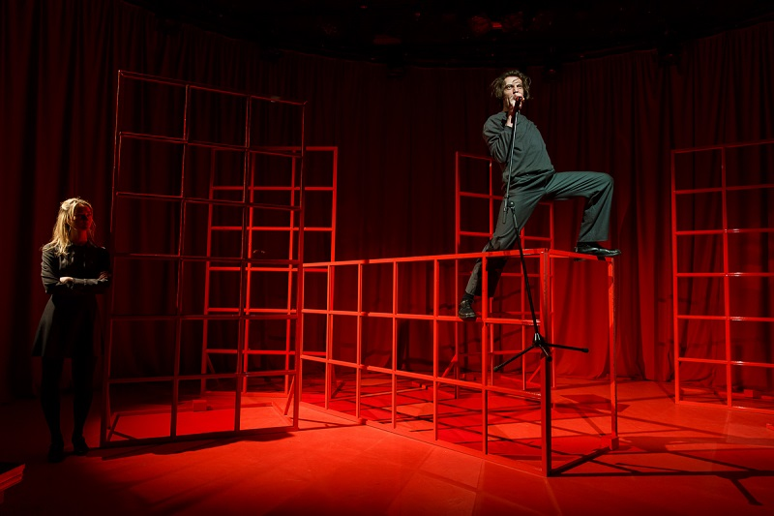Scene from the production Us, Rock, Sex and the USSR. Uģis – Eduards Johansons, Vizma—Klinta Reinholde. Photo: M. Markovskis
This interpretation of the production’s title is in line with postmemory theory, which posits that learning about the historical experiences of previous generations contributes to the formation of collective memory and is crucial in the context of identity formation for future generations. “And yet postmemory is not a movement, method, or idea; I see it, rather, as a structure of inter- and trans-generational transmission of traumatic knowledge and experience. It is a consequence of traumatic recall but (unlike posttraumatic stress disorder) at a generational remove” (Hirsh 106). The convergence of the show’s authors’ global perspective and the literary characters they have devised is most evidently exemplified in the character of Uģis, portrayed by actor Eduards Johansons. Uģis is a country boy who studies in Riga and lives with his brother. He is, therefore, somewhere between belonging to society and being somewhat alienated from it. Uģis is at the centre of the play’s action, yet he remains outside the events. He breaks the train window, but another person faces the consequences. The text reveals the factual details surrounding the conviction of a young man, Raimonds Ploriņš, for the destruction of a train following a rock concert. Uģis falls in love with a girl, Vizma, played by the actress Klinta Reinholde, but she prefers Andrejs, played by Sandis Runge.
An analysis of the dialogues shows that Uģis’s character is relatively naive, and his views are too idealistic for the Soviet era and more in line with the views of today’s youth. Scene 16 of the play, entitled “Compulsory military service,” is a case in point. In it, Uģis has conversations with his brother Ivo, who is a typical 1980s “farcovshchik” (a term used in the USSR to describe those engaged in the illicit trade of smuggled goods on a relatively small scale). When discussing conscription, Uģis tells his brother: “Ivo, I will never touch a gun. I won’t shoot. It’s just not going to happen.”
Avoidance of Soviet army service was a common occurrence in the 1980s, mainly motivated by fears of the violence and brutality inherent in Soviet military structures, along with a reluctance to serve in the army of occupation. The pacifism exposed by the Uģis, on the other hand, is a more contemporary phenomenon. Moreover, in the episode in which the contestants present their outfits in turn, accompanied by an ironic text, Uģis is the only one who exemplifies free thinking. In Scene 4 “Riga Fashion or Deficit,” where the characters’ appearances are ironically staged like a fashion show, a comment is made about Uģis:
The trousers are a little baggy, which detracts from their conventional elegance. The main feature of the image is the unkempt, excessively long and conspicuous hair. Similarly, a concert-goer’s hair is not just a fashion statement; it is an act of audacity. Is he crazy, a hippie, a drug addict or otherwise bad?
Furthermore, this comment about Uģis is supported by his own statement:
No, he is a dissident. In Latin, the term “dissident” means “renegade, speaking against,” while in the context of the Soviet Union it meant ‘anti-Soviet element’ or a person who spurns the established order, attempts to subvert it and openly challenges it. It is reasonable to conclude that such actions will result in imprisonment or commitment to a mental institution.
In other instances, however, Uģis is portrayed as a mimetic in the conversations of his schoolmates. The musical compositions of the group Pērkons serve to bridge the temporal divide between the past and the present. This is also reflected in the text by Uģis, which the author has labelled as “Uģis Manifesto“: “The only place I can find refuge is in music; everything there is real. They sing about reality. About me!”
Some of the Pērkons songs included in the performance were not written yet back in 1985, which indicates that the music represents a liminal transition from one era to another. The desire to unite generations in the code name “us” is also evidenced by the playwright’s explanation in the copy of the play’s text. This is exemplified by Uģis’ estimation of the number of people in the train carriage at the time of the demolition. Subsequently, Vizma provides an estimation of the approximate number of people present at the time of the demolition. A number of spectators is indicated in brackets. This suggests that the distinction between the stage and the audience, as well as between different temporal periods, is no longer a significant barrier. In the concluding episode “Rock against the locator,” Vizma articulates the following: “The system had finally collapsed, but the individuals who remained in the country and formed the nascent independent Latvia were the same people who had been affected by the system. The situation had become irreversibly compromised.”
In the play, Ance Muižniece instructs Vizma to convey the difficulties that the Latvian society was reluctant to acknowledge. The traumatic period of occupation has irreversibly altered the identity of the generations affected by the occupation. The playwright’s objective is to identify and illuminate the manifestations of cultural trauma in the lives of previous generations, compelling the characters to confront various morally challenging circumstances and revealing their decisions. In his work, “National Trauma and Collective Memory,” American anthropologist Arthur Gale Neal proposes that the signs of national trauma are “individual and collective reactions to a volcanic event that shook the foundations of social order” (ix). The concert of the group Pērkons, which is situated at the centre of the production and around which all other events take place, can be considered a volcanic event in itself. The expression of trauma is the reaction of both the society of that time and the characters of the play to this event. By combining a fictitious scenario with a factual account, the author achieves a generalisation of the situation and also reveals the challenging moral quandary in which no solution can be wholly justified.
Visual Metaphors
The spatial solution of the performance also reveals the Soviet system as a cultural trauma, specifically through the visualisation of one of the common attributes of the Soviet period – the “red corner.” The Soviet system designated the “red corner” as a kind of ideological altar in every institution and factory. However, the scenographer Pamela Butāne resolved this concept metaphorically. The stage is literally red and shaped like a cage, symbolising the concept of being cornered. One individual is positioned within the cage, while another observes and listens. The observers are situated within the room, while the Red Riflemen are selected as a symbol, thereby establishing a connection between different historical periods and, quoting the playwright, representing “the notion of the constant proximity of war, the need to fear the enemy who will come at any moment.”
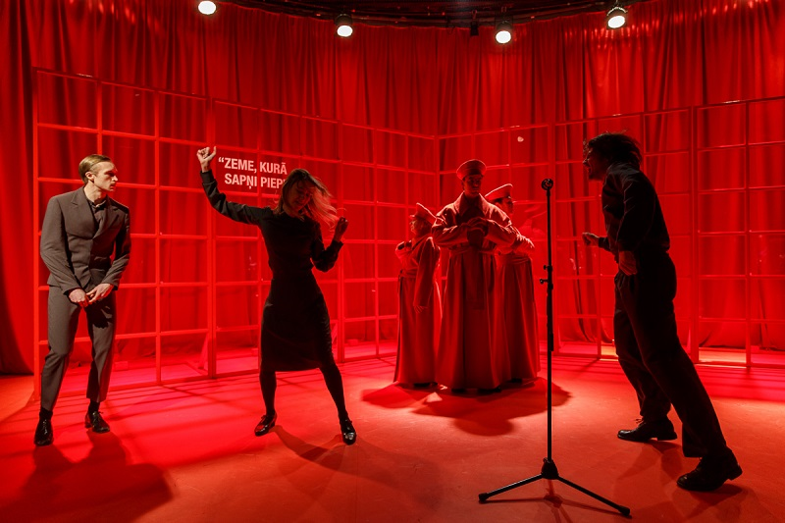Scene from the production Us, Rock, Sex and the USSR. From left side: Andrejs – Sandis Runge, Vizma – Klinta Reinholde, Uģis – Eduards Johansons. In the background: Red Riflemen, imitating a monument in Riga. Photo: M. Markovskis
The Red Riflemen, an ironic symbol of the Soviets, are set in the context of historical experience. At the time of the First World War, Latvia was a constituent state of the Russian Empire. As the Russian army sustained casualties, the Tsarist government permitted the formation of national military units, anticipating the patriotic self-sacrifice of soldiers engaged in combat on Latvian soil. The Latvian Riflemen suffered significant casualties in the battles. Following the Bolshevik coup, some riflemen were persuaded by the communist promises of the right of self-determination of the peoples and joined the Russian Civil War. They are historically known as the Red Rifles. Those riflemen who did not participate in the Russian Civil War were omitted from Soviet historiography. In the Soviet Union, only the Red Riflemen were permitted to be acknowledged. However, the fate of the Red Riflemen who remained in the Soviet Union after the Russian Civil War was not revealed to the public. These men were killed in Stalin’s repressions in 1937 and 1938. It is also possible that the Red Rifles as a symbol were taken from Podnieks’ film The Constellation of Riflemen, which he made in 1982 with screenwriter Arnolds Plaudis. The film uses the memories of old men to create a portrait of the Latvian Red Rifles. This was one of the first films made during the Soviet era to tell the truth about the complicated history of the Latvian people. During the First World War, inspired by the idea of a free and independent Latvia, about 60,000 men volunteered for the rifle battalions. At the time the film was made—in the early 1980s—about 300 of them were still alive, aged between 80 and 100. Today, not a single one remains. The film captured unique and now historic material that has no rival and will never have one.
Another element of the space is the use of slogans drawn from socialist ideology, which serve to emphasise the genre of the performance—satire. The slogans can be considered an ironic metatext that caricatures the disharmony between the Soviet morals and the real ones. For instance, the slogan “Economy should be economical” elucidates significant concepts in the Soviet lexicon, including deficit and blat—hard-to-get goods and the process of networking to gain access to these goods. The genre indicates that the creators of the production attempt to learn and understand the Soviet system as traumatic and contradictory, yet simultaneously demonstrate immunity to it by satirising the symbols of the socialist system. However, according to Mikhail Bakhtin’s research on the institution of the carnival and the culture of laughter, the institution of the carnival serves to break the social hierarchy that keeps some people oppressed (5–7).
Conclusion
The message of the production is conveyed through the dramatic conflicts and the choices made by the characters, with which the creators of the performance seek to demonstrate that although the traumas of the parents are deep and justified, they are not the traumas of the younger generation. The space of understanding is presented as a transition stage to a different type of social relationship. This allows us to conclude that the younger generation of theatre makers has a desire to learn about the past and create a common collective memory about it. Nevertheless, history does not prevent them from creating a future society without transferring the trauma of the older generations. At the same time, the clearly recognised past experiences allow an adequate assessment of the current geopolitical situation. Instead of traditional annotation, the performance program includes excerpts from the playwright’s diary, offering insight into the historical context in which the play was created. These entries indicate the timing of the production coincided with the Russian invasion of Ukraine. The link between the Soviet occupation and contemporary Russia is therefore apparent. Kitija Balcare, the theatre critic of the new generation, summarises: “The production Us, Rock, Sex and the USSR can be considered an explanatory dictionary of the Soviet era, or torn pages from such articles collected in the USSR, found in the areas of experience of generations living side by side.”
Note: This research is funded by the Latvian Council of Science, project “Navigating the Latvian History of the 20th-21st Century: Social Morphogenesis, Legacy and Challenges” (No VPP-IZM-Vēsture-2023/1-0003)

Bibliography
Alexander, Jeffry C. “Toward a Theory of Cultural Trauma.” Cultural Trauma and Collective Identity, edited by Jeffrey Alexander, U of California P, 2004, pp. 1–30.
Assmann, Aleida, and Linda Shortt. Memory and Political Changes. Palgrave MacMillan, 2012.
Bakhtin, Mikhail. Rabelais and His World. Indiana UP, 1984.
Balcare, Kitija. “Sarkanā vārdnīca. Par režisora Jāņa Znotiņa izrādi ‘Mēs, roks, sekss un PSRS’ Valmieras teātrī.” LSM, 20 Apr. 2022. Accessed 9 July 2024.
Carlson, Marvin. The Haunted Stage: The Theatre as Memory Machine. U of Michigan P, 2001.
Hermanis, Alvis. History Research Commission. 2019. Accessed 9 July 2024.
Hirsh, Mariann. The Generation of Postmemory: Writing and Visual Culture After Holocaust. Columbia UP, 2012.
LETA. Nacionālā teātra Jaunajā zālē jauna izrāde “Zilā.” 1 May 2017. Accessed 9 July 2024.
Muižniece, Ance. Re: Jautājumi par dramaturģijas tapšanu. Received by Vēsma Lēvalde, 21 January 2024.
Muižniece, Ance. “Mēs, roks, sekss un PSRS. ” 2022. Theatrical script.
Neal, Arthur, G. National Trauma and Collective Memory: Major Events in the American Century. M. E. Sharpe, 1998.
Shakespeare. Hamlet. Folger Shakespeare Library. 2020. Accessed 2 July 2024.
Zelče, Vita, et al. Atmiņas institūts un medijpratība. Rīga, 2023. LU Akadēmiskais apgāds.


*Vesma Levalde (Dr.art.) is a Latvian theatre researcher and critic, associate professor at RTU Humanities and Art Centre, and editor and author of the Latvian electronic theatre magazine KRODERS.LV. Her main interests include regional cultural history and its representation in contemporary drama, the digital age and media society, and the interpretation of classical texts in contemporary theatre. She is a member of the Latvian chapter of AITC/IATC; as an academic she has developed the following courses of study: Stage Culture and Performative Multimedia Art; Analysis of Current Processes in Theatre.
Contact details: vlevalde@gmail.com; vesma.levalde@rtu.lv; https://orcid.org/0000-0002-0584-761X
Copyright © 2024 Vesma Levalde
Critical Stages/Scènes critiques, #30, Dec. 2024
e-ISSN: 2409-7411
This work is licensed under the
Creative Commons Attribution International License CC BY-NC-ND 4.0.

