REGULATORY MATRIX INFLUENCE ON ADAPTABILITY OF ATTRACTOR SELECTION IN VIRTUAL NETWORK TOPOLOGY CONTROL METHOD
Dmitrijs Finaskins

Telecommunications institute, Riga Technical University, Azenes street 12, LV-1048, Riga, Latvia
Dmitrijs.Finaskins@rtu.lv

REGULATORY MATRIX INFLUENCE ON ADAPTABILITY OF ATTRACTOR SELECTION IN VIRTUAL NETWORK TOPOLOGY CONTROL METHOD

Abstract:Telecommunication network topologies are dynamically changing nowadays. The core telecommunication networks are basically based on fiber optics infrastructure. In such networks WDM technology is used to transmit multiple flows of traffic over a single fiber. Virtual network topology (VNT) is used to route IP traffic over WDM networks. VNT control system must be adaptive to traffic changes and dynamically reconfigure VNT. This can be achieved by using attractor selection, which models biological system behaviour. Biological systems are extremely adaptive to unknown changes in environmental conditions. This adaptability could be used as a model for VNT control system. The attractor selection in this VNT control method is based on a system of stochastic differential equations, which use load on links, retrieved by SNMP, and stochastic fluctuations – Gaussian noise – as input parameters to dynamically reconfigure VNT.
The object of the paper - how adaptability of VNT, controlled by attractor selection, depends on regulatory matrix. The regulatory matrix is the most important parameter in attractor selection method, since it shows the relationships between node pairs. The variety of network topologies has been simulated with different activation and inhibition probabilities as well as with different regulation function threshold.
Keywords: Virtual Network Topology, VNT, Adaptability, Attractor, Regulatory matrix.
REGULĒJOŠĀS MATRICAS IETEKME UZ ATRAKTORA IZVĒLES METODES ADAPTIVITĀTI VIRTUĀLO TĪKLU TOPOLOĢIJU VADĪBAS METODĒ
Kopsavilkuma teksts: Mūsdienās telekomunikāciju tīklu topoloģijas dinamiski mainās. Pārsvarā tiek izmantotas šķiedru optikas infrastruktūra maģistrālu sakaru nodrošināšanai. Šajā tīklā tiek izmantota WDM tehnoloģija, lai pārraidītu vairākas trafika plūsmas, izmantojot vienu optisko šķiedru. Virtuālā tīklu topoloģija (VNT) tiek izmantota IP trafika pārradīšanai WDM tīklā. VNT vadības sistēmai jābūt adaptīvai attiecībā pret trafika izmaiņām un sistēmai dinamiski jāpārkonfigurē VNT. Šo mērķi var sasniegt, izmantojot atraktora izvēles metodi, tā modelē bioloģiskas sistēmas uzvedību. Bioloģiskās sistēmas ir ļoti adaptīvas attiecībā pret nezināmām izmaiņām apkārtējā vidē. Šī adaptivitāte var tikt izmantota kā modelis VNT sistēmas vadībai. Atraktora izvēles metode VNT vadībai tiek aprakstīta ar stohastisko diferenciālo vienādojumu sistēmu, tā izmanto noslodzes uz saitēm, izmantojot SNMP un stohastiskās fluktuācijas – Gausa troksni – kā ieejas parametrus, lai dinamiski pārkonfigurētu VNT.
Dotās publikācijas mērķis – izpētīt kā VNT adaptivitāte, kuru vada atraktora izvēle, tiek atkarīga no regulējošās matricas. Regulējošā matrica ir vissvarīgakais parametrs atraktoru izvēles metodē, tā kā tas parāda attiecības starp mezglu pāriem. Simulācijās tika izmantotas dažādas tīklu topoloģijas ar dažādām aktivācijas un aizlieguma varbūtībām, kā arī tika izmantoti dazādi regulējošās funkcijas sliekšņi.
Atslēgvārdi: Virtuālā Tīklu Topoloģija, VNT, Adaptivitāte, Atraktors, Regulējošā Matrica.
Introduction
Core telecommunication networks nowadays are based on Wavelength Division Multiplexing (WDM) technology. In such division multiplexing technology transmitting/receiving channels are divided by wave length. It allows transmitting multiple traffic channels over a single fiber. Traffic by fiber optics can be transmitted over long distances without any additional equipment. Because of that WDM networks are commonly used to carry Internet traffic at backbone level. The major protocol of Internet is IP protocol. One of possibilities to carry IP traffic over WDM network is to construct virtual network topology, which includes transmitting/receiving channels (lightpaths) and IP routers. There are many VNT control methods, which configure/reconfigure VNT according to traffic demand matrices. Traffic demand matrices show how traffic flows are distributed via lightpaths.
One of the most exciting Internet opportunities for end-users is to share their pictures, videos and so on with other users; to communicate with each other using online services such as Skype. These cause constant and rapid changes in traffic flows between IP routers in VNT. There is a need to reconfigure VNT over a period of time in order to provide high-level service with minimal delays. VNT needs to be adaptable to changes in traffic demand.
There are two modes of constructing traffic demand matrices – offline and online or dynamical mode. In offline approach traffic demand matrices are constructed using previous known information about changes in traffic demand (Agrawal et al., 2006; Chen et al., 2008; Ricciato et al., 2002). The major weakness of this approach – offline methods will not work correctly if traffic flow changes will be different from ones expected. Online approach allows reconfiguring VNT dynamically. In this case periodical measurement results are used. To evaluate VNT status, information about average or maximum link utilization, packet delays can be used. Based on this information new lightpaths are added to source-destination pair of nodes if, for example, link utilization between these nodes is more than threshold and deleted if lightpath is underutilized.
The majority of online VNT control methods are used when traffic demand is changing periodically and gradually (Lakhina et al., 2004). This approach will not work if changes of traffic demand are not predictable. There is a need to develop such VNT control method, which is adaptable to unknown changes in network environment.
One of the approaches is to use attractor selection, which represents mechanism of adaptation to unknown changes of biological systems (Koizumi et al., 2008). The main idea of attractor selection – the system is driven by two components – deterministic and stochastic. Attractors are a part of the equilibrium points in the solution space. Conditions of such system are controlled by very simple feedback. When conditions of a system are suitable (close to one of the attractors), it is driven almost only by deterministic behavior, stochastic influence is very limited. When conditions of the systems are poor, deterministic behavior influence is close to zero and in this case system is driven by stochastic behavior. It randomly fluctuates searching for a new attractor. When this attractor is found, deterministic behavior again dominates over stochastic.
In this paper a research of attractor selection method is presented, which is adopted from (Furusawa et al., 2008) and described in (Koizumi et al., 2008). The object of the paper - how adaptability of VNT, controlled by attractor selection, depends on regulatory matrix.The paper is organized as follows. In the next section attractor selection mechanism is briefly described and the rest of the paper is devoted to network simulations and result analysis.

Attractor selection mechanism
Every pair of nodes, between which connection can be established, is represented by control unit$u_{ij}$, where i and j are indexes of nodes. Every control unit has its control value $x_{u_{ij}}$. Indexes s and d refers to source and destination nodes.
How control values change over time can be expressed by differential equation, also known as Langevin equation (Koizumi et al., 2008):

$$\frac{{dx}_{u_{ij}}}{dt}=v_{g}∙f\left(\sum_{u_{sd}}{W\left(u_{ij},u_{sd}\right)∙x_{u_{sd}}-θ_{u_{ij}}}\right)-v_{g}∙x_{u_{ij}}+η (1)$$

where v_{g}– indicates conditions of VNT ,
W($u_{ij},u_{sd}$) – regulatory matrix ofVNT,
$θ_{u_{ij}}$ – coefficient, which depends on minimum and maximum loads on links in VNT,
$η$ – Gaussian noise.
As it was used in (Koizumi et al., 2008), Gaussian noise with mean value 0 and variance 0.1 is used. The first term in Equation (1) represents regulation function f(z):

$$f\left(z\right)=\frac{1}{1+e^{-z}} ;z=\sum_{u_{sd}}{W\left(u_{ij},u_{sd}\right)∙x_{u_{sd}}-θ_{u_{ij}}} (2)$$

Dynamically adjusting $θ_{u_{ij}}$, the number of lightpaths, assigned to node pair can be controlled. $θ_{u_{ij}}$ is defined as follows(Koizumi et al., 2008):

$$θ_{u_{ij}}=-\frac{y_{u_{ij}}-y_{min}}{y_{max}-y_{min}}∙2θ_{c}-θ_{c} (3)$$

where $y_{u_{ij}}$ – load on link between nodes i and j,
$y_{max}$- maximum load on link in the network,
$y_{min}$- minimum load on link in the network,
$θ_{c}$ – coefficient, which scales $y_{max}$ and $y_{min}$.

The amount of lightpaths, assigned to node pair $u_{ij}$ is a function of unit control value $x_{u_{ij}}$. More lightpaths are assigned to node pair, which has higher control value.
Regulatory matrix $W\left(u_{ij},u_{sd}\right)$ is the most important parameter of Equation (1), since it shows the relationships between node pairs. Every element of this matrix can be -1, 0, or 1; it represents the influence of node pair $u_{ij}$ on node pair $u_{sd}$. According to model, proposed in (Furusawa et al., 2008), -1 corresponds to inhibition of the node $u_{ij}$by $u_{sd}$, 0 corresponds to no relation and 1 to activation. These values are multiplied by corresponding control values $u_{ij}$. In such way node pairs affect each other – if $u_{sd}$ is activated by $u_{ij}$, increasing in $x_{u_{ij}}$ will increase $x_{u_{sd}}$ and, as it was mentioned above, increase the amount of lightpaths between nodes s and d. In (Furusawa et al., 2008) has been shown that if gene pairs can activate or inhibit each other with probability 0.03 and no relation with probability 0.94, such biological network will be extremely adaptable to unknown changes in environment. For example, if your network consists of 6 node pairs, one of possible regulatory matrix realizations can be found in Table 1. As it can be seen, node pair $u_{12}$ is inhibited by node pairs $u_{23}$and $u_{24}$;$u_{14}$ is activated by node pair $u_{23}$.
Table 1
Example of the regulatory matrix
Node pair | $$u_{12}$$ | $$u_{13}$$ | $$u_{14}$$ | $$u_{23}$$ | $$u_{24}$$ | $$u_{34}$$
$$u_{12}$$ | 0 | 0 | 0 | 0 | 0 | 0
$$u_{13}$$ | 0 | 0 | 0 | 0 | 0 | 0
$$u_{14}$$ | 0 | 0 | 0 | 0 | 0 | 0
$$u_{23}$$ | -1 | 0 | 1 | 0 | 0 | 0
$$u_{24}$$ | -1 | 0 | 0 | 0 | 0 | 0
$$u_{34}$$ | 0 | 0 | 0 | 0 | 0 | 0

So for every node pair we construct regulation function, which is defined by Equation (2). Adjusting $θ_{u_{ij}}$, we can move regulation function in the negative or positive direction, as it is shown in Figure 1.
As it was mentioned above, v_{g} indicates conditions of VNT. As an input parameter for v_{g} maximum link utilization in the network is used. Maximum link utilization is selected as an input parameter because it can be easily retrieved using Simple Network Management Protocol (SNMP). But other parameters, such as average delay between node pair $u_{ij}$ can also be used to indicate the conditions of VNT. It will be referred to v_{g} as activity or goodness of VNT after this. Activity of VNT is defined as follows (Koizumi et al., 2008):

$v_{g}=\left\{\begin{aligned}\frac{100}{1+e^{(δ∙\left(u_{max}-ζ\right))}}, &u_{max}≥ζ \\ \frac{100}{1+e^{(\frac{δ}{5}∙\left(u_{max}-ζ\right))}}, &u_{max}<ζ\end{aligned}\right.$ (4)
where $δ$ - gradient of link utilization,
$ζ$– target link utilization.

From Equation (4) it can be seen that $ζ$ is a threshold for VNT activity v_{g}. If maximum link utilization is more than $ζ$, activity of VNT dramatically degraded and stochastic behavior dominates over deterministic and the system is searching for a new attractor. Activity function can be seen in Figure 2.
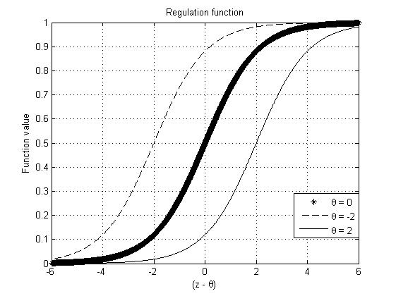
Fig. 1. The regulation function’s example

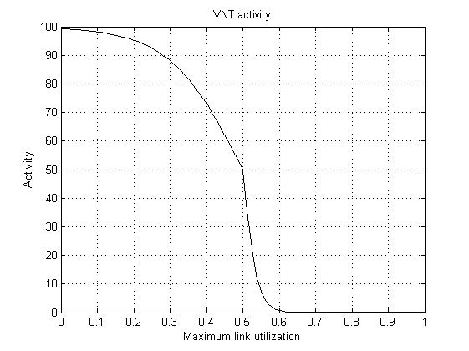
Fig. 2. VNT activity function

As it was mentioned above, the number of lightpaths between node pairs depends on control unit value $x_{u_{ij}}$. More lightpaths are assigned to node pairs with a higher control unit value. It is supposed that every node has $K_{r}$ receivers and $K_{t}$ transmitters.
The amount of assigned transmitters and receivers is a function of $x_{u_{ij}}$ normalized by all control unit values of all node pairs, which use transmitters and receivers from node i to node j. The number of lightpaths between nodes i and j is defined as follows (Koizumi et al., 2008):

$$N_{u_{ij}}=\min\left(K_{r}∙\frac{x_{u_{ij}}}{\sum_{s}{x_{u_{sj}}}}\right), min\left(K_{t}∙\frac{x_{u_{ij}}}{\sum_{d}{x_{u_{id}}}}\right) (5)$$

Network simulations
The network with 6 nodes and 15 bidirectional links will be simulated. Each node has 6 transmitters and 6 receivers. Traffic demand matrices are randomly generated using uniform distribution in certain time moments T=1, 2, 4 hours. Total simulation time is 5 hours. Measurements of load on links are done every minute. To simplify model, let’s assume that upload/download traffic demand matrices are the same. In the first set of simulations activation, inhibition and taking no action probabilities will be changed and it will be analyzed how it affects VNT activity and maximum link utilization. In the second set of simulations, regulation function threshold ($θ_{c}$ in Equation 3) will be changed. Any other parameters during all simulations are constant, they are chosen according to research (Finaskins 2013). In simulations only taking no action (0) probability is stated, inhibition and activation probabilities can be calculated, using expression $\frac{1-P_{o}}{2}$, where $P_{0}$ is taking no action probability.
In Figures 3 and 4 maximum link utilization in VNT network can be seen with respect to taking no action probability. Please pay attention to time moment [4; 5]. As it can be seen, in VNT
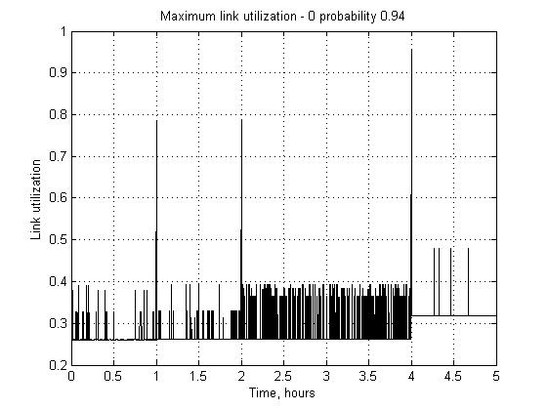
Fig. 3. Maximum link utilization– 0 probability 0.94

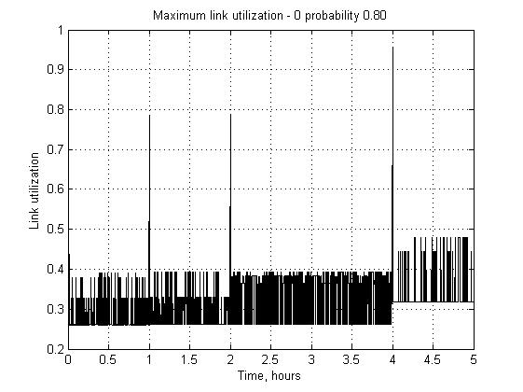
Fig. 4. Maximum link utilization – 0 probability 0.80

with taking no action probability 0.94 maximum link utilization is more stable, in opposite in Figure 4 we can see fluctuations. It happens because with taking no action probability 0.80 regulatory matrix will contain more -1/+1 and if network activity is rather high, it will strongly influence network. As it can be seen in Figures 5 and 6, network activity is also differs in time moment [4; 5]
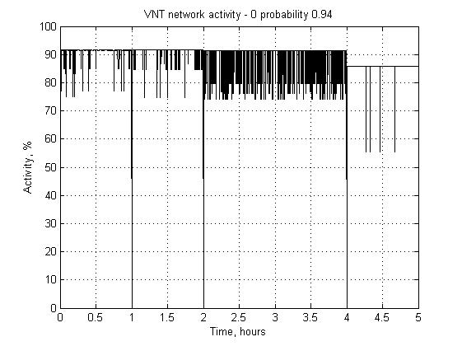
Fig. 5. VNT network activity – 0 probability 0.94

In time slots T=1, 2 and 4 VNT activity degrades due to changes in environment (maximum link utilization increases), in result stochastic behavior dominates system and the system state is driven by $η$. System randomly fluctuates searching for a new attractor. As soon as the system is close to an attractor VNT activity increases and deterministic behavior again dominates over stochastic one.
In Figures 5 and 6 we can see a very interesting effect. The system conditions are good (activity is about 90%), but the maximum link utilization increases unexpectedly, although there are no changes in traffic demand at this time moments. It happens because stochastic behavior always influences system conditions, even if VNT conditions are good. It causes VNT activity degradation. At this moment noise drives the system and a new attractor is being searched. After some time a new attractor has been found and system activity recovers. Because of noise random nature it cannot be predicted when it will happen.

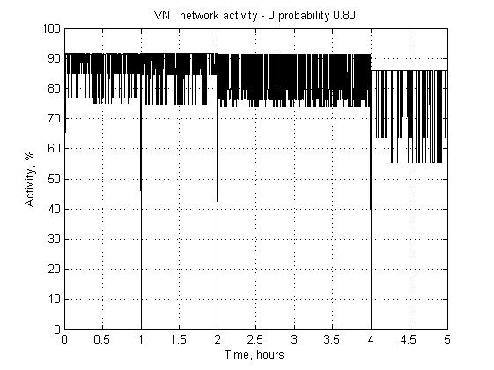

Fig. 6. VNT network activity – 0 probability 0.80

As it can be seen, when the probability of taking no action is decreased and probability of inhibition and activation is increased, VNT becomes unstable. It can be concluded that if traffic demand is uniformly distributed, the regulatory matrix can be generated using probabilities described in (Furusawa et al., 2008).
Now let’s see how $θ_{c}$ influences maximum link utilization and network activity. In previous simulations (Figures 3 - 6), $θ_{c}$ = 1. Two simulations will be done using $θ_{c}$ = 100 and 0.01. Such big difference is used in order to see the regularity of changing this parameter. The results can be seen in Figures 7 and 8. Here only maximum link utilization for both cases is represented. As it can be seen, $θ_{c}$ dramatically influence stability of VNT control method.
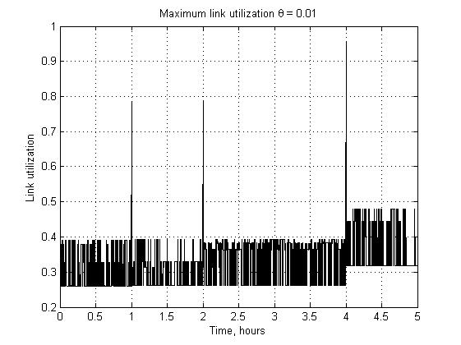
Fig. 7.Maximum link utilization $θ_{c}$ = 0.01
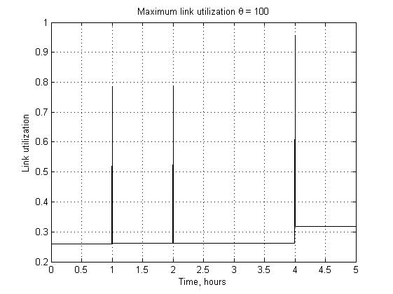
Fig. 8.Maximum link utilization $θ_{c}$ = 100

Discussion
In this paper regulatory matrix influence on adaptability of attractor selection has been studied. Uniformly distributed function for traffic demand matrix generation has been used. This distribution has been selected as it allows researching how VNT control method will adapt to unknown changes if traffic demand will vary from 0 to 1 (with respect to link capacity) with equal probability. On the other hand, it is vital to know how attractor selection mechanism deals with traffic in case when traffic demand matrix is generated using normal distribution (Gaussian distribution). This question is actual for large Internet service provider (ISP) networks, where probability of loads on links is not uniformly distributed in most cases. Some other distribution functions such as logarithmic and Poison are also needed to be studied – if attractor selection method is able to successfully deal with such distributed traffic.
Conclusions
- Gaussian noise cause system randomly fluctuates searching for a new attractor. At this moment stochastic behavior dominates deterministic.
- As it has been shown in some cases Gaussian noise can cause system unexpectedly change its state. But on the other hand thanks to the same Gaussian noise the system quickly re-establishes its conditions.
- If taking no action probability is decreased, VNT becomes more unstable and less adaptable.
- Coefficient $θ_{c}$, which scales minimum and maximum link utilization, has a huge impact on stability of VNT
References
Agrawal, G. and Medhi, D., November 2006. Lightpath topology configuration for wavelength-routed IP/MPLS networks for time-dependent traffic. In Proceedings of GLOBECOM, pp. 1-5.
Chen, B., Rouskas G. N. and Dutta R., October 2008. On hierarchical traffic grooming in WDM networks. IEEE/ACM Transactions on Networking, vol. 16, pp. 1226-1238.
Finaskins D., April 2013. Adaptability of attractor selection in virtual network topology control method. Proceedings of the 6-th International Scientific Conference, Jelgava, Latvia. pp. 72-77.
Furusawa, C. and Kaneko, K., January 2008. A generic mechanism for adaptive growth rate regulation. PLoS Computational Biology, vol. 4, p. e3.
Koizumi, Y., Miyamura, T., Arakawa, S., Oki, E., Shiomoto, K., Murata, M., 2008. Proceedings of the 3rd International Conference on Bio-Inspired Models of Network, Information and Computing Systems, Hyogo, Japan, Article No. 9.
Lakhina, A., Papagiannaki, K., Crovella, M., Diot, C., Kolaczyk, E.D. and Taft, N, June 2004. Structural analysis of network traffic flows. In Proceedings of ACM Sigmetrics, pp. 61-72.
Ricciato, F., Salsano S., Belmonte A. and Listanti M., June 2002.Off-line configuration of a MPLS over WDM network under time-varying offered traffic.In Proceedings of IEEE INFOCOM, vol. 1, pp. 57-65.

