In-situ heat flow measurements before and after energy efficiency measures in apartment buildings in Latvia.

Gatis Zogla¹, Andra Blumberga¹
¹ Institute of Environmental Protection and Energy Systems, Riga Technical University, Riga, Latvia
M.Sc. Gatis Zogla. Tel.: +371 26324712, e-mail: gatis.zogla@rtu.lv

Keywords: bad construction work quality, in-situ heat flow measurement, U-value, wall insulation.

Introduction

Majority of apartment buildings in Latvia have been built between 1940’s and 1990’s. Thanks to very low energy prices, these buildings were built according to very low energy efficiency standards. Nowadays when energy prices have increased, energy efficiency measures in some of these buildings have been implemented. According to energy audits, which were done before renovating these buildings, energy consumption for space heating should decrease by approximately 50%.

Savings in apartment buildings after energy efficiency measures

Analysis of energy consumption data of 13 renovated buildings was carried out to understand what were the real savings after implementation of energy efficiency measures. Two cities in Latvia – Cēsis and Kuldīga – were chosen for this study. Five buildings in Kuldīga and eight buildings in Cēsis were studied.

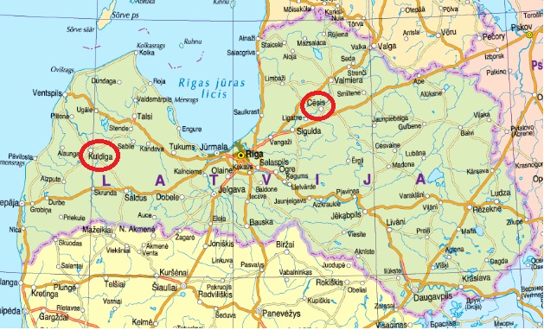
Fig.1. Location of studied buildings

There were mainly three types of buildings:
- Concrete panel buildings (2 buildings);
- Combined concrete panel and brick buildings (5 buildings);
- Brick buildings (6 buildings).
All of these buildings were built between 1960 and 1990. During energy consumption analysis all data were recalculated to same climatic conditions. Climatic conditions of Riga (capital of Latvia) were chosen in order to be able to compare energy consumption of all 13 buildings. Standard climatic conditions for heating season in Riga are:
- The length of heating season – 203 days;
- The average outdoor temperature during heating season – 0 ºC.
After recalculating all energy consumption data before and after implementing energy efficiency measures energy consumption for space heating was obtained (see Table 1)

Table 1
Energy consumption data before and after energy efficiency measures
Nr. of building | Heat consumption for space heating before renovation, kWh/m²a |  | Heat consumption for space heating after renovation, kWh/m²a |  | Savings, %
1. | 142 |  | 94 |  | 34,1%
2. | 152 |  | 111 |  | 26,8%
3. | 134 |  | 98 |  | 28,4%
4. | 142 |  | 147 |  | -3,3%
5. | 121 |  | 93 |  | 22,7%
6. | 166 |  | 125 |  | 24,8%
7. | 145 |  | 93 |  | 35,7%
8. | 152 |  | 109 |  | 27,5%
9. | 167 |  | 115 |  | 33,1%
10. | 147 |  | 120 |  | 18,8%
11. | 190 |  | 140 |  | 29,1%
12. | 149 |  | 124 |  | 17,2%
13. | 156 |  | 119 |  | 25,1%
Average |  | 151 |  | 114 |  | 24,6%

The results of this analysis showed that approximately 25% in real energy savings are achieved but calculations showed that savings should be around 50%. A study was made to understand why this difference between calculated and achieved savings occured. Around 10% of missing 25% could be explained thanks to the increased indoor temperatures after renovation of buildings. There were more buildings where the indoor temperature after renovation did not increase (for instance in buildings Nr. 1., 4., 7 and other).

In-situ heat flow measurements

After analyzing the implemented energy efficiency measures there was some doubt in the quality of the construction works in the buildings. It was decided to use in-situ measurements to determine the typical U-values of the walls before and after insulation. Heat flow measurements in five different types of walls were carried out:
- Not insulated aerated concrete panel;
- Not insulated silicate brick wall;
- Not insulated clay brick wall with air space;
- Insulated aerated concrete wall (10 cm polysterene);
- Insulated brick wall (10 cm polystyrene).

Measurements were done with TRSYS01 equipment from Hukseflux Thermal Sensors. Data processing was done according to ISO 9869:1994 “Thermal insulation – Building elements – In-situ measurement of thermal resistance and thermal transmittance”.

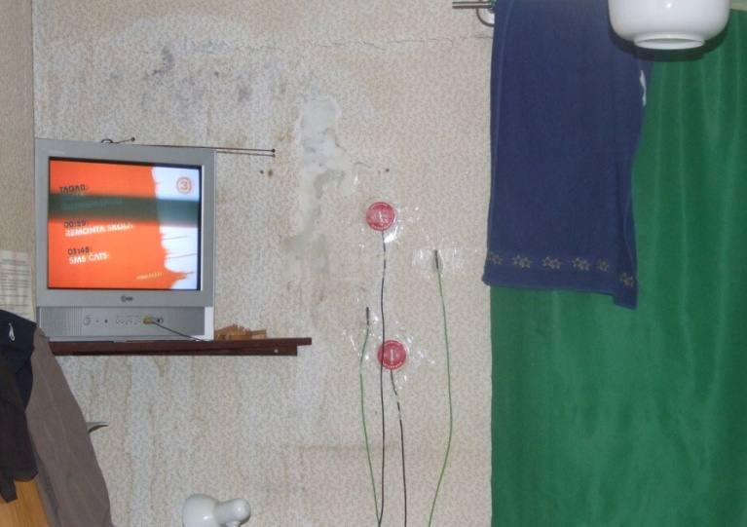 | 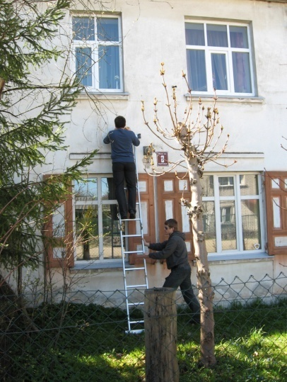
a | b
Fig.2. Measurements of aerated concrete panel wall (a) and preparation for measurements (b).

Some of measurement results for not insulated aerated concrete panel can be seen in Fig.3.

Fig.3. Heat flow and temperature difference between inner and outer wall surface

Knowing the instantaneous heat flow and temperature difference it is possible to calculate the instantaneous U-value or the heat transmittance of the wall. This can be seen in Fig.4.

As can be seen in Fig.4, the instantaneous U-values of the wall are varying between 0,7 to 1,2 W/m²K. This happens because the change of outdoor temperature occurs faster than the change in heat flow in the wall. By further analysis of measurement data it was possible to determine the U-values of the different types of walls.

Fig.4. Instantaneous U-values of not insulated aerated wall (measurement in Fig.2.a)

The results of measurements and comparison to theoretical U-values, which are calculated according to Latvian building code and ISO 6946:2007 “ Building components and building elements – Thermal resistance and thermal transmittance – calculation method”, can be seen in Table 2.

Table 2
Measured and calculated U-values of different types of walls
Nr. | Type of wall | Theoretical U-value, W/m²K | Measured U-value, W/m²K | Difference from theoretical value, W/m²K
1. | Aerated concrete panel wall (25 cm) | 0,90 | 0,895 | -0,05
2. | Silicate brick wall (39 cm) | 1,395 | 1,50 | +0,105
3. | Clay brick wall with air gap between bricks (12cm brick + 14 cm air gap + 24 cm brick) | 1,12 | 1,13 | +0,01
4. | Insulated aerated concrete panel wall (25 cm panel + 10 cm polystyrene) | 0,284 | 0,66 | +0,376
5. | Insulated silicate brick wall (59 cm bricks + 10 cm polystyrene) | 0,28 | 0,77 | +0,49

As can be seen from the table the difference between not insulated wall theoretical and measured U-values are quite small but in case of insulated walls it is very significant.

Further analysis showed that building construction companies in Latvia use technique when the heat insulation material is fixed to outer wall with air gap between insulation material and the existing wall.

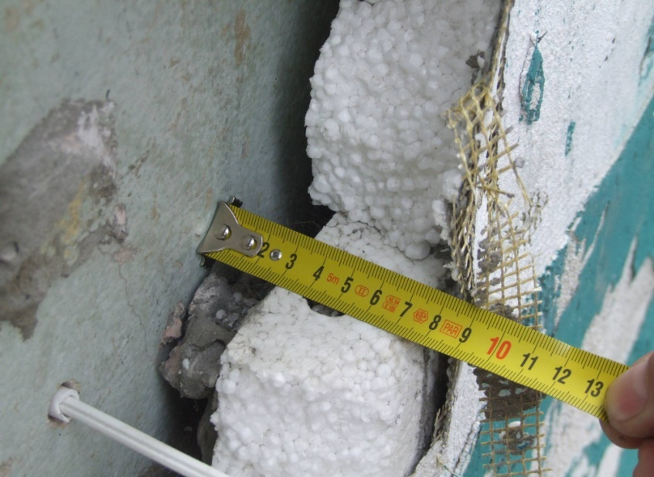
Fig.5. Air gap between wall and insulation material

Bad construction work quality allowed outdoor air to circulate in-between the air gap, which caused an increase in heat losses. When asked about this wall insulation technique, some of construction companies replied that this technique is called ventilated facade. It was big news for them when it was explained that in ventilated facades air circulation is happening not on the inner but on the outer side of heat insulation.

Conclusions

Unfortunately in Latvia building construction companies practically are not responsible for the quality of their work. And usually no quality is required and no quality check of construction works is carried out. However, thanks to results of these measurements some of building construction companies in Latvia have changed the technique how to insulate walls so that no ventilated air gap is created. Taking into account the results of this study, first buildings with measured 50% energy savings were refurbished in the summer of 2009.

