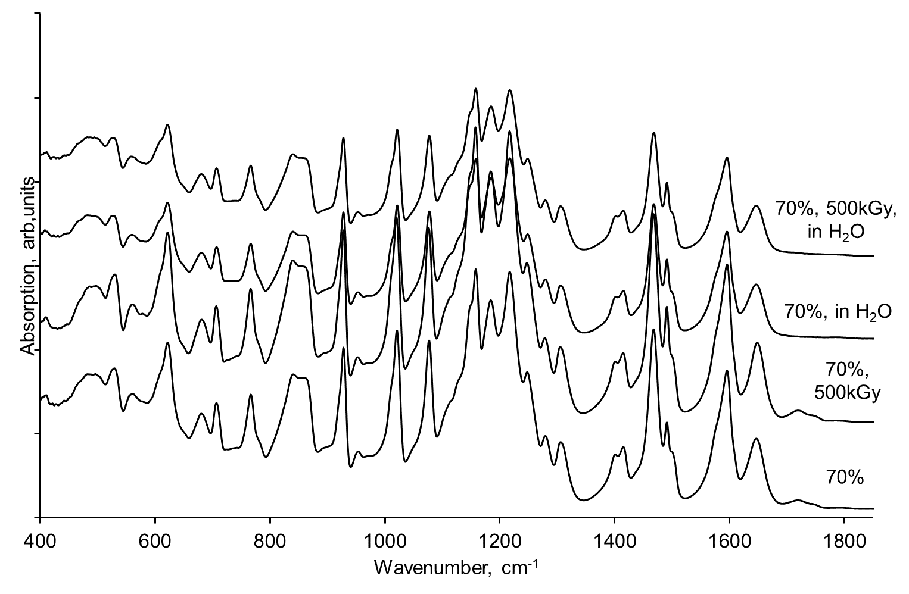
Fig.S1. FTIR spectra of SPEEK membranes with sulfonation degree 70%: non-irradiated, non-irradiated exposed to water, irradiated and irradiated in water
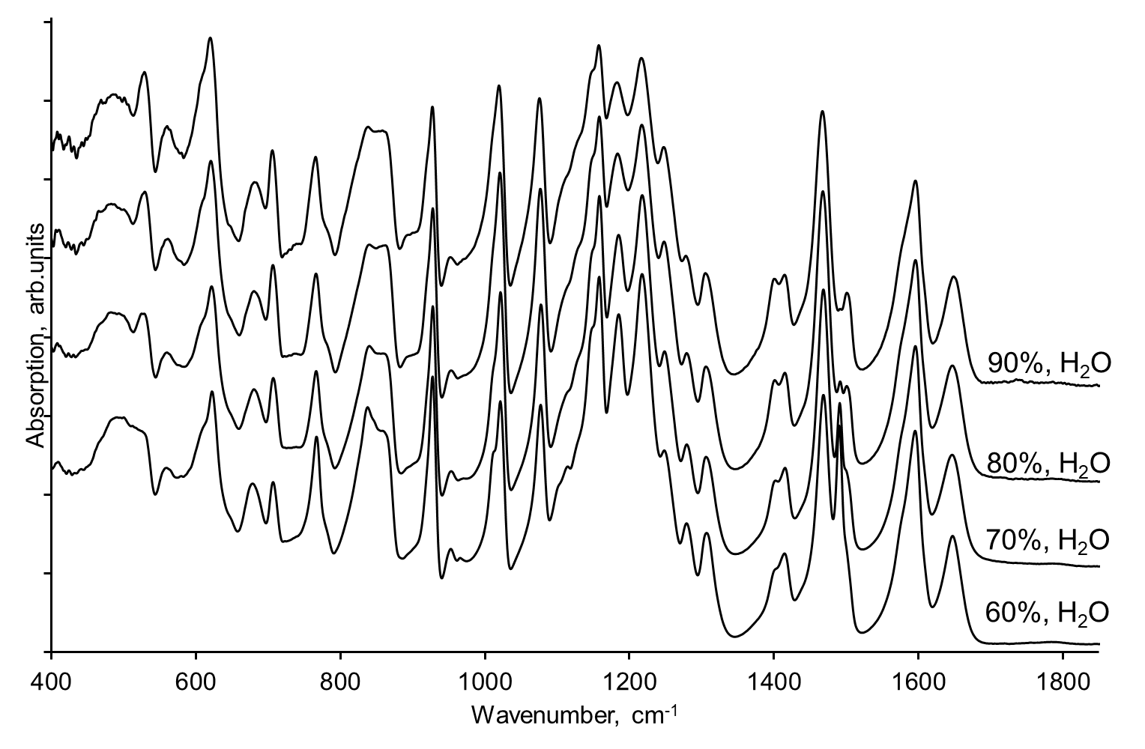
Fig.S2. FTIR spectra of nonirradiated SPEEK membranes exposed in water, with sulfonation degree 60, 70, 80 and 90%
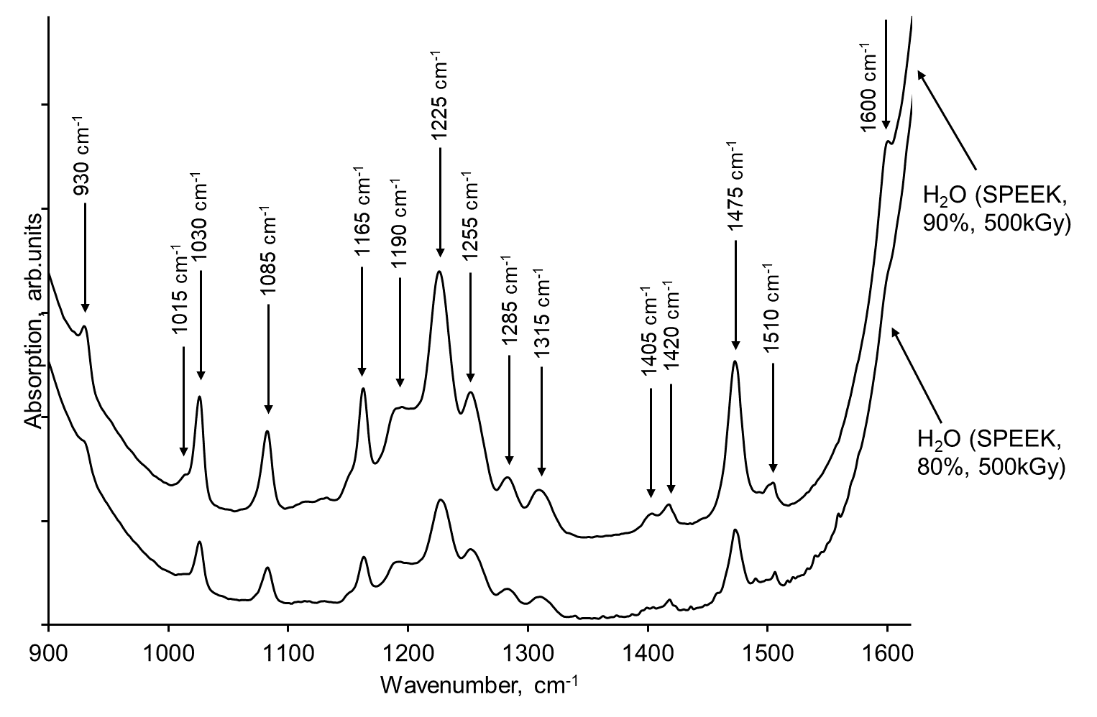
Fig.S3. FTIR spectra of water phase, where SPEEK membranes, 80 and 90% were dissolved asfter irradiation
Table S1 Assignments of the bonds occurred in the FTIR spectra of SPEEK water phase samples
Wavenumber, cm⁻¹ | Assignment | Reference
930 | Stretching vibration of S-O, diphenyl ether group | [1, 2]
1015 | Symmetric stretching of S-O mode | [3]
1030 | symmetric stretching vibration of the sulfonic acid group in SPEEK | [4]
1085 | asymmetric stretching vibration of the sulfonic acid group in SPEEK | [4]
1165 | O=S=O asymmetric stretching | [1]
1190 | diphenyl ether groups, C-O-C stretching | [5, 6]
1225 | Signals due to 1:2:4-substituted phenyl rings | [7]
1255 | Asymmetric stretching of –SO₃H group | [7]
1285 | Stretching of 1,2,4-substituted phenyl rings | [21] [7]
1315 | bending motion of carbonyl group | [1]
1405 | Ring vibration characteristics from benzene | [6]
1420 | Skeletal ring vibration | [8]
1475 | Ring vibration characteristics from benzene, CH bending | [6, 9]
1510 | Ring vibration characteristics from benzene | [6]
1600 | Ring vibration characteristics from benzene, sym. stretching of C=O | [6, 7]

References
1. Leon, V., et al., Spectroscopic study of double-walled carbon nanotube functionalization for preparation of carbon nanotube / epoxy composites. Carbon, 2012. 50(14): p. 4987-4994.
2. Zhao, F., D. Li, and Z. Jin, Preliminary Investigation of Poly-Ether-Ether-Ketone Based on Fused Deposition Modeling for Medical Applications. Materials, 2018. 11(2): p. 288.
3. Naresh Muthu, R., S. Rajashabala, and R. Kannan, Synthesis and characterization of polymer (sulfonated poly-ether-ether-ketone) based nanocomposite (h-boron nitride) membrane for hydrogen storage. International Journal of Hydrogen Energy, 2015. 40(4): p. 1836-1845.
4. Vaivars, G., K. Krūkle-Bērziņa, and M. Markus, Modelling IR Spectra of Sulfonated Polyether Ether Ketone (SPEEK) Membranes for Fuel Cells. Key Engineering Materials, 2020. 850: p. 138-143.
5. Shukla, D., Y.S. Negi, and V. Kumar, Modification of Poly(ether ether ketone) Polymer for Fuel Cell Application. Journal of Applied Chemistry, 2013. 2013: p. 386903.
6. Jean-Fulcrand, A., et al., Effect of temperature on tribological performance of polyetheretherketone-polybenzimidazole blend. Tribology International, 2019. 129: p. 5-15.
7. Maranesi, B., et al., Cross-Linking of Sulfonated Poly(ether ether ketone) by Thermal Treatment: How Does the Reaction Occur? Fuel Cells, 2013. 13(2): p. 107-117.
8. Al Lafi, A.G., FTIR spectroscopic analysis of ion irradiated poly (ether ether ketone). Polymer Degradation and Stability, 2014. 105: p. 122-133.
9. Tsou, H.-K., et al., Low-temperature deposition of anatase TiO2 on medical grade polyetheretherketone to assist osseous integration. Surface and Coatings Technology, 2009. 204(6): p. 1121-1125.

