Sulfonamide-incorporated bis(α-aminophosphonates)as promising carbonic anhydrase inhibitors: Design, synthesis, biological evaluation, and X-ray crystallographic studies

Marjan Sobatiª, Morteza Abdoliª, Andrea Angeli^{b}, Alessandro Bonardi^{b}, Marta Ferraroni^{c}, Claudiu T. Supuran*^{,b}, Raivis Žalubovskis*^{,a,d}

ª Institute of Chemistry and Chemical Technology, Faculty of Natural Sciences and Technology, Riga Technical University, Riga, Latvia;
^{b}Neurofarba Department, Pharmaceutical and Nutraceutical Section, University of Florence, Via Ugo Schiff 6, Sesto Fiorentino, 50019 Florence, Italy;
^{c}Dipartimento di Chimica “Ugo Schiff”, University of Florence, Via della Lastruccia 3, 50019 Sesto Fiorentino, Florence, Italy;
^{d}Latvian Institute of Organic Synthesis, Riga, Latvia;

SUPPLEMENTARY MATERIAL

Summary of Data Collection and Atomic Model Refinement Statistics for hCAs
 | CA II + 5a
PDB ID | 8R2F
Wavelength (Å) | 1.00
Space Group | P21
Unit cell (a, b, c, α, β, γ) (Å,°) | 42.56, 41.64, 72.52  90.00, 104.47, 90.00
Limiting resolution (Å) | 41.24-1.25 (1.27-1.25)
Unique reflections | 65314 (2166)
Rmerge (%) | 4.7 (38.2)
Rmeas(%) | 5.2 (45.0)
Redundancy | 5.7 (3.4)
Completeness overall (%) | 95.8 (64.8)
<I/σ(I)> | 18.6 (2.8)
CC (1/2) | 0.999 (0.868)
Refinement statistics
Resolution range (Å) | 41.24-1.25
Rfactor (%) | 14.01
Rfree(%) | 17.17
r.m.s.d. bonds(Å) | 0.0238
r.m.s.d. angles (°) | 2.1579
Ramachandran statistics (%)
Most favored | 97.2
additionally allowed | 2.8
outlier regions | 0.0
Average B factor (Å²)
All atoms | 18.476
Inhibitor | 48.739
solvent | 29.018

Figure S1
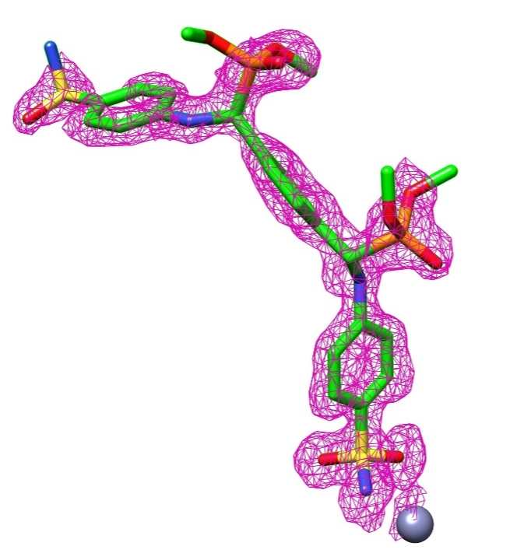
Electron density of inhibitor 5a bound to zinc (grey) in hCA II active site. 2F_{o}-F_{c} maps and contoured to the 1.0 $σ$ level.



