Table S1
The characteristic IR spectra absorptions of the functional groups used to study FTS products
Absorption band (cm⁻¹) | Functional group | Assignment | Compounds
2958; 2872; 1465; 1378 | Methyl group  (-CH₃) | υ_{asym} -CH₃; υ_{sym} -CH₃;  δ_{antisymetric} -CH₃; δ_{umbrella} -CH₃; | Paraffin, olefin,  longer or long-chain alcohol
2923; 2854; 1455; 720 | Methylene group  (-CH₂-) | υ_{asym} -CH₂-; υ_{sym} -CH₂-;  δ_{scissoring} –CH₂-; δ_{rocking} –CH₂-* | Paraffin, olefin,  longer or long-chain alcohol
3075; 2997; 1642; 992; 909 | Vinyl group  (-CH=CH₂) | υ_{asym} =CH₂; υ_{sym} =CH₂;  υ -C=C-; γ_{twist} =CH_{2;}  γ_{bend} =CH₂ | 1-olefin
964 | R-CH=CH-R₂ | γ_{bend} -CH=CH- (trans) | trans-olefin
3345; 1056 | Hydroxyl group  (-OH) | υ -OH; υ C-OH (primary) | Longer or long-chain alcohol
υ - stretch
υ_{asym} – asymmetric stretch
υ_{sym} – symmetric stretch
δ –bend
γ - out-of-plane
* four or more –CH₂- groups are in a chain

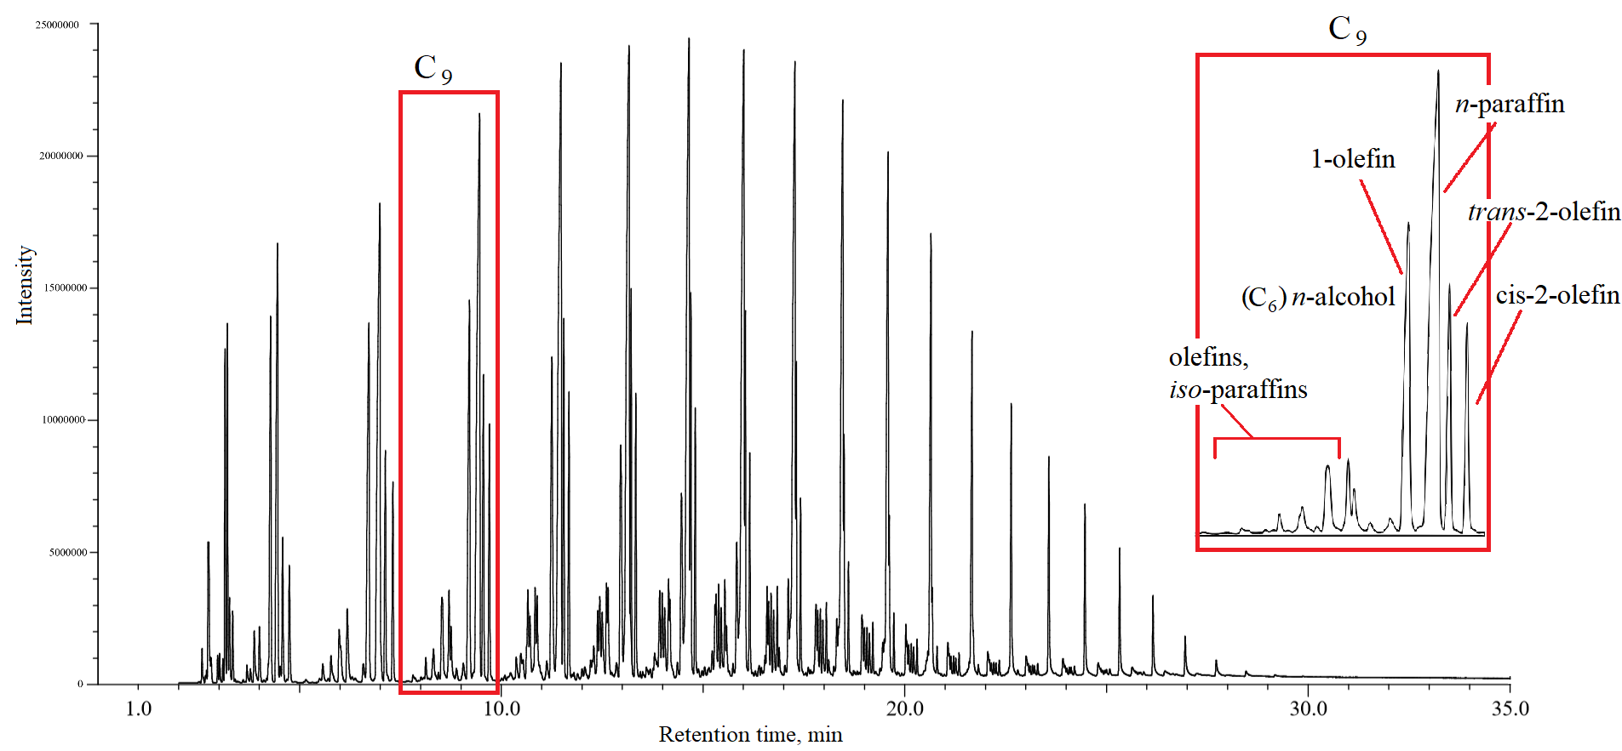
Fig. S1. A typical FID chromatographic picture of the liquid hydrocarbon phase products for reaction in presence Fe/SiO₂ (H₂/CO = 2, GHSV = 4515 NmL∙g⁻¹∙h⁻¹, 20 bar, 280 °C)

For the entire spectrum of compounds, the order of the group elution depends on carbon atom number in the molecules (Fig. S1.). Within each C_{n} group at first eluted methyl- branched paraffins and olefins, that have the sp² carbon greater then C₂, followed by n-alcohol, 1-olefin, n-paraffin, trans-2-olefin, and cis-2-olefin. The carbon number for the n-alcohol eluted in each C_{n} region was C_{n-3}. The range of alcohols that was found in liquid hydrocarbon phase was C₅–C₁₄.

909
965
1060
Fig. S2. FTIR spectra of FTS liquid hydrocarbon phase obtained in presence of Fe/SiO₂ (T= 240 °C, 260 °C, 280 °C, 300 °C)

Figure S2 shows FTIR spectra of liquid hydrocarbon phase obtained during FTS at different temperatures. According to Table S1, the presence of an intense band at 3345 and 1056 cm⁻¹ corresponds to O-H and C-O stretching vibrations, respectively, which indicates alcohols. It is known that alcohols with a chain length greater than 10 carbons (long-chain alcohols) are well soluble in non-polar solvents. The absorption bands between 2854 - 3075 cm⁻¹ and 1378 - 1465 cm⁻¹ correspond to the methyl- and methylene group stretching and bending vibrations which indicated paraffins and olefins in these products. Figure S1 shows the presence of absorption band at 909 cm⁻¹ which corresponds to =CH₂ bending vibrations, respectively, which indicates 1-olefins, while the presence of absorption band at 965 cm⁻¹ corresponds to -CH=CH- (trans) bending vibrations which indicates trans-olefins. According to the obtained results, the hydrocarbon phase consists of paraffins, olefins, and long-chain alcohols, which coincides with GC–MS and NMR analysis. Besides, content of 1-olefins and alcohols decreases while content of trans-olefins increases with increasing temperature.
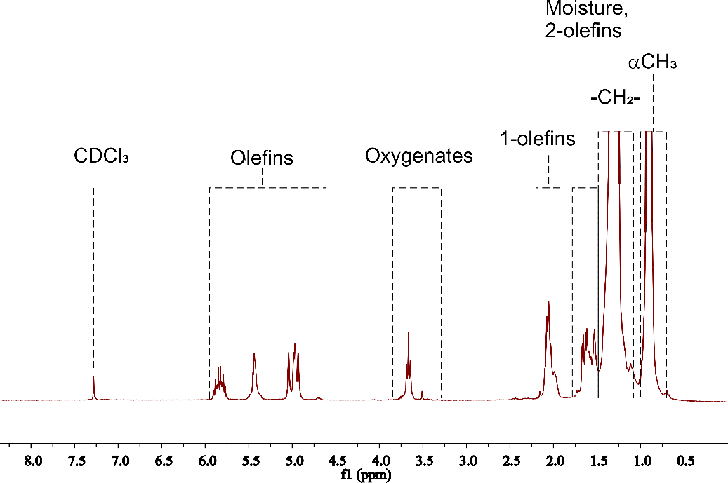
A

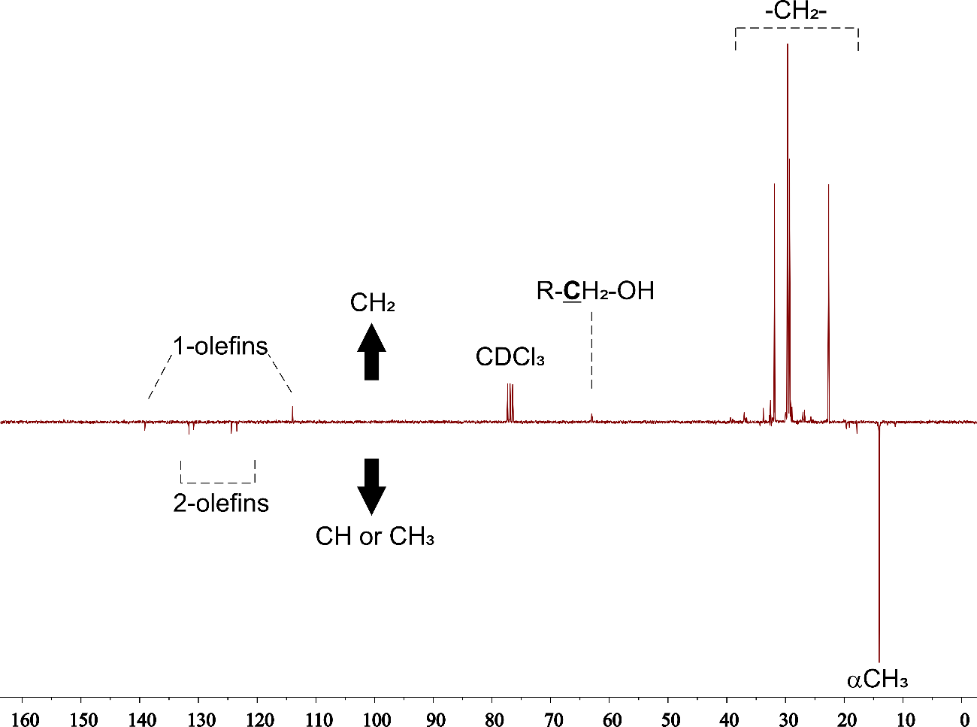
B

Fig. S3. Typical ¹H NMR (A) and ¹³C NMR (B) spectra of liquid hydrocarbon phase products obtained in presence of Fe/SiO₂ (H₂/CO = 2, GHSV = 4515 NmL g⁻¹ h⁻¹, 20 bar, 280 °C)

Typical NMR spectra of liquid hydrocarbon phase products obtained in chloroform solution is presented in Figure S3. The ¹H NMR spectrum shows signals for the -CH₂- groups at 1.27 ppm and for the -CH₃ groups at 0.89 ppm. Signals of very low intensity were detected between 3.3 and 3.9 ppm due to oxygenated species, and between 4.6 and 6.0 due to olefinic proton groups.
¹³C NMR spectrum shows intense signals at 31.9, 29.7, 29.3, 22.6, and 14.0 ppm corresponding to γ, ε, δ, β, and α carbon groups in n-alkanes. Many low intensity signals were observed between 20 and 40 ppm corresponding to branched alkane fraction. Low intensity signals of the 1-olefins were observed at 139.1 and 114.0 ppm, signals at 131.6, 130.8, 124.4, 123.5 ppm are due to 2-olefins and signal at 63.0 ppm corresponds to R-CH₂-OH. According to the obtained results, the hydrocarbon phase consists of paraffins, olefins, and long-chain alcohols, which coincides with GC–FID/MS.

