Electronic Supplementary Information
Rapid, High Yield Aqueous Synthesis of Ultrafine Magnetite Nanoparticles from Fe(III) Precursor at Room-Temperature
Andris Šutka,1* Sanda Bitina,1 Krisjanis Smits,2 Anna Šutka,1 Liga Bikse,2 Mikhail Maiorov,3 Tanel Käämbre,4 Martin Timusk,4 Lauma Laipniece,5 Kristine Lazdovica 5
1 Institute of Materials and Surface Engineering, Faculty of Materials Science and Applied Chemistry, P. Valdena 3/7, LV1048 Riga, Latvia
2 Institute of Solid State Physics, University of Latvia, Kengaraga 8, LV1063 Riga, Latvia
3 Institute of Physics, University of Latvia, Miera 32, LV2169 Salaspils, Latvia
4 Institute of Physics, University of Tartu, W. Ostwaldi Str.1, 50411 Tartu, Estonia
5 Institute of Applied Chemistry, Faculty of Materials Science and Applied Chemistry, P. Valdena 3/7, LV1048 Riga, Latvia
Fig. S1. FTIR transmittance spectra in the range of 4000-400 cm-1 of the samples synthesized in the presence of CTAB surfactant and without the CTAB.

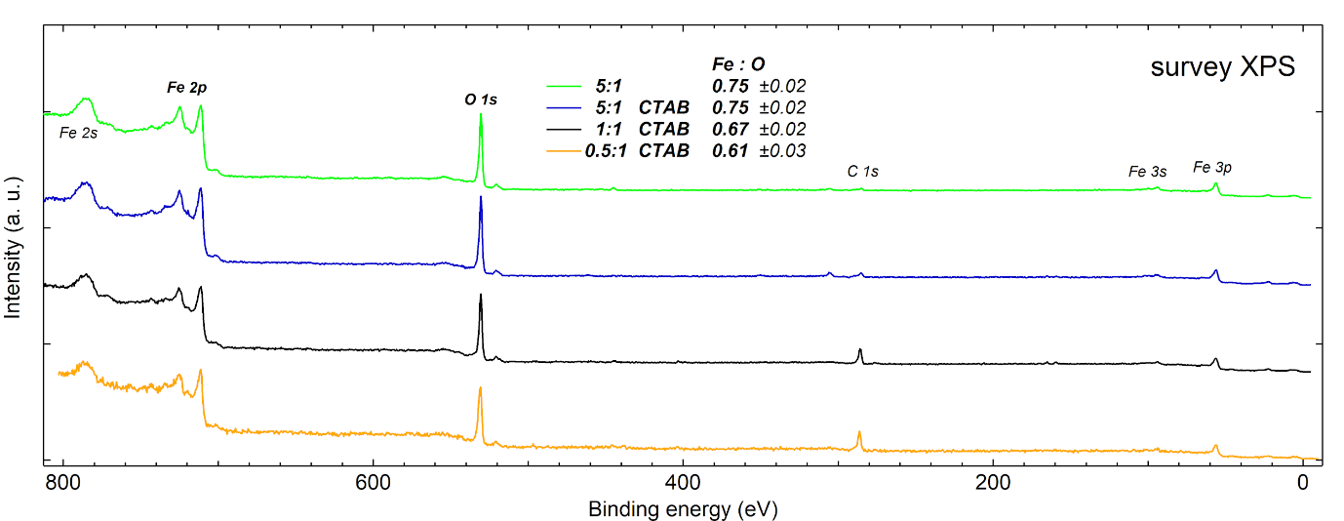
Fig. S2. XPS survey spectra. The Fe:O atomic content ratio deduced from survey XPS is close to 3:4 (as in magnetite) to within experimental uncertainty for all the samples (see Table ST1 below).

Table ST1. Elemental content as deduced from survey XPS.

Sample | Fe:O | Fe (2p) %at. | O (1s) %at. | C (1s) %at.
5:1 | 0.75 | 41.5 | 55.5 | 3.0
5:1 CTAB | 0.75 | 39.9 | 53.5 | 6.6
1:1 CTAB | 0.67 | 32.5 | 48.6 | 18.9
0.5:1 CTAB | 0.61 | 26.9 | 44.1 | 2 9.0

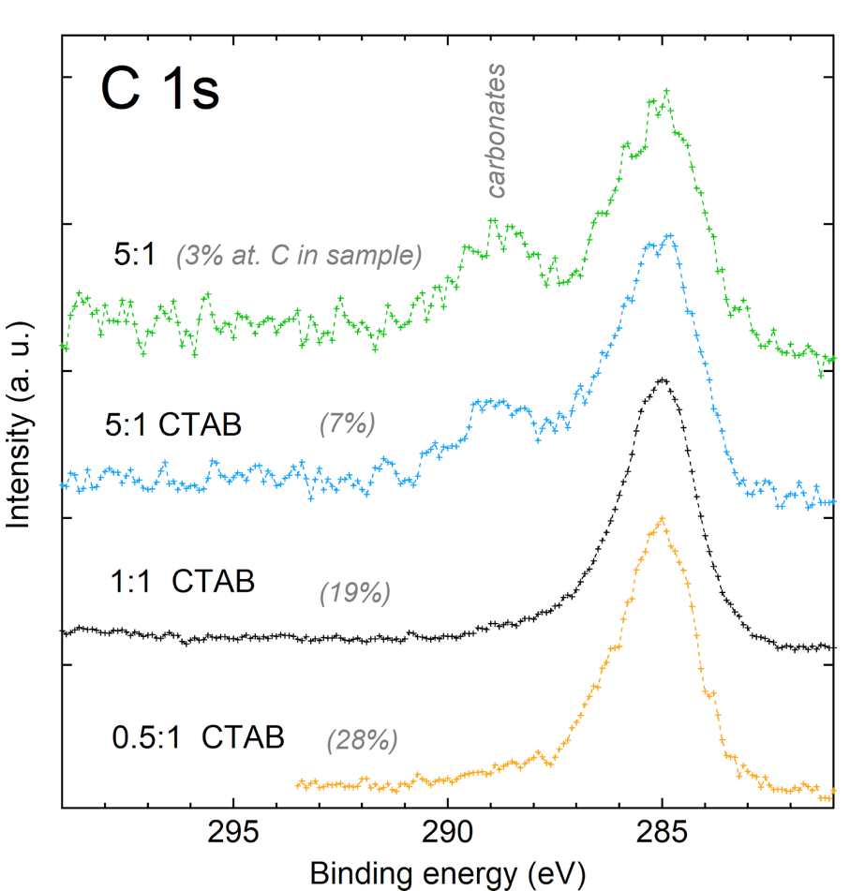

Fig. S3. The C 1s XPS shows that the carbonate component at ~288 eV binding energy^{1,2}, which amounts to ~20% of the overall (relatively low) adventitious carbon content for the 5:1 samples (the topmost two curves) does not grow in proportion with the overall detected carbon content in the other two samples (see Table ST1; it can be assumed to be mostly contaminant carbon at particle surfaces, within the XPS probe depth of a few nanometers) reassuring no bulk carbonate buildup even in the samples with larger C content (two bottom curves). The high binding energy shoulder at ~531.5 eV in the O 1s XPS (Fig. 4 in main article), particularly the more pronounced one for the 0.5:1 sample, still originates in hydroxyl species -- either at surface, as it is common for these (oxide) materials, or also in the bulk of the material, as suggested by the XRD results (for the 1:1 and 0.5:1 samples).
Remarks:
1) I n O 1s, the carbonate and hydroxyl features virtually coincide, i.e. are not distinguishable in the O 1s XPS. The absence of increase (with the overall C content) of carbonate compound here in C 1s XPS shows that the increasing O 1s shoulder comes from increase in hydroxyl density (at surface, or throughout the sample).
2) As the XPS is always preferentially probing the top surface, as the photoelectron escape probability, without undergoing inelastic scattering, is an exponentially decaying function of depth. Therefore, even C content as high as ~30%, as deduced from the XPS here, would correspond here to only a ~0.7 nm ³ top adsorbant layer of airborne hydrocarbons that stick to surface during sample transport to (ex situ) XPS measurements, and characterises plausibly rather the affinity of the surface to adsorb (hydro)carbon species, than sample synthesis.

References
1. Shi, S., Zhang, M., Deng, T., Wang, T., Yang. G.: A facile strategy to construct binder-free flexible carbonate composite anode at low temperature with high performances for lithium-ion batteries. Electrochim. Acta. 246, 1004-1015 (2017)
2. Zhang, Y. X., Jia, Y.: Fluoride adsorption on manganese carbonate: Ion-exchange based on the surface carbonate-like groups and hydroxyl groups. J. Colloid Interf. Sci. 510, 407-417 (2018)
3. Tanuma, S., Powell, C. J., Penn:Surf, D. R.: Calculations of electron inelastic mean free paths. V. Data for 14 organic compounds over the 50–2000 eV range. Interf. Anal. 21, 165 (1994)

