Supporting information

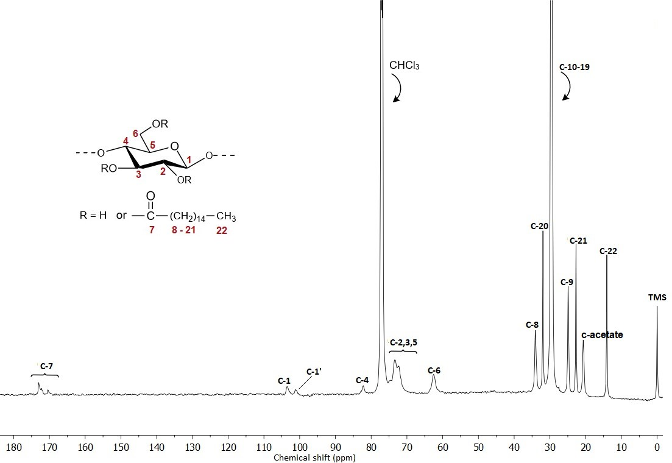
Figure S1. Full ¹³C NMR spectrum of CP-5 (DS= 2.3) in chloroform-d (125 MHz, 40°C).

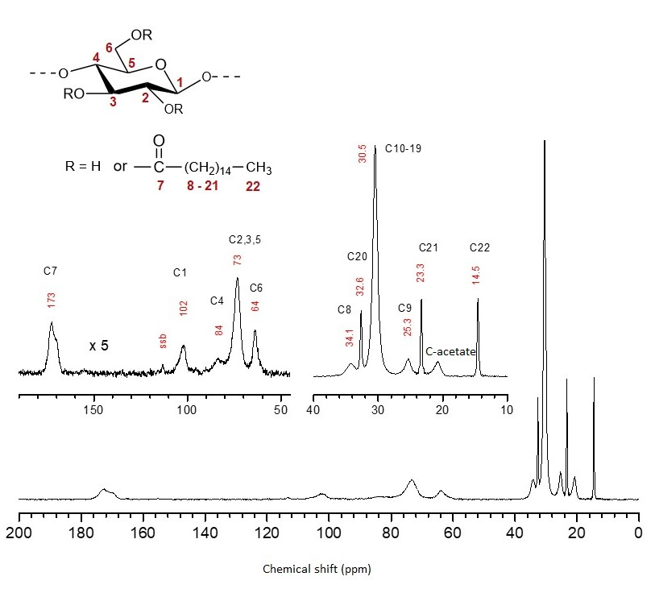
Figure S2. ¹³C MAS NMR spectrum of CP-5 ((DS= 2.3, 4000 scans, relaxation delay 30 s). The chemical shifts of the peaks are given in red.

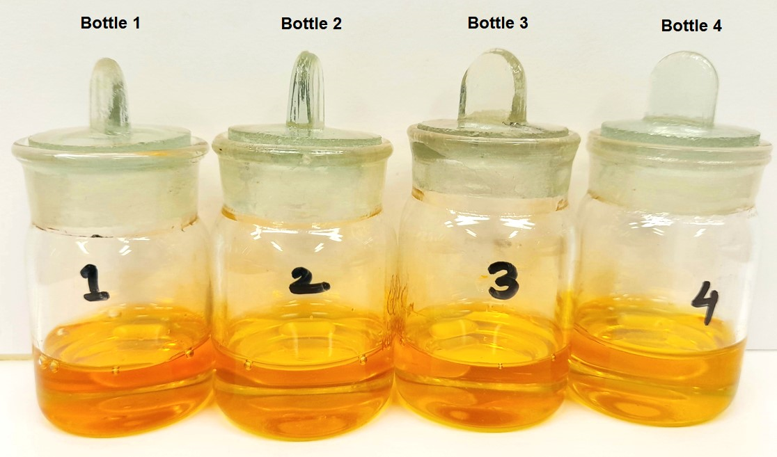

Figure S3. A comparative study of pure IL (Bottle 1) and IL+DMSO (Bottle 2) heated at 100°C for 5 hours with pure IL (Bottle 3) and IL+DMSO (Bottle 4) stored at RT.

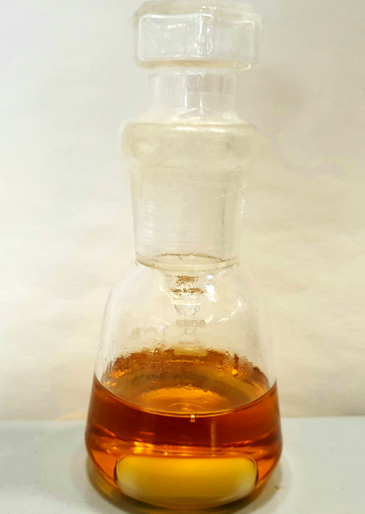

Figure S4. The mixture of cellulose and IL+DMSO after heating for 5 hours at 100°C under an inert atmosphere.

