Exploring dual solvatochromic traits in novel fluorescent benzanthrone ethynyl derivatives
Armands Maļeckis ª*, Marija Cvetinska ª, Evans Griškjāns ª and Elena Kirilova ^{b}
a Institute of Technology of Organic Chemistry, Faculty of Materials Science and Applied Chemistry, Riga Technical University, Riga, Latvia;
b Department of Applied Chemistry, Institute of Life Sciences and Technology, Daugavpils University, Daugavpils, Latvia
*Corresponding author. Institute of Technology of Organic Chemistry, Faculty of Materials Science and Applied Chemistry, Riga Technical University, P. Valdena Str. 3, LV-1048 Riga, Latvia. E-mail address: armands5maleckis@inbox.lv (A. Maļeckis).

Supplemental material

[M+H]⁺ calc | [M+H]⁺ found | Δ
349,1023 | 349,1031 | 0,0008
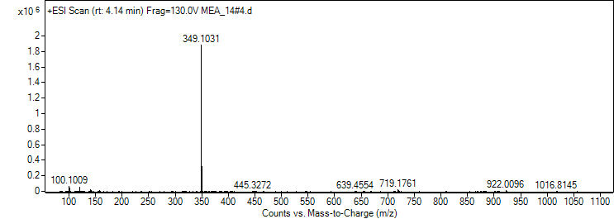
Figure S1. Compound 2a HRMS spectrum.

[M+H]⁺ calc | [M+H]⁺ found | Δ
327,1200 | 327,1185 | 0,0015
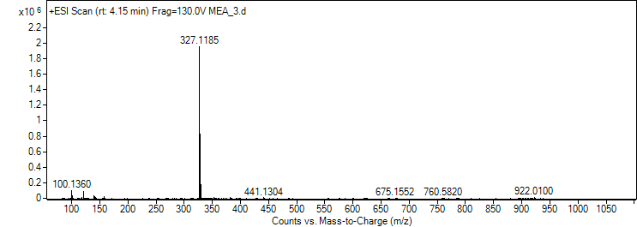
Figure S2. Compound 2b HRMS spectrum.

[M+H]⁺ calc | [M+H]⁺ found | Δ
359,1067 | 359,1065 | 0,0002
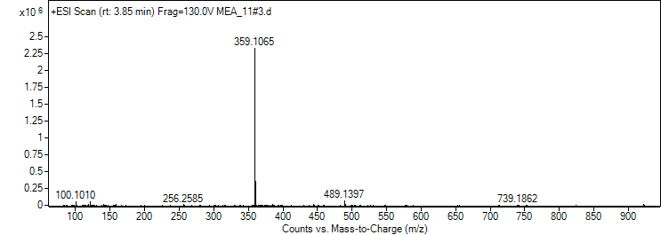
Figure S3. Compound 2c HRMS spectrum.

[M+H]⁺ calc | [M+H]⁺ found | Δ
361,1223 | 361,1209 | 0,0014
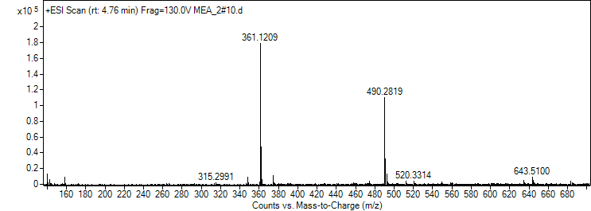
Figure S4. Compound 2d HRMS spectrum.

[M+H]⁺ calc | [M+H]⁺ found | Δ
347,1179 | 347,1180 | 0,0001

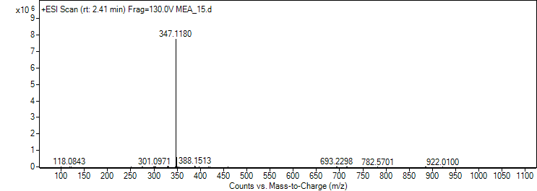
Figure S5. Compound 2e HRMS spectrum.

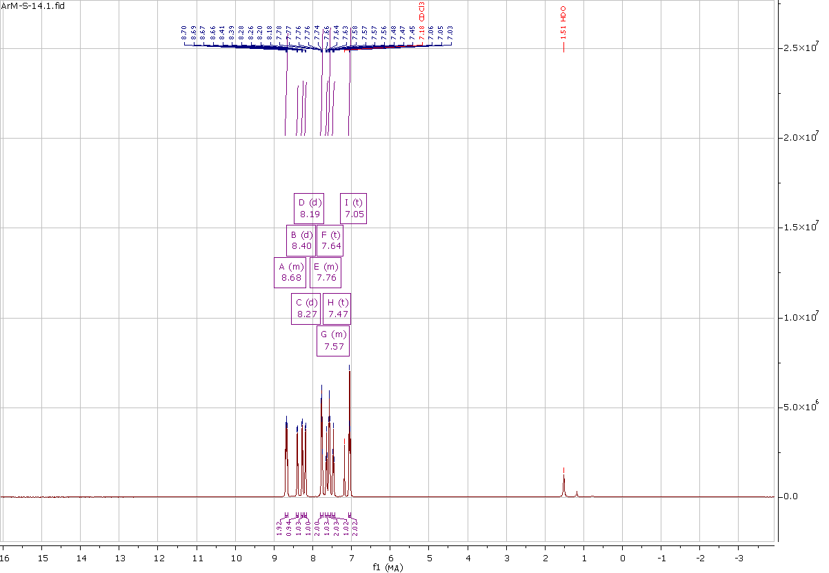
Figure S6. Compound 2a ¹H NMR (500 MHz, CDCl₃).
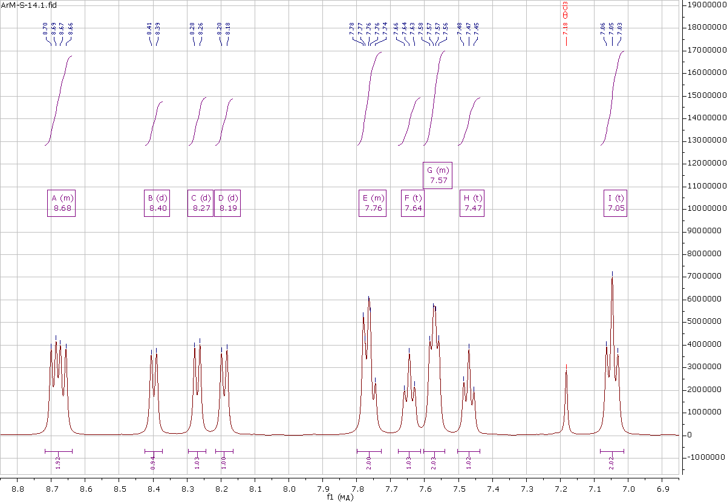
Figure S7. Compound 2a ¹H NMR aromatic region (500 MHz, CDCl₃).

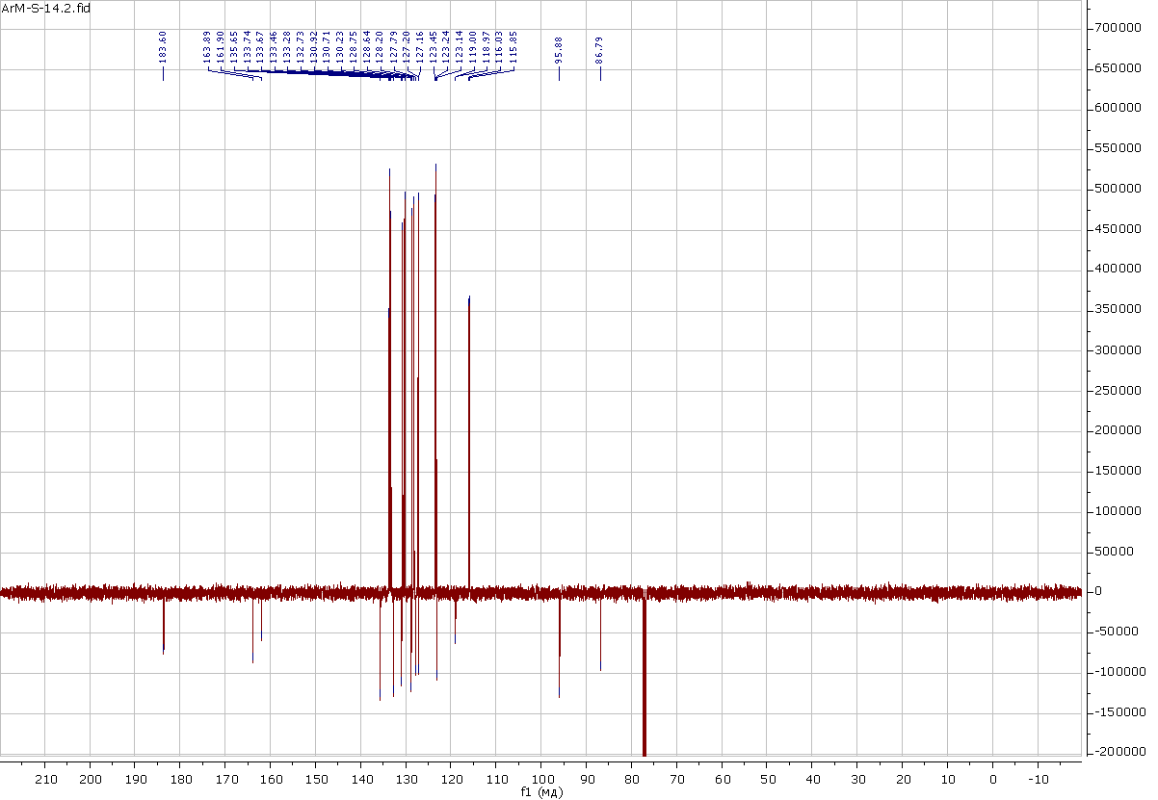
Figure S8. Compound 2a APT NMR (126 MHz, CDCl₃).
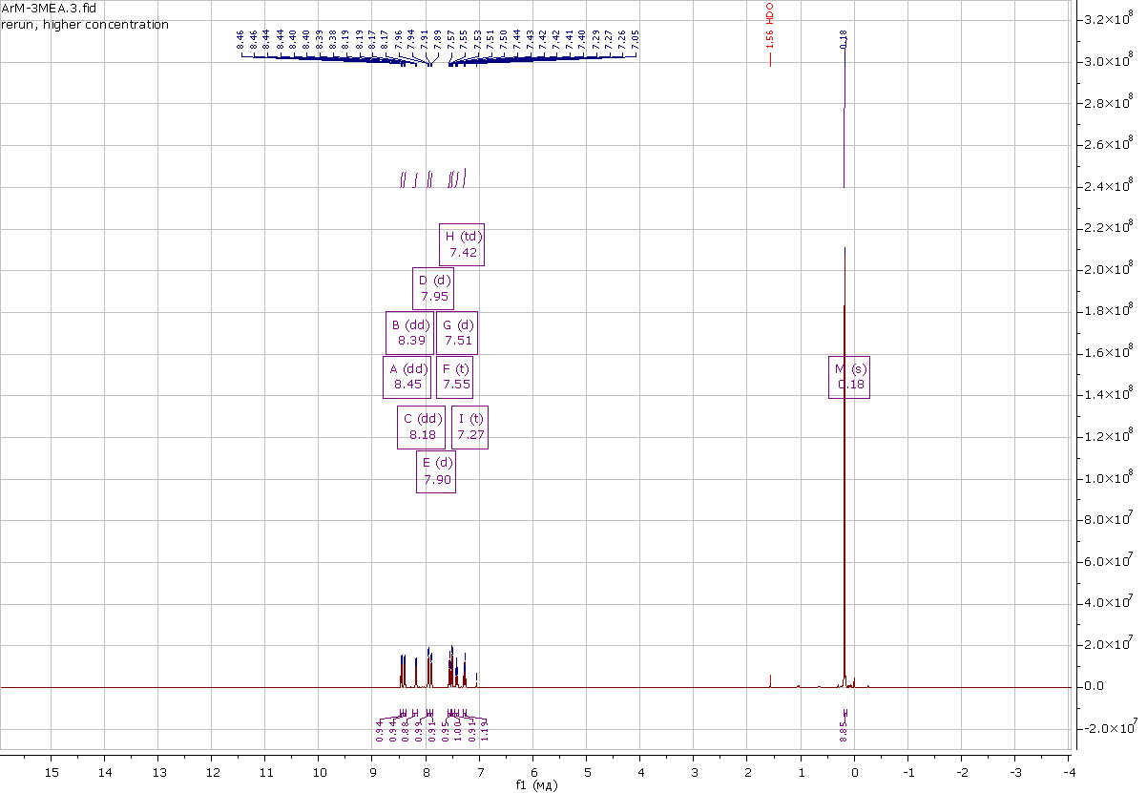
Figure S9. Compound 2b ¹H NMR (500 MHz, CDCl₃).
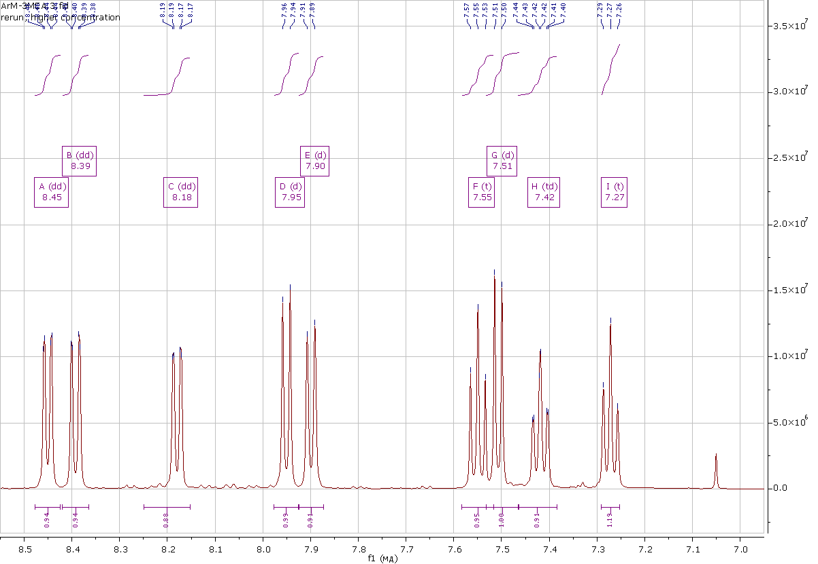
Figure S10. Compound 2b ¹H NMR aromatic region (500 MHz, CDCl₃).
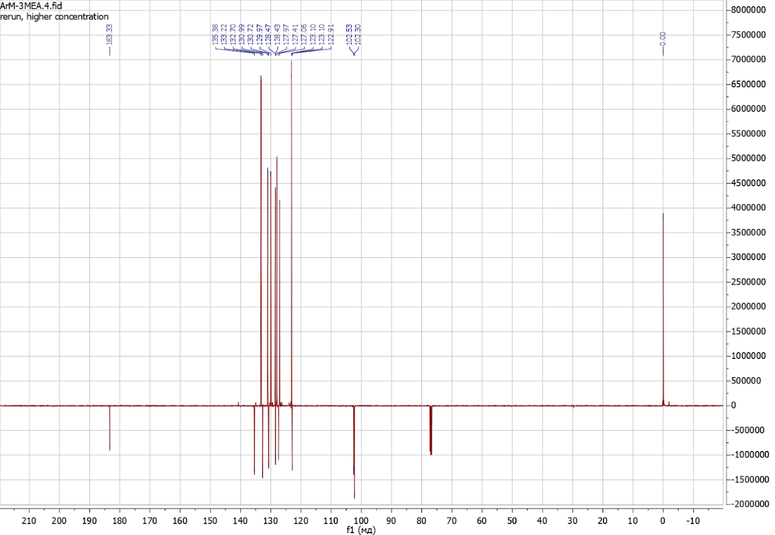
Figure S11. Compound 2b APT NMR (126 MHz, CDCl₃).

