Supplementary Materials

Surface Modification Strategies for Improved Cellulose Nanocrystal Integration in 3D-Printed Bio-Based Acrylate Matrix
Beate Beatrise Bruvere ª, Maksims Jurinovs ª, Oskars Platnieks ^{a,}*, Anda Barkane ª, Sergejs Gaidukovs ^{a,}*
¹Institute of Chemistry and Chemical Technology, Faculty of Natural Sciences and Technology, Riga Technical University, P. Valdena Str. 3, LV-1048, Riga, Latvia
* Corresponding authors: Oskars.Platnieks_1@rtu.lv, Sergejs.Gaidukovs@rtu.lv
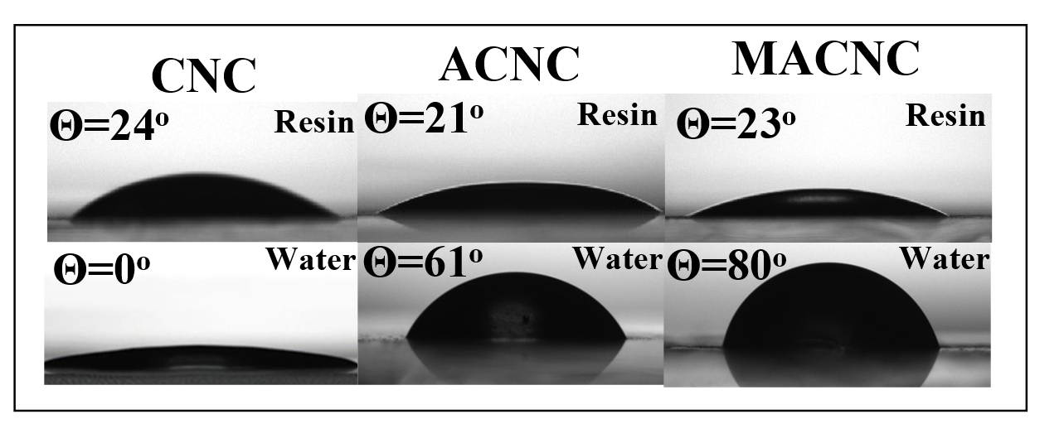
Fig. S1. Wetting angle of CNC, ACNC, and MACNC with a water and resin droplet.
Fig. S2. FTIR spectra of C=O group with dashed lined for theoretical spectra obtained with Lambert-Beer’s equation
Fig. S3. FTIR spectra of printed and resin samples.

