SUPPLEMENTARY DATA:

Thermogravimetric analysis

Sample: S10
Isotherm at 600 °C for 120 min
Heating rate 10 °C/min

Data is available in a .txt file under request.

Thermogravimetric analysis

Sample: virgin CF (dry fibers with universal sizing)
Isotherm at 600 °C for 120 min
Heating rate 10 °C/min

Data is available in a .txt file under request.

Raman Spectra
Excitation laser: 532 nm (green)

Sample: S07
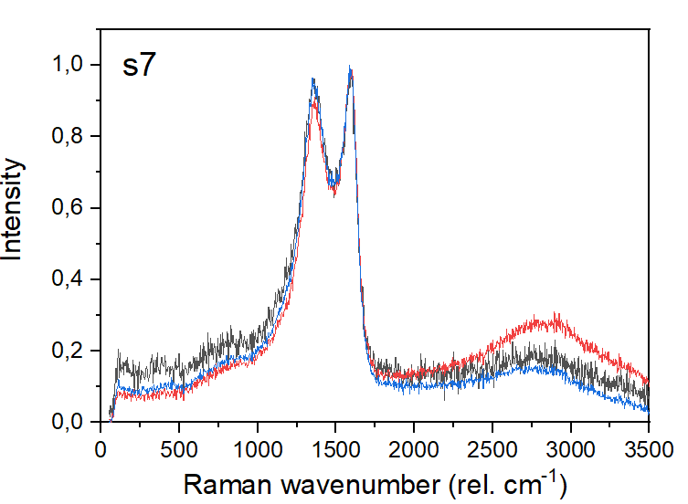

Sample: S10
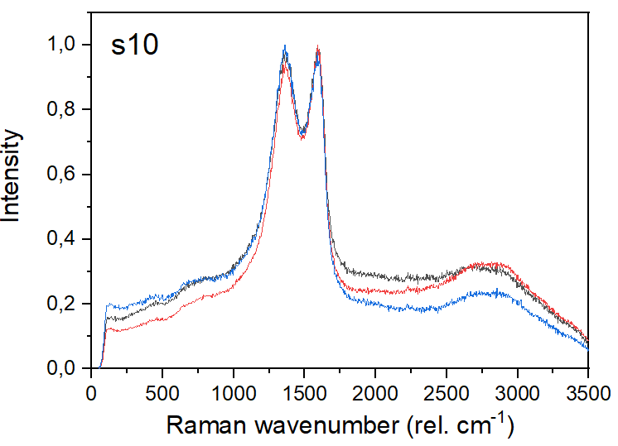

Sample: S11
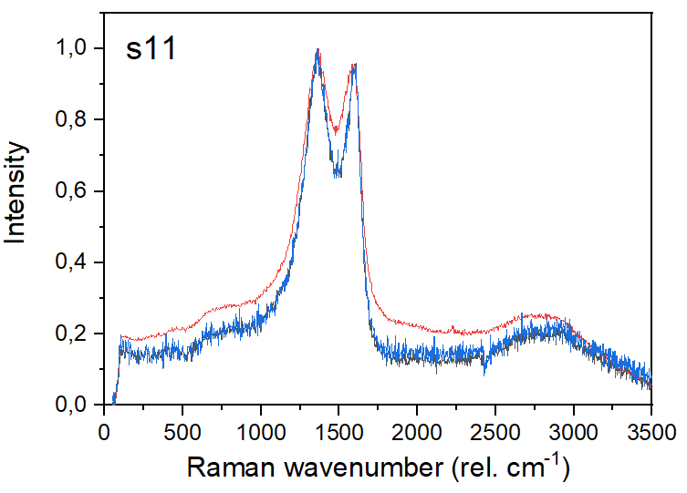
Sample: S14


