Condition monitoring for electromechanical relays in railway automation
Mareks Mezitis, Vladimirs Karevs
Riga Technical University (Riga, Latvia), Riga Technical University (Riga, Latvia)
marek@dzti.edu.lv, vladimirs.karevs@ldz.lv

Abstract - 21st century and relays are remain elements of automation systems. At the present stage of relay construction development and design you can use this automatic element without maintenance. However, the migration on new relays types is not always advisable. In some applications the issue of control of electromechanical relays is up-to-date. The issue is relevant also for renovation operation efficiency increasing.
Search words – relay, relay with first class of safety, impulse relay, anchor, electromechanical system, contact group, electrical life, impulses shortening, relay coil, kinetic energy of anchor, wear of hardening, inductance of rail coil, effect of anchor dynamic.

Introduction
On the current relay system of railway automation, as well as microprocessor-relay system automation imply two basic approaches to maintain. Approach dictated by the type of relay. The current trend involves using relays, which are replaced with new end-of-life – regardless of the state.
Both approaches are based on prediction of limit of device state. The probability of sudden failure increases in abnormal conditions. When using subsystems in line on the time of diagnosis or portable equipment, it is possible to use economically more profitable service as. It also lets you monitor normal state and a pre-failure one way to guard against sudden failure.
The methodology of subsystems is examined in many works, but relay parameters monitoring methodology is not accepted in this.

Perspective
The relays of first class of safety are one from basic elements for interlocking in relay centralization. Contacts systems are protected from direct welding; makeweight is guarantee for contacts off-state when impulse of power is removed from relay coil. The relays of first class of safety have guaranteed life time.
Likewise, for railway automatic specific task designed some special types of relays. One of these types – impulse relays. Feature is the use of constructive solutions applied for relays from first class of safety.
The important parameter for impulse relay is speed of operating.
The inertial properties of the relay lead to shortening of repeated impulse.
Shortening time:
${∆t{=t}_{on}-(t}_{power}-t_{on-state}^{delay}+t_{off-state}^{delay})$ Where:
$t_{on}$ – relay on time;
$t_{power}$ – time of power impulse;
$t_{on-state}^{delay}$ – time delay for on-state after start of power impulse;
$t_{off-state}^{delay}$ - time delay for of-state after end of power impulse.
System settings for stability that use impulse relays-repeaters, shortening is the normalized parameter:

$t_{on-state}^{delay}=const$ & $t_{off-state}^{delay}=const$.

Relay has electrical, time, mechanical parameters.
Relay parameters (fig.1), as electrical appliance define user settings, such as mechanical and electrical life. A number of mechanical and electrical operations, after which comes in ultimate state.

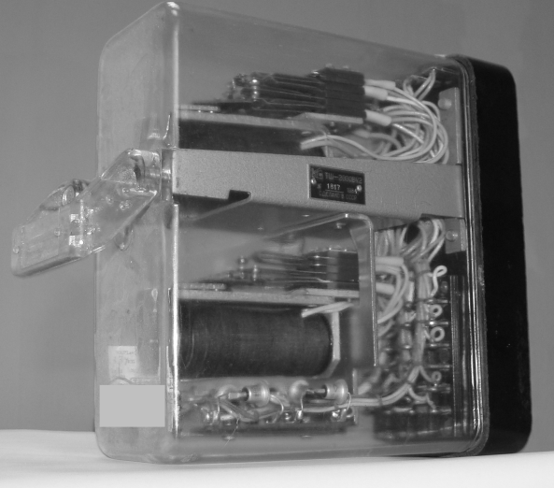

Photo 1. Relay-repeater ТШ

The greatest interest is real-time monitoring for relay electromechanical system. This is discussed in this article.
In [1] discusses methods and techniques for determining mechanical characteristics of relay.
Unlike [1] the authors suggest that the electromechanical relay useful information system is the normal state, rather than a numeric score. Technique [1] does not imply a determination of parameters of relay on existing equipment.
Impulse relays are most subjected to wear. This is special design type of relays, which does not apply to first class of safety. Of characteristics has a
guaranteed response time and release time. This type of relays commonly used for rail track coding circuits.
The state of relay determines sustainability options in rail track code circuits. At pulsing temp equal 2 Hz, ТШ-65 (see Photo 1) relay-repeater reaches limit by number of electrical closes 42.000.000 (2) through 243 days. In real relay-repeater don’t work with examined temp constantly.
ТШ-65 replaced for prophylactic repair once in one year. Since the wear is partial, the relay resource is reduced from now and then.

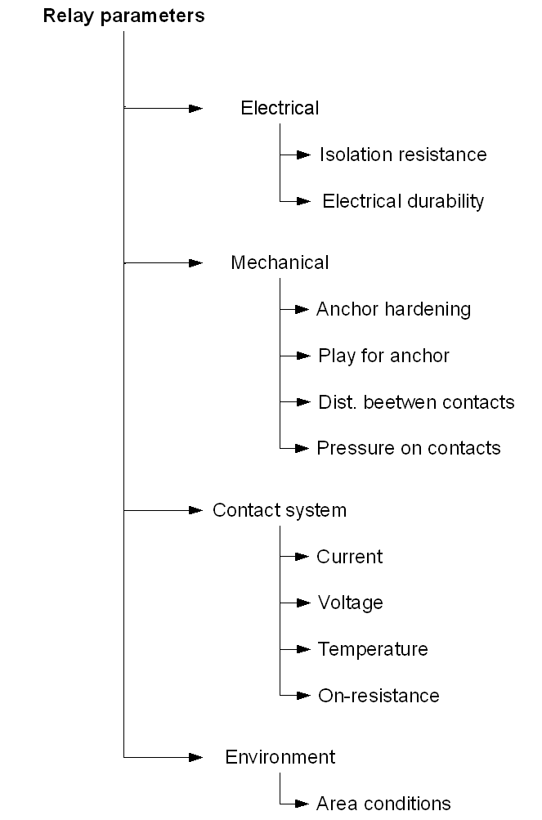

Figure 1. Parameters of relay

State of the contact system can be assessed visually. Evaluation of electromechanical system requires additional hardware.

Transitions in relay coil
Authors support and develop a methodology for monitoring in real time. In automatic system power circuit for relays has specific character (fig.2/a-b), i.e. relay coil can be powered by rectifier without filter elements (fig.2/b).

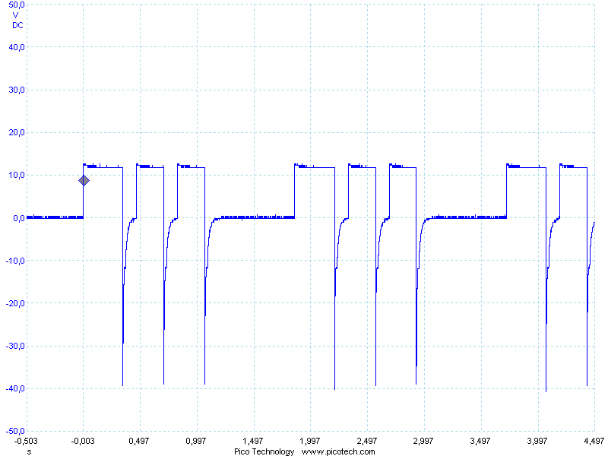

Figure 2/а. Relay coil powered from direct current source

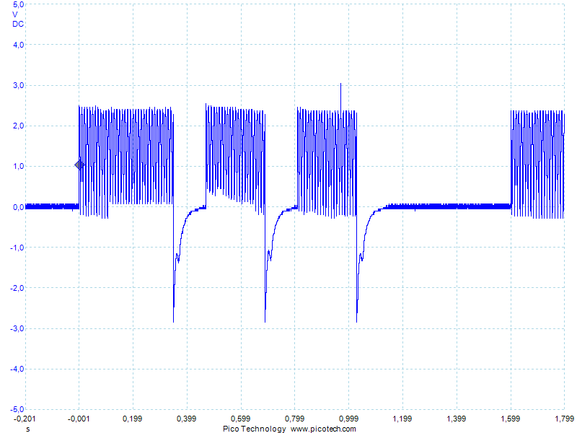

Figure 2/b. Relay coil powered from rectifier without filtering

Figure 3/a. Transition process in the relay coil on 1Om current sense

Fig. 3/a shows voltage form on current sense – current form in relay coil on powering impulse time:
t0 – time interval between start of powering impulse and anchor moving;
t1 – time interval between start of powering impulse and current level in coil 70% of nominal;
t2 – time interval between start of powering impulse and current level in coil 100% of nominal;
t3 – time interval between start and end of powering impulse.
Thus the most reliable evaluation can be determined after switching off powering impulse from relay windings on time interval t6 (fig. 3/b).
Reliability is also due to the fact that the pulse amplitude is set to 40 ÷ 60V and duration t6 > t2.
No additional current sensor requires for processing. It allows for identification of the state of electromechanical system in real time.
When a voltage impulse powers relay coil, current I in the winding grows smoothly during t2. In t0 moment attraction of relay anchor fixed to the core. This attraction makes changes on electromagnetic field.
The rising time t1 for current in relay coil according level on 70% from Inom. is a characteristic of inductances for coils, relays and state of relay mechanical system (figure 3/a).
After powering impulse, energy stored in inductance during time interval t4, causes impulse of voltage on relay winding. At the time t5 relay anchor release manifests in the changing of behavior of the recession.
The ohm-resistance for relay winding power circuit is evaluated during time interval t4:
$$R_{coil}={U_{nom.}}/{I_{nom.}}$$
Time point’s t5 & t0 are defined with state of the relay anchor.

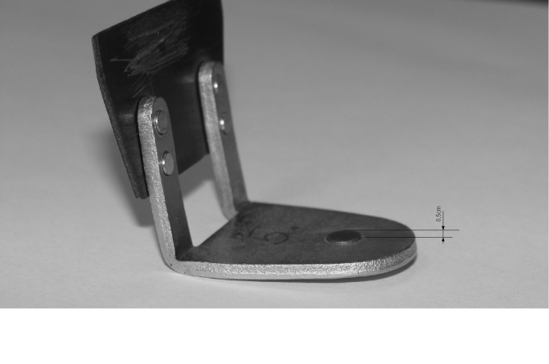

Photo 2. Work hardening on relay ТШ anchor

Anchor work hardening Δ [mm] defines an air gap between the anchor and cored relay (Photo 3.).

Statics
Proposed mathematical description is designated for a specifics aims of diagnosis or output control and can be used for determination of the characteristics of relays and rejection of anchors with worn out hardening.

Figure 3/b. The transition after powering impulse on relay winding

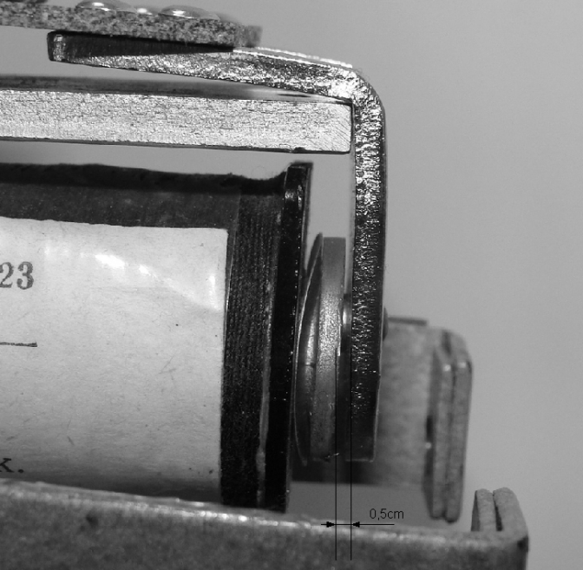

Photo 3. Air gap depended from hardening.

Viewing on electromechanical system allocates three interesting static state (fig.4):
$L^{1}=L_{coil}+L_{anchor on }(Δ)$ , where $L_{coil}$- core inductance; $L_{anchor on }\left(Δ\right)$ - inductance from anchor in on-position;
$L^{2}=L_{coil}+L_{anchor off}$ , where $L_{coil}$- inductance of relay coil; $L_{anchor off}$- inductance from anchor in the off-position;
$L^{3}=L_{coil}$ , where $L_{coil}$ - inductance in electromechanical system without anchor.
In a static schema difference $L^{1}(Δ){-L}^{2}$ is the distance between the core and anchor and depended from hardening. The difference can be calculated after measurements of inductances in on- and off-positions. Restriction on use of this method has a value of coil inductance on that can have a value larger than the upper limit of inductance meter.
Relative evaluation of hardening is available to change the inductance (fig.4), analyzing effects of presence of anchor.

Figure 4. Curves, type change for inductance in electromechanical system

Dynamics
Attraction of anchor causes a change in an electromagnetic field that is passed to the relay coil units of energy. Kinetic energy of magnetized anchor in dynamic is converted to a pulse in the relay coil (fig. 5). Pulse parameters defined with magnetization of anchors, with distance that anchor takes when changing states, with speed. Initial conditions are work hardening Δ [mm], pressure on plate Pr [gram], the intensity of the magnetic field.

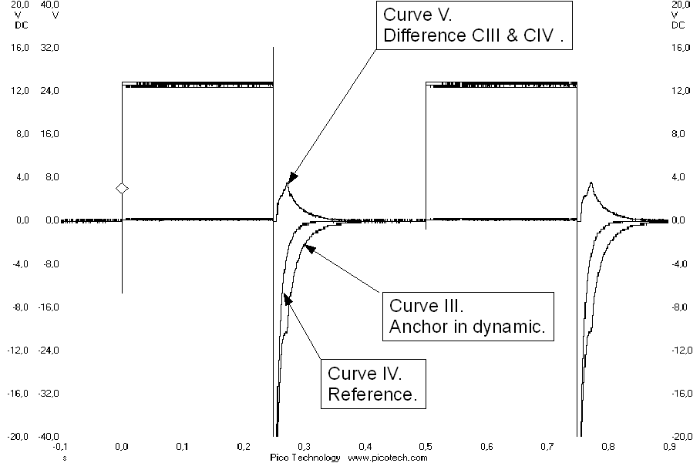

Figure 5. Anchor Δ [mm] = 0.62

Equivalent circuit relay with dynamic anchors (fig.6).

Figure 6. Equivalent circuit relay

$I_{coil}\left(t\right)= f(W,L,∆,Pr,R_{coil})$ , where
$W$ - energy stored in relay coil;
$L$ - relay coil inductance;
$∆$ - hardening height;
$Pr$ - pressure from contact groups on plate;
$R_{coil}$ - relay coil ohm-resistance.

Real-time state evaluating
In practice, wear scale for hardening measured by the change of maximum momentum for energy, caused by anchor in dynamic.
We offer for each type of relay experimentally obtained values for t5min t5max (fig.7), with maximum and minimum permissible height of hardening. On figure 7 time moment t5min corresponds to Δ [mm] = 0.62 and t5max corresponds Δ [mm] = 0.26. If the effect of anchor manifests itself within that time, the influence of anchor on relay is allowed.
Matching criteria:

$Anchor normal if {t_{5 min}<t}_{5 }< t_{5 max}$ .

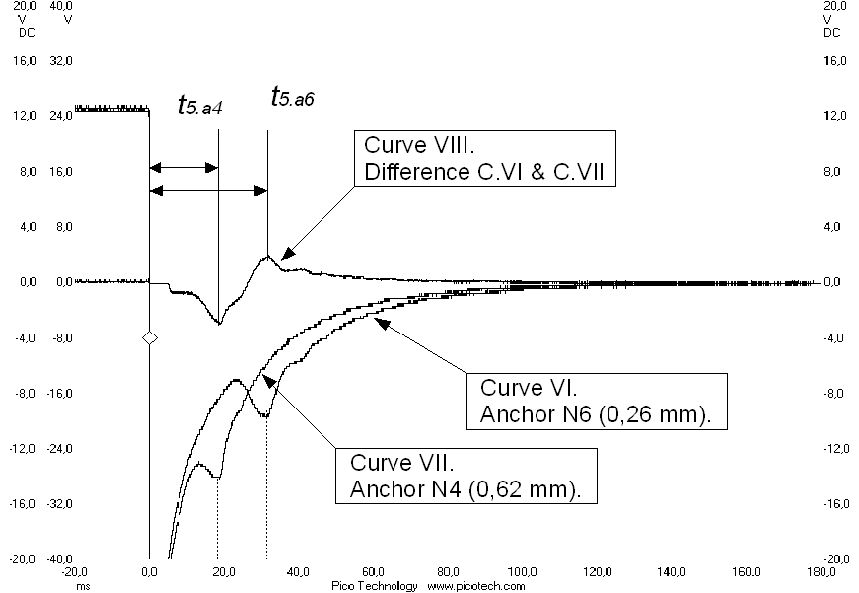

Figure 7. Real time evaluating of hardening influence

Figure 8. Block diagram

Testing for relays were pattern that is shown in figure 8.
Scheme is:
- G – pulse generator;
- Rel –relay for testing;
- Equal - equivalent inductance for electromechanical system of relay with fixed anchor;
- Amp – differential amplifier;
- Comp – comparator;
- MCU – micro processing unit.

The MCU handles signals from generator and comparator, calculates the time between signal from generator and peak of deferential signal.

The computed time increases with scale of wear increasing. When it reaches the maximum time then necessary the relay replacement. A valid value, of course, is with some reserve. This should make it possible to replace the relay until the wear and tear can affect work equipment in general.
In assessing the time used results collecting and average value.

Evaluating technology
Additional hardware device is in the form of hand-held or build-in equipment (fig.9).

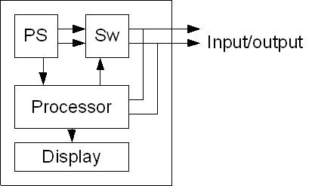

Figure 9. Tester for evaluating

Contains:
- PS - power source;
- SW - switch;
- Processor - processor;
- Display - display.

The staff uses information, about relay parameters validation on schedule provided by onboard equipment while taking decision about replacing the device.

Conclusion
Mathematical representation of the anchor dynamic effects is not straightforward. Analysis of effects allows control the time moment of changes for anchor state. Assessment of hardening impact analysis described just obtained. Reliability evaluation guarantees that the measurement duration is simply in technical realization. The play of anchor accelerates wear of hardening. Tracking rate of wear would appreciate play on electromechanical system. Use of health information about hardening diagnosis increases penetration deep of diagnostic subsystem in terms proposed in [3].

Literature
1.Патент РФ 2074439. СПОСОБ ИЗМЕРЕНИЯ МЕХАНИЧЕСКИХ ПЕРЕМЕЩЕНИЙ В ЭЛЕКТРОМАГНИТНЫХ РЕЛЕ.
2.Аппаратура железнодорожной автоматики и телемеханики. В.И.Сороко, Б.А.Разумовский М: Транспорт, 1981,-с:.
3. Numerical criteria for diagnostic subsystem. V.Karevs, M.Mezitis, RTU 51 ISC.

Biography
Vladimirs Karevs was born in 1970.
He is qualified as radio engineer at Riga Technical University in 1987. He is holder of a master’s degree in transport electronic and telematics at Riga Technical University since 2008. From 2008 up now studies RTU doctoral course. He works as principal engineer of metrology in Latvian railway communication and signaling division since 2011. He is professional in special electronic devices design area.

Mareks Mezitis was born in 1975. He is holder of a bachelor’s degree in transport electronic and telematics at Riga Technical University since 1996. He is qualified as engineer at Riga Technical University in 1998.He is holder of a master’s degree at Riga Technical University since 1999.He is doctor of science since 2003. He works as head of Railway automatic and telematics department in Railway institute in Riga Technical University since 2001.
He is avowed as expert in railway automatics.

