Precision Assessment of Surface Coating Roughness Height 3D Parameter St
Maris Kumermanis^{1,a}, Janis Rudzitis^{2,b}
^{1,2}Riga Technical University, Institute of Mechanical Engineering, Ezermalas Str. 6K - 414, Riga,
LV-1006, Latvia
ªmaris.kumermanis@rtu.lv, ^{b}arai@latnet.lv
Keywords: 3D surface roughness; theory of probability; total height of the surface; TiN coating measurements.
Abstract. One of the main surface coating quality indexes of details of mechatronic systems is surface roughness. And the surface roughness is described by surface roughness parameters. Nowadays characterization of surface roughness using three-dimension (3D) methods and parameters become more and more important. This type of surface quality characterization, unlike the two-dimension (2D) methods, provide a more complete view on the surface qualities, since the surface roughness is viewed as a spatial object. Within the last ten years intensive work is being carried out on the development of 3D roughness standards, therefore it is necessary to agree on a unified approach in the assessment of surface roughness 3D parameters. To make possible application of the ISO/DIS 25178 standard being developed one needs information on the determination of 3D surface roughness parameter precision, such as number of measurements, dimensions of measurement areas and their disposition on the measured surface.
The present work provides the surface roughness assessment principles when measuring the 3D roughness of coated surfaces by means of contact-type measurement devices, based on the regularities of the theory of probability [1]. The work considers one of the basic parameters of roughness – total height of the surface St. This parameter determines the beginning of contact process. The work determines the number of measurement areas at the chosen probability of parameter precision and credibility. The result is compared with a two-dimension surface model. The experimental testing was carried out on surface coatings obtained by the help of nanotechnologies – at present very important coatings in the machine and apparatuses engineering.
Experimental surface roughness measurements for steel surfaces having TiN coating were carried out to verify the previously mentioned theoretical coherences. Parameters St and Rt (maximum height of profile) were measured and their mean values were calculated for different sizes of measurement areas and profile traces. In case of St the measurement areas have the side lengths (L×L) 2, 3 and 4 cut-off lengths, in case of Rt the measurement traces L consisting of 2 to 8 cut-off lengths. 5 separate measurements were made on each surface. The measurement results were processed using mathematical statistical method.
The research has resulted in the proposals for the parameter St measurement regulations.
Surface roughness 3D model
Researches of surface roughness 3D parameters are connected with surface 3D model. Previous researches [1, 4, 5] show that irregular type surface roughness can be described by a normal two-dimension random field h(x,y). The input parameters of this field form the following group:
- one height parameter (Sa – mean arithmetic deviation);
- step parameters in two mutually perpendicular directions (Sm₁ and Sm₂).
On the basis of this model one can determine probabilistic characteristics of total height of surface St: the expected mean value M and dispersion D.
Let’s mark with
${\text{h}}_{\text{1}}\text{=h}\left(\text{x}\text{,}\text{y}\right)$ (1)
the normal random field and with ${\text{h}}_{\text{1}}\text{,}{\text{h}}_{\text{2}}\text{,…, }{\text{h}}_{\text{6}}$ - its derivatives:
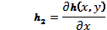${\text{h}}_{\text{2}}\text{=}\frac{\text{∂h}\left(\text{x}\text{,}\text{y}\right)}{\text{∂x}}$; ${\text{h}}_{\text{3}}\text{=}\frac{\text{∂h}\left(\text{x}\text{,}\text{y}\right)}{\text{∂y}}\text{; }{\text{h}}_{\text{4}}\text{=}\frac{{\text{∂}}^{\text{2}}\text{h}\left(\text{x}\text{,}\text{y}\right)}{\text{∂}{\text{x}}^{\text{2}}}\text{; }{\text{h}}_{\text{5}}\text{=}\frac{{\text{∂}}^{\text{2}}\text{h}\left(\text{x}\text{,}\text{y}\right)}{\text{∂x∂y}}$; ${\text{h}}_{\text{6}}\text{=}\frac{{\text{∂}}^{\text{2}}\text{h}\left(\text{x}\text{,}\text{y}\right)}{\text{∂}{\text{y}}^{\text{2}}}.$ (2)
Since the normal random field derivatives constitute the normal random field their joint distributions ${\text{h}}_{\text{1}}\text{,}{\text{h}}_{\text{2}}\text{,…, }{\text{h}}_{\text{6}}$ can be examined on the basis of a multidimensional distribution.
The multidimensional density of these random values has the following form:
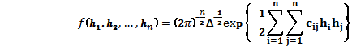$\text{ f}\left({\text{h}}_{\text{1}}\text{,}{\text{h}}_{\text{2}}\text{,…, }{\text{h}}_{\text{n}}\right)\text{=}{\left(\text{2π}\right)}^{\text{-}\frac{\text{n}}{\text{2}}}{\text{Δ}}^{\text{-}\frac{\text{1}}{\text{2}}}\text{exp}\left\{\text{-}\frac{\text{1}}{\text{2}}\sum_{\text{i=1}}^{\text{n}}{\sum_{\text{j=1}}^{\text{n}}{{\text{c}}_{\text{ij}}{\text{h}}_{\text{i}}{\text{h}}_{\text{j}}}}\right\}$ , (3)
where 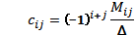${\text{c}}_{\text{ij}}\text{=}{\left(\text{-1}\right)}^{\text{i+j}}\frac{{\text{M}}_{\text{ij}}}{\text{Δ}}$;
${\text{M}}_{\text{ij}}$ – minor determinant $Δ$ ;
$\text{ Δ}$ – determinant of random value correlation matrix.
The correlation matrix has the following form:
$\left|\begin{matrix}{\text{k}}_{\text{11}} & {\text{k}}_{\text{12}} & \text{…} & {\text{k}}_{\text{1n}} \\ & {\text{k}}_{\text{22}} & \text{…} & {\text{k}}_{\text{2n}} \\ & & \text{…} & {\text{k}}_{\text{nn}}\end{matrix}\right|$ (4)
where ${\text{k}}_{\text{ij}}$ - the corresponding correlation moments of variables (Eq. 1) and (Eq. 2).
Characteristics of parameter St probability
When investigating two surface contact processes – contact areas, approximation values, etc., one needs to know the maximum roughness height, because it determines the beginning of contact.
In case of a homogeneous random field the parameter St distribution law has the following form [2]:
$\underset{\text{Ω→∞}}{\text{lim}}{\text{P}\left\{{\text{ξ}}_{\text{max}}\text{≤}{\text{B}}_{\text{Ω}}\text{+Z}{\text{A}}_{\text{Ω}}\right\}\text{=}\text{exp}\left(\text{-}{\text{e}}^{\text{-Z}}\right)}$, (5)
where $\text{Ω}$ – research area on a plane;
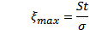${\text{ξ}}_{\text{max}}\text{=}\frac{\text{St}}{\text{σ}}$ – normalized height against standard deviation;
$\text{Z}$ – random value: $\text{ Z≈}\left({\text{ξ}}_{\text{max}}\text{-}\sqrt{\text{2lnt}}\right)\sqrt{\text{2lnt}}$; (6)
$\text{ t}$ – non-dimensional quantity of research area $\text{ Ω}$ ;
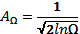${\text{A}}_{\text{Ω}}\text{=}\frac{\text{1}}{\sqrt{\text{2lnΩ}}}$; ${\text{B}}_{\text{Ω}}\text{≈}\sqrt{\text{2lnΩ}}$. (7)

Expected mean value
According to (5) the function of parameter Z distribution probability:
$\text{ F}\left(\text{Z}\right)\text{=}\text{exp}\text{⁡}\text{(-}{\text{e}}^{\text{-Z}}\text{)}$,
and the density of probability distribution:
$\text{ f}\left(\text{Z}\right)\text{=}{\text{F}}^{\text{'}}\left(\text{Z}\right)\text{=}\text{exp}\left(\text{-Z}\right)\text{exp}\text{(-}{\text{e}}^{\text{-Z}}\text{)}$. (8)
So the expected mean value for parameter Z is:
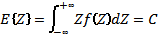$\text{ E}\left\{\text{Z}\right\}\text{=}\int_{\text{-∞}}^{\text{+∞}}{\text{Zf}\left(\text{Z}\right)\text{dZ=C}}$, (9)
where C = 0,577 – Eiler’s constant.
According to (6)
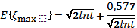$\text{ E}\left\{{\text{ξ}}_{\text{max}}\right\}\text{=}\sqrt{\text{2lnt}}\text{+}\frac{\text{0,577}}{\sqrt{\text{2lnt}}}$ (10)
The research field Ω should be determined by non-dimensional values. It might be:
$\text{ Ω=}{\text{N}}_{\text{1}}{\text{N}}_{\text{2}}$, (11)
where ${\text{N}}_{\text{1}}\text{,}{\text{N}}_{\text{2}}$ - number of zeros on two, mutually perpendicular directions x, y of the surface.
Assuming that the surface anisotropy coefficient is 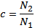$\text{ c=}{\text{N}}_{\text{2}}\text{/}{\text{N}}_{\text{1}}$ we get:
$\text{ Ω=}{\text{N}}_{\text{1}}^{\text{2}}\text{c.}$ (12)
Putting Eq. 12 in the Eq. 10
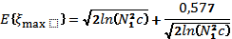$\text{ E}\left\{{\text{ξ}}_{\text{max}}\right\}\text{=}\sqrt{\text{2ln}\left({\text{N}}_{\text{1}}^{\text{2}}\text{c}\right)}\text{+}\frac{\text{0,577}}{\sqrt{\text{2ln}\left({\text{N}}_{\text{1}}^{\text{2}}\text{c}\right)}}$ (13)
Analyses of the Eq. 13 shows that over $N_{1}≥100$, which is frequently met in abrasively processed and coated surfaces the influence of the second member does not exceed 7%, thus:
$\text{ E}\left\{{\text{ξ}}_{\text{max}}\right\}\text{≈}\sqrt{\text{2ln}\left({\text{N}}_{\text{1}}^{\text{2}}\text{c}\right)}$ (14)
So considering normalization:
$\text{ E}\left\{{\text{S}}_{\text{t}}\right\}\text{≈σ}\sqrt{\text{2ln}\left({\text{N}}_{\text{1}}^{\text{2}}\text{c}\right)}$. (15)
To compare $\text{ E}\left\{{\text{S}}_{\text{t}}\right\}$ with the corresponding rough surface profile parameter let’s examine an isotropic surface case, when $\text{ c=1}$.
The curves given on Fig. 1 show the average absolute maximums of surface (a) and its profile (b). We see that the total height of profile$\text{Rt}$, which is set on the determined length, is $\sqrt{\text{2}}$ times smaller than the total height of surface$\text{St}$, which is set on a square area where side lengths are equal to the trace length of the corresponding profile of the same surface. This can be explained by a small probability that the surface cut will cross the real surface maximum.

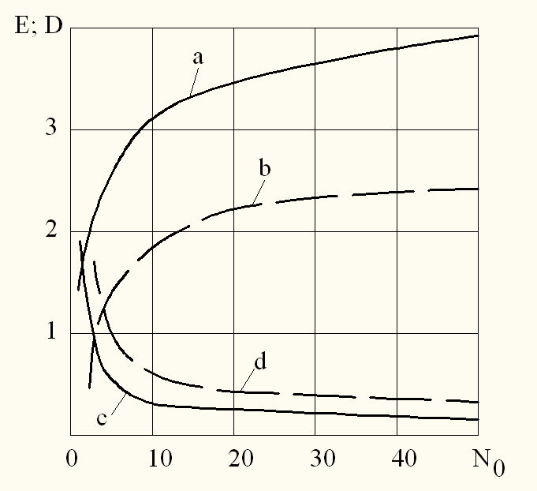
Figure 1. The expected mean value and dispersion of the roughness total height
( ____surface St, _ _ _ _ profile Rt [3])

Dispersion
The dispersion of irregular roughness profile parameter Rt can be determined as follows [2]:
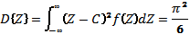$\text{ D}\left\{\text{Z}\right\}\text{=}\int_{\text{-∞}}^{\text{∞}}{{\left(\text{Z-C}\right)}^{\text{2}}\text{f}\left(\text{Z}\right)\text{dZ}\text{=}\frac{{\text{π}}^{\text{2}}}{\text{6}}}$, (16)
where C – normalising multiplier.
Based on the Eq. 6, and considering the Eq. 16 we get:
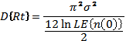$\text{ D}\left\{\text{Rt}\right\}\text{=}\frac{{\text{π}}^{\text{2}}{\text{σ}}^{\text{2}}}{\text{12ln}\frac{\text{LE}\left\{\text{n}\left(\text{0}\right)\right\}}{\text{2}}}$ (17)
We find the absolute maximum dispersion of irregular roughness surface:
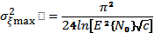${\text{ σ}}_{\text{ξmax}}^{\text{2}}\text{=}\frac{{\text{π}}^{\text{2}}}{\text{24ln}\left[{\text{E}}^{\text{2}}\left\{{\text{N}}_{\text{0}}\right\}\sqrt{\text{c}}\right]}$ (18)
And for isotropic roughness:
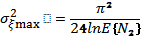${\text{ σ}}_{\text{ξmax}}^{\text{2}}\text{=}\frac{{\text{π}}^{\text{2}}}{\text{24lnE}\left\{{\text{N}}_{\text{2}}\right\}}$ (19)
Considering normalization:
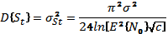$\text{ D}\left\{{\text{S}}_{\text{t}}\right\}{\text{=σ}}_{\text{St}}^{\text{2}}\text{=}\frac{{\text{π}}^{\text{2}}{\text{σ}}^{\text{2}}}{\text{24ln}\left[{\text{E}}^{\text{2}}\left\{{\text{N}}_{\text{0}}\right\}\sqrt{\text{c}}\right]}$ (20)

The dispersion of total height of surface St also is smaller that for profile Rt. This can be explained by the high informative content of the square measurement area, when comparing to the trace. Figure 1 gives a graphical comparison of dispersion of parameters Rt and St.
Conclusions
As a result of the performed researches of surface roughness parameters St and Rt we can conclude that parameter St has a bigger expected mean value and smaller dispersion as compared with the profile parameter Rt. It means that measurements of surface roughness 3D parameters provide information, which is closer to the real surface roughness as compared to the profile measurements. Thus also in tribological calculations preference should be given to the initial data, which are obtained in 3D measurements, because when using profile parameters the probability that the profile will cross the real surface peaks is much smaller.
Acknowledgments
This work has been supported by the ESF within the project 2010/0299/2DP/2.1.1.2.0/10/APIA/VIAA/135 “Development of industrial technology prototype for multi-component nanostructured ion-plasma wear-resistant coatings”.
www.fivesgroup.com
References
1. Kumermanis M., Rudzitis J. Microtopography model of rough surface. Solid State Phenomena Vols. 147-149. – Trans Tech Publications, Switzerland, 2009 – pp. 686-689.
2. Piterbart V.I. Asimtoticeskaja puassonovost cisla bisokix vibrasov i raspregelenije maksimuma gaussovskogo odnorodnogo pola. Vibrosi slucainih polei. Nr.29. Moscow: MGU, 1972, pp. 90-118.
3. Rudzitis J. Kontaktnaja mehanika poverhnostej, 1-aja cast (in Russian). – RTU, Riga, 2007, 193. pp.
4. Rudzitis J. Kontaktnaja mehanika poverhnostej, 2-aja cast (in Russian). – RTU, Riga, 2007, 193. pp.
5. Naijak P.R. Primenenije modeli slucainogo polja dlja issledovanija serohovatih poverhnostei. Problemi trenija i smazki. N.3., 1971 – pp. 85-95.

