Study of Generator Modes Effects on Electric Power Quality and Air Gap

Rihards Elmanis-Helmanis, *Riga Technical university;* Marina Griscenko, *Riga Technical university*

*Abstract –* The study examines hydroelectric power generator characteristics, voltage quality, air gap and vibration, in different operational modes – no-load mode, 90, 45, 10 MW load, 90 MW load with -50 MVAr to 20 MVAr reactive power and synchronous compensator mode with 0 MW- 20 MW active power and synchronous compensator mode with -10 MVAr to -60 MVAr reactive power.

Developed framework for power quality and air gap measurements assessment of hydropower generator shows that correlation exists between voltage, air gap and vibration characteristics. Analysis and comparison of different operational modes are performed to identify, which modes are important during diagnostics of machine condition in hydroelectric generators.

*Keywords* – Air gap, hydroelectric power generation, power quality, vibrations.

# Introduction

The evaluation of technical characteristics of energy generation equipment and power quality is determined by set of standards and legal requirements. Nevertheless, intentions to discover possible reasons for power quality distortion and eccentricity faults regardless of standard limits are important to ensure continuous and reliable operation for hydro power units. Moreover, increased use of automated control for hydro power plants requires solving new problems of the increasing nonlinear loads form new technologies.

This study combines vibration measurements with electromagnetic force measurements, power quality measurements and air gap measurements of hydro power generation units.

The main objective of the study was to evaluate, which of the listed measurements should be used in the future to improve existing control and diagnostics procedure of hydroelectric power generator.

The second objective of the study was to determine the required scope of reconstruction and balancing for the inspected unit. This would be possible after analysis of rotor eccentricity type, which is obtained from air gap diagram and evaluation of vibration spectrum frequency components.

Hypothesis of the study states that generator work characteristics like power quality, air gap and vibration are highly reliant on different operation modes.

Previous study on power quality [1] already showed that some distortion of voltage curve could be observed in no-load mode. Consequently, the extended research was required to identify whether distortion occurs in other modes used more frequently for generator operation.

Therefore, to evaluate both centrifugal and electromagnetic forces effects on the air gap and rotor form, the measurements were performed in different no-load and loaded work conditions (modes).

Experiment revealed that correlation between mechanical and electrical characteristics, like electromagnetic force (EMF) exists. Both fundamental and contemporary studies support the given statement. In 1998 Gruwell, David R., and Fouad Y. Zeidan discussed interdependence of vibration and eccentricity measurements [2], while Tiirats T., Pabut O. et.al. in 2014 showed, that mechanical vibrations of generators could be caused by eccentricity in a slow-speed machines [3].

The correlation between measured electromagnetic force, rotor air gap and vibration was observed as well for the particular hydro power generator unit [1].

Three minutes long measurements were taken at no-load mode with excitation of 13,8 kV and nominal rotational speed, measurements with 90 MW active power mode with and without reactive power and Synchronous Compensation (SK) mode with different reactive power. The list of all modes used during the study are presented in Table I and Table V.

# materials and methods

To meet the objective of the study the set of measurements were performed on hydropower generating unit with the power analyzer for three-phase electrical networks, laser tachometer kit, vibration measurement equipment from different manufacturers.

The voltage quality, electromagnetic force (EMF), vibration and rotor air gap were measured on hydro power generation unit with nominal power of 90 MW and nominal rotating speed 88,24 rotations per minute (RPM). The generator of the unit had 68 poles, the stator had 72 poles, 7 slots on each pole, therefore each phase of 3-phase component sine wave contributed to 168 anchor windings.

The used air gap measuring system, or air gap sensors LS 120 from Meggitt for large hydro generators measures the air gap between rotor and stator, using the capacitive technology.

Tachometer kit was used to identify vibration and air gap values for one RPM and each rotor pole.

The voltage characteristics were analyzed based on every generator pole with equipment from Chauvin Arnoux group.

Vibrations were analyzed using SKF equipment and National Instruments data acquisition equipment.

Acquired data was processed through LabVIEW, MatLAB and Microsoft Office Excel tools [4].

The technique of obtaining Delta values of air gap for rotor was discussed in the previous study on power quality, and was based on measuring maximum value of measured air gap and average value of all air gap measurements [1]. Delta values are compared and plotted to illustrate air gap of the rotor. For each rotor pole delta value is expressed in millimeters. For evaluation of eccentricity (Table I) delta value is expressed as percentage.

To analyze air gap, EMF and vibration root mean square (RMS) value, data for 8 rotations were acquired and exported, since data, obtained for one rotation only does not represent correct mean value of the experiment. After obtaining 17 rotations in a row, the statistical equation (1) was used to find optimal sample size to estimate a mean.

$n={(\frac{z_{α/2}σ}{B})}^{2}$, (1)

where *n* represents optimal sample size to estimate a mean, $z_{α/2}$- confidence interval, equal to 95%, $σ$- Standard deviation from 17 rotations, *B* - the error bound on the estimate.

The optimal sample size for no-load mode was found to be 6. The optimal sample size for majority of measurement loads, including SK 0MVAr, SK -50MVAr and 90MW modes was found to be 8.

Since in each mode measurement time was approximately 3 minutes, data of 8 rotations was exported from 15th-21st seconds of 2nd minute. There was also some discrepancy of EMF values during several rotations, therefore mean value of EMF from 8 rotations was used in the study.

The following equations illustrated instant phase loads in the three-phase electrical system with load, which contains no distortion:

$\begin{matrix}u_{a}=U_{n}sin⁡(ω_{n}t+φ_{1n}) \\ u_{b}=U_{n}sin⁡(ω_{n}t+φ_{2n}) \\ u_{c}=U_{n}sin⁡(ω_{n}t+φ_{3n})\end{matrix}$ (2)

where uа, ub, uc are instant phase loads in the system, $U_{n}$ is nominal value of phase load amplitude, n is nominal value of angular frequency, $φ$- phase angle between the current and voltage .

Loads in equation (2) have sine wave form, stable amplitude and are all symmetric [5]. In practice, real instant phase loads will have discrepancies from the perfect sine wave, therefore the equation $U\left(t\right)=U_{n}$ would not be true and equation (3) would be used for calculation instead.

$∆U\left(t\right)=U\left(t\right)-U_{n}$                               (3)

After some testing modes it was possible to evaluate, how critical the $U\left(t\right)$ or $∆U\left(t\right)$ values were. For better precision the magnitude of 3rd order harmonic rather than the total harmonic distortion was evaluated in this study.

The power quality measurements were performed both on generator side and network side.

The maximum distortion of the voltage on generator side for the third harmonic ( ${∆U}_{max}$) was found to be 0,7 kV. At the same time no similar defect was observed on network side. The distortion appeared only during no-load mode, in which power generation unit is not operated on everyday basis.

# results and discussion

From the data obtained it is possible to analyze voltage waveform, rotor air gap and rotor eccentricity. Some non-symmetry of rotor poles form was discovered.

Analysis of rotor air gap has its limitations. It did not reveal the true cause of voltage curve distortion, because it does not describe stator pole faults, therefore stator should be examined separately. Figure 4 illustrates the air gap and EMF on rotor poles with 90 MW active power.

Total eccentricity is evaluated, based on results, provided in Table I.

According to the standard [6], eccentricity below 3% is considered to be acceptable, and above 8% - unacceptable. The eccentricity, measured in this study exceeds optimum limit, and requires some corrections.

Table I shows that the greatest value of Delta is registered during modes with reactive power. Figure 3 illustrates the maximum values of Delta on each rotor pole in mode with reactive power. Peak value on 42nd rotor pole in SK mode with -20 MVAr reactive power helps to identify the place for possible corrections. Therefore this study suggests extending the framework for air gap measurement, provided in the standard [6]. In addition to measurements in no-load mode and start-up load it is suggested to measure air-gap in SK mode with -20 MVAr or -30MVAr reactive power and mode with 90 MW active power and -30MVAr reactive power.

Values of air gap (delta) in different operational modes

|  |  |  |
| --- | --- | --- |
| Mode | Delta upper sensor | Delta lower sensor |
| No-load | 3.77% | 4.81% |
| 90,5 MW | 3.75% | 4.23% |
| 45 MW | 3.04% | 3.77% |
| 10MW | 3.77% | 4.31% |
| Start-up | 3.53% | 3.15% |
| 90MW 20MVAr | 3.93% | 4.43% |
| 90MW -10MVAr | 3.72% | 4.75% |
| 90MW -20MVAr | 3.51% | 4.55% |
| 90MW -30MVAr | 4.60% | 4.84% |
| 90MW -40MVAr | 3.65% | 4.50% |
| 90MW -50MVAr | 4.32% | 5.00% |
| SK -63MVAr | 5.13% | 5.85% |
| SK -60MVAr | 5.84% | 5.44% |
| SK -50MVAr | 4.88% | 5.34% |
| SK -40MVAr | 4.97% | 5.99% |
| SK -30MVAr | 6.53% | 5.90% |
| SK -20MVAr | 4.07% | 6.72% |
| SK -10MVAr | 5.07% | 5.56% |
| SK 0MVAr | 5.12% | 4.85% |
| SK 10MVAr | 4.86% | 4.33% |
| SK 20MVAr | 4.63% | 4.00% |

Martin Karlsson in his study showed that for reactive loads EMF should increase and as a result unbalance response will be also increasing [7]. Numerical values obtained from the experiment support that finding for the particular generation unit, since the greatest unbalance (Delta values in Table I) was still observed during modes with reactive power.

R. Kangro, T. Vaimann, A. Kallaste et al. in their studies showed that air gap of generator determines the eccentricity of the generator and rotor form [8]. Based on eccentricity studies [5,7], from Figure 3 one could conclude that measured rotor has dynamic eccentricity and could be further analyzed as elliptical rotor displaced.

Figure 1 and Figure 2 illustrates some discrepancy between upper and lower sensor measurements in synchronous compensator mode. The difference in values could be caused either by conctruction faults, temperature fluctuations or vibration, because lower sensor provided greater values in majority of the loads. However, the trendline, which describes eccentricity, is quite similar for both lower and upper sensors. Figure 1 and Figure 2 show reverse air gap values. To describe properly the eccentricity of the rotor, obtained Delta values should be multiplied with -1, as shown on Figure 3 and Figure 4.



1. Air gap, Delta value on 68 rotor poles in different synchronous compensator modes, upper end.



1. Air gap, Delta value on 68 rotor poles in different synchronous compensator modes, lower end.

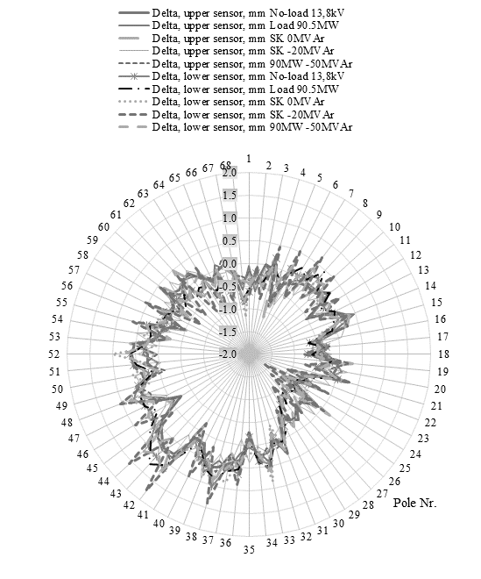

1. Air gap on each rotor pole in different modes.

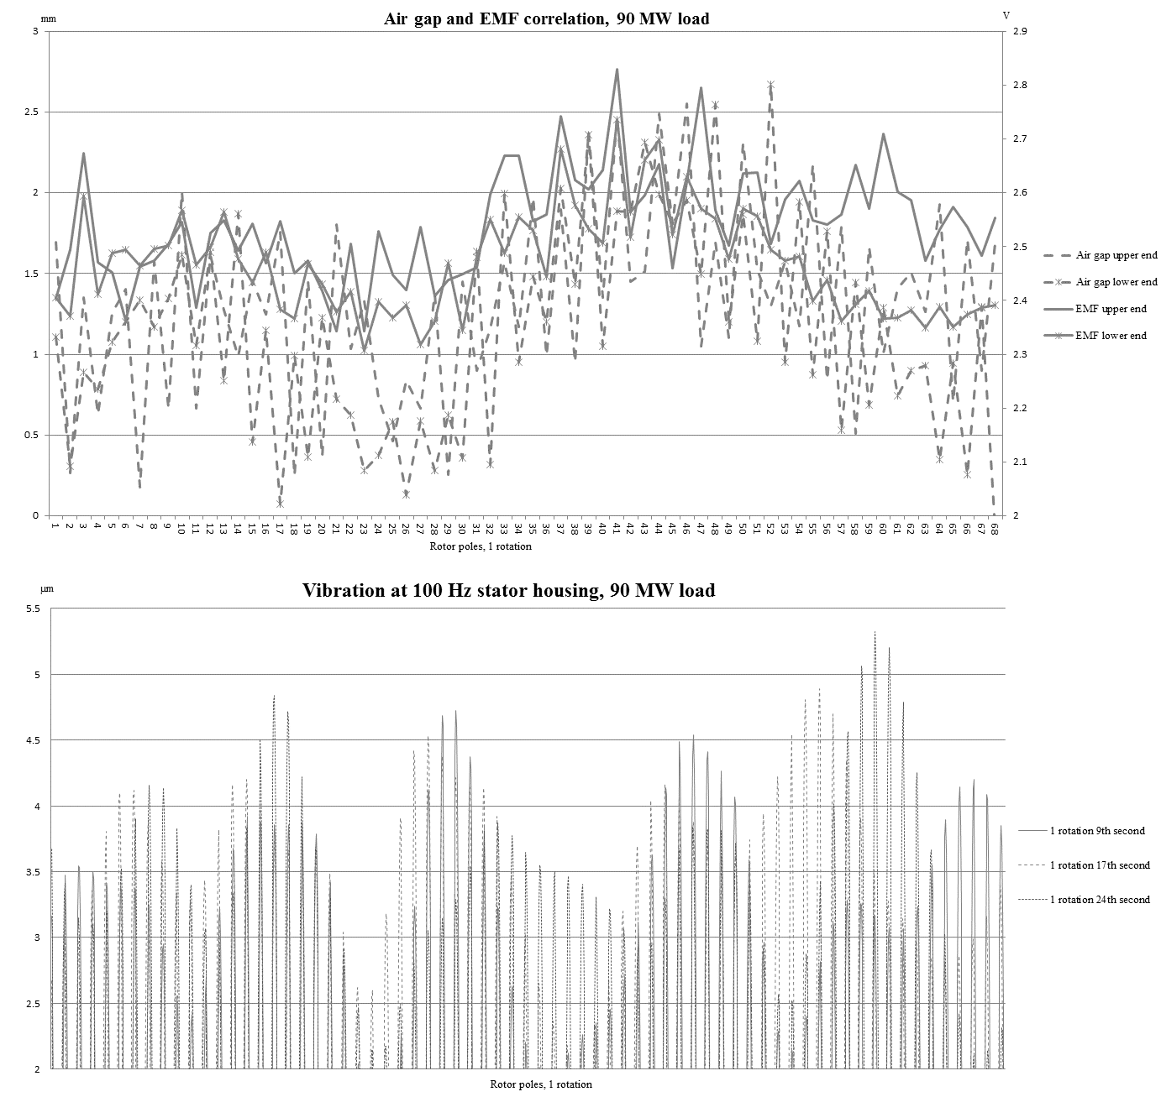

1. Correlation of air gap EMF and 100 Hz stator housing vibration on each rotor pole.

During the experiment in the no-load mode some samples were obtained, for which voltage quality distortion is obvious. The particular example of voltage sine wave with distortions is showed in Figure 5. Literature review suggested that the cause of distortion could be manufacturing fault of a single stator pole [9,10]. Most probably distortions were caused by generator fault, and were not a subject of any power grid defects. Figure 6 illustrates that the distortions were the same for all of three phases and during all no-load mode measurement time.

Figure 6 also demonstrates that there were no similar distortions observed during mode with 90 MW load, therefore the defect has no direct effect on efficiency of the unit in a short run [6].

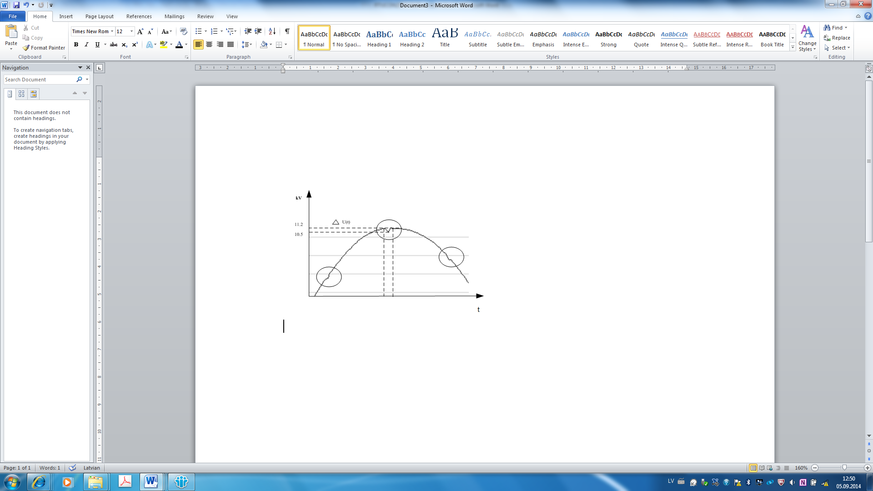

1. Graphical representations of 1 phase current in no-load mode.



1. 1st, 2nd and 3rd Harmonics in different modes. I– no-load mode; II – 90 MW load active power; III – synchronous compensator mode P=0MW, Q=-60 MVAr.

Figure 5 and Figure 6 show that no-load mode is the only operation mode where distortion of voltage curve is registered. Previous study [1] already discussed the effect, that in 90 MW mode voltage distortion is not present. However, hydro power generator rarely operates with 90 MW only. This study proves that distortion does not exist also in synchronous compensation regime. Figure 6 illustrates, that in 90 MW load resulting current are not perfect sine waves. This deviation from perfect sinusoids is expressed in terms of harmonic distortion of the voltage waveforms [9,10].

The distortion, shown on Figure 7 suggests that the eccentricity is present, as proved by EMF and air gap measurements.

The voltage waveform distortions in no-load mode with 13,8 kV showed that there is some mechanical fault on the stator side. The part of the voltage waveform is presented in Figure 5, where cycled parts highlight distortions discovered.



1. Characteristics of three rotor poles in a row. I– no-load mode; II – 90 MW load active power; III – synchronous compensator mode P=0MW, Q=-60 MVAr.

Vibration was measured on generator bearings and turbine bearings, stator housing and core.

Table II-Table V lists some main values of vibration, which proves that possible cause of difference could be stator displacement. In particular case the stator wall was not perfectly vertical, therefore constant discrepancy between any two or more lower and any two or more upper end values appeared.

Some results on vibration of generator bearings are presented in Table II - Table IV. Increased vibration was registered for modes with small loads. Deeper analysis of bearings vibration was done by evaluating 1X, 2X and 3X components (1st, 2nd and 3rd harmonics) of vibration frequency spectrum.

Figure 8 illustrates vibration for all modes measured, where the greatest values correspond to 10 MW load, 90MW -20MVAr load, SK -30MVAr and SK 0MVAr and SK 20MVAr loads.

This study included also analysis of low-frequency vibration spectrum for the stator housing and lower end, upper end and the middle of the stator core. Using the LabVIEW application [4], the Butterworth filter was applied to obtain 1,4 -10 Hz vibration of the stator. The second harmonic was the greatest for low-frequency vibration for given four measurement places. Table V shows the value of frequency components for stator housing in different modes. The value of 2X – second harmonic significantly exceeds values of 1st and 3rd harmonics. The large value of 2X supports the statement that rotor has elliptical eccentricity as illustrated of Figure 3.



1. Vibration of stator housing in different operation modes.

Values of Peak to Peak and Peak to Peak rms vibration for no load mode, blades opening 120 mm

|  |  |  |
| --- | --- | --- |
| Generator vibrations | P-P, µm | P-P rms, µm |
| Generator bearing case in radial direction for right side of the unit | 57 | 19 |
| Generator shaft, left side of the unit | 165 | 79 |
| Generator shaft, tailwater end of the unit | 155 | 88 |

Values of Peak to Peak and Peak to Peak rms vibration for 90,7 MW load, blades opening 475 mm

|  |  |  |
| --- | --- | --- |
| Generator vibrations | P-P, µm | P-P rms, µm |
| Generator bearing case in radial direction for right side of the unit | 27 | 15 |
| Generator shaft, left side of the unit | 102 | 69 |
| Generator shaft, tailwater end of the unit | 135 | 98 |

Values of Peak to Peak and Peak to Peak rms vibration for SK mode, P=0, Q=-60 MVAr

|  |  |  |
| --- | --- | --- |
| Generator vibrations | P-P, µm | P-P rms, µm |
| Generator bearing case in radial direction for right side of the unit | 20 | 10 |
| Generator shaft, left side of the unit | 77 | 51 |
| Generator shaft, tailwater end of the unit | 80 | 61 |

analysis of low frequency vibration spectrum, measured on stator housing

|  |  |  |  |
| --- | --- | --- | --- |
| Mode | Vibration spectrum frequency components | | |
| 1X | 2X | 3X |
| No-load | 11.388669 | 35.738752 | 5.930982 |
| 90,5 MW | 12.017837 | 31.116946 | 4.815196 |
| 45 MW | 12.64851 | 32.528925 | 5.607003 |
| 10MW | 11.334957 | 34.000162 | 4.784253 |
| Start-up | 12.812626 | 32.227129 | 5.156564 |
| 90MW 20MVAr | 11.53488 | 29.11292 | 4.32969 |
| 90MW -10MVAr | 11.725649 | 27.694687 | 4.094163 |
| 90MW -20MVAr | 11.431873 | 26.962667 | 3.853341 |
| 90MW -30MVAr | 11.911527 | 25.545815 | 3.680798 |
| 90MW -40MVAr | 10.983126 | 24.223946 | 3.310648 |
| 90MW -50MVAr | 9.617344 | 26.816302 | 3.552621 |
| SK -63MVAr | 8.687969 | 27.090404 | 3.679773 |
| SK -60MVAr | 9.572561 | 28.495209 | 4.026392 |
| SK -50MVAr | 10.08865 | 29.675787 | 4.47944 |
| SK -40MVAr | 9.237478 | 30.695353 | 4.879064 |
| SK -30MVAr | 9.106438 | 32.226874 | 5.186455 |
| SK -20MVAr | 10.45442 | 33.655169 | 5.589146 |
| SK -10MVAr | 10.247858 | 34.176759 | 6.014942 |
| SK 0MVAr | 9.433396 | 34.915833 | 6.234626 |
| SK 10MVAr | 9.040082 | 36.00856 | 6.433749 |
| SK 20MVAr | 0.191224 | 0.199076 | 0.401218 |

Study showed that EMF measurements have more limitations, compared to air gap measurements. In no-load mode EMF force value is close to zero, therefore for the next studies it is recommended to describe electromagnetic field with the finite element method.

For further analysis it is advisable to install measurement equipment during hours of most intensive plant operation, since group start-ups and shut-down could provide additional information about power quality [11].

# Conclusion

The study described how the rotor of hydro power generator is affected by the exciting current, air gap eccentricity and vibration amplitudes in different operation modes. It was concluded that rotor has greatest voltage distortion in no-load mode with 13,8 kV excitation. The voltage waveform distortions in no-load mode showed that there could be some mechanical fault on the stator side, like manufacturing fault of a single stator pole.

This study proved that same conclusions about rotor eccentricity could be obtained from analysis of low-frequency vibration spectrum of stator housing and core, EMF and air gap. Rotor has dynamic eccentricity and could be further analyzed as elliptical rotor displaced. The eccentricity exceeds optimum limit of 3 % and should be corrected.

The study showed that generator work characteristics like power quality, air gap and vibration are highly reliant on each particular mode and there is a strong correlation between given characteristics. Only one characteristic (air gap or vibration spectrum frequency component) could be used to determine rotor eccentricity type. However, air gap and EMF analysis provides more accurate information about air gap for particular poles. Study suggests that either air gap or EMF measurements should be performed complementary to regular generator vibration control procedure. The control of power quality could be used to meet other objectives.

The standard [6] determines that air gap should be measured in no-load and start-up mode. The study showed that the framework of air gap diagnostics should be extended. In addition to no-load and start-up other modes with -20MVar and -30 MVAr reactive power should be analyzed. Also at least one synchronous compensation mode with reactive power should be used for eccentricity analysis. Extended methodology is useful not only to improve precision, but also to identify defects of particular rotor poles.

##### References

1. Griscenko M., Elmanis-Helmanis R., Skopans U. “Power generator mechanical faults effects on electric power quality”, PQ2014 Conference proceedings: June 2014.
2. Gruwell, David R., and Fouad Y. Zeidan. "Vibration and Eccentricity Measurements Combined with Rotordynamic Analyses on a Six Bearing Turbine Generator." Proceedings of the Twenty-Seventh Turbomachinery Symposium: 1998.
3. Tiirats T., Pabut O., Kallaste A., , Herranen H., Naar H., Vaimann T., “Analysis of Mechanical Vibrations Caused by Eccentricity in a Slow- Speed Slotless Permanent Magnet Generator”, PQ2014 Conference proceedings: June 2014.
4. Griscenko M., Kulikovskis G. "Vibration monitoring of power generation systems, using built-in MATLAB functions for data analysis." Proceedings of LLU EFRD conference: May 2014.
5. Вольдек, А. И. "Электрические машины. Учебник для студентов высш. техн. учебн. заведений." Л.: Энергия 832: 1978.
6. Стандарт ОАО РАО “Методики оценки технического состояния основного оборудования гидроэлектростанций”, 2011.
7. Karlsson, M., et al. “Rotor dynamic analysis of an eccentric hydropower generator with damper winding for reactive load.” Journal of applied mechanics74.6 (2007): 1178-1186.
8. Kangro R., Vaimann T., Kallaste A., Belahcen A.. “Air-Gap Eccentricity Analysis of Slow-Speed Slotless Permanent Magnet Synchronous Generator”, PQ2014 Conference proceedings:June 2014.
9. BS EN 50160:2000 - Voltage Characteristics of Public Distribution Systems, standard published 02/15/2000 by British-Adopted European Standard.
10. Shmilovitz, Doron. "On the definition of total harmonic distortion and its effect on measurement interpretation." IEEE Transactions on Power delivery 20.1 (2005): 526-528.
11. Nicolet, C., Avellan, F., Allenbach, P., Sapin, A., Simond, J. J., Hérou, J. J. “Transient Phenomena in Francis Turbine Power Plants: Interaction with the Power Network”. No. LME-WORKINGPAPER, 2009-001.,2003

##### authors

[](http://l-adm-7.energo.lv:7778/lepo/servlet/photo?EMP_NUM=12028)**Rihards Elmanis-Helmanis**, born in 1982 in Riga, Latvia, holds a Master degree in Electrical Engineering from Riga Technical university since 2007 and is currently working on PhD Thesis in Electrical Engineering. Rihards is working as a manager of Inspection group at AS “Latvijas elektriskie tikli”, Riga, Latvia since 2010. Rihards started his carrier at the laboratory of at AS “Latvijas elektriskie tikli” in 2004 as an electrical engineer.

[](http://l-adm-7.energo.lv:7778/lepo/servlet/photo?EMP_NUM=14555)**Marina Griscenko**,born in 1987 in Riga, Latvia, holds a Master degree in Mechanical Engineering from Riga Technical university since 2011 and MBA degree from Riga Business school since 2014. She is currently working on PhD Thesis in Mechanical Engineering at Riga Technical university. She works as a Mechanical Engineer at AS “Latvijas elektriskie tikli”, Riga, Latvia since September, 2013 and is member of the company labor union since March, 2014.